



**SM6P07 Digital Media Project**

**50% Individual Coursework**

**2024-25 Autumn**

**Student Name: Avinash Gyalzen Lama**

**London Met ID:** 22068804

**College ID: np01mm4a220101**

**External Supervisor: Bibek Gurung**

**Internal Supervisor: Dibesh Maskey**

**Assignment Due Date: Wednesday, May 7, 2025**

**Assignment Submission Date: Wednesday, May 7, 2025**

**Word Count: 2227**

**Project File Links:**

|  |  |
| --- | --- |
| **YouTube Link:** | Keep Unlisted YouTube URL of your Project Here |
| **Google Drive Link:** | Keep Google Drive URL of your Project Here with Anyone in Organization can View Option Enabled |
| **Github Link:** | **https://github.com/Pyroknightsushi/Final-Year-Project** |
|  |  |

*I confirm that I understand my coursework needs to be submitted online via Google Classroom under the relevant module page before the deadline in order for my assignment to be accepted and marked. I am fully aware that late submissions will be treated as non-submission and a marks of zero will be awarded.*

Table of Contents

Table of Figures 6

Preface 9

Introduction 10

Topic, Research Question & Target Audience 11

Title 11

How do environmental storytelling, lighting, and texture design in a 3D space enhance player immersion and emotional engagement in narrative-driven games? 11

Target Audience 11

Aim of project 13

Resources 14

Software to be used 14

Maya 14

Blender 14

Adobe Photoshop & Substance Painter 14

After Effects 14

Premiere Pro 14

Websites Used 15

Shutterstock, Istock, Pinterest, ArtStation 15

Quixel Bridge 15

Polyhaven 15

System Requirements 16

Drawing Tablet 16

Desktop 16

Product Research 17

Character Modelling 17

Character Rigging 18

Character Texturing 19

XGen Hair Research 20

Environment Modelling 21

Box Mapping 22

Character Animations 23

2D Image to 3D Model 24

Creating Wires/Cables using Curves 25

Creating Neon Signs 26

Creating Fur with nHair 27

Adding Glow to Objects 28

Project Plan 29

Pre-Production 31

Concept and Script 31

Character Design 32

Environment Research 35

Mood Board 38

Storyboard 39

Production 40

Project File Setup 40

Character Modelling & Texturing 42

Character 42

UV Unwrapping Character 47

Texturing 50

Fur 53

Rigging 55

Environment Modelling 59

Modular Kit 59

Air Conditioner 61

Electric Box 67

Trash Dumpster 71

Window 76

Wires 78

Downloaded Assets 83

Scene Assembly 86

Animation 90

Walk Cycle 90

Run Cycle 91

Short Jump 92

Long Jump 93

Lighting 94

Window Emissions 94

Tube Lights 96

Neon Signs 97

Spotlights 98

World Lighting 99

Render Settings 100

Post-Production 103

Problem 1 & its solution 103

Problem 2 & its solution 105

Problem 3 & its solution 105

User Testing and Finding 107

Survey Form Results 107

Third Party Testing 114

Appendix 117

Weekly Log 117

# Table of Figures

Figure 1 Research on character modelling 17

Figure 2 Research on Character rigging 18

Figure 3 Character Texturing Research 19

Figure 4 Xgen Hair Research 20

Figure 5 Environment Modelling Research 21

Figure 6 Box Mapping Research 22

Figure 7 Character Animation Research 23

Figure 8 2D Image to 3D Model Research 24

Figure 9 Creating Wires/Cables using Curves Research 25

Figure 10 Research into creating neon signs 26

Figure 11 Research into creating hair with nHair 27

Figure 12 Research into adding glow to objects 28

Figure 13 Old Gantt chart 29

Figure 14 New gantt chart 30

Figure 15 Rough Script 31

Figure 16 Cat Reference 1 32

Figure 17 Cat Reference 2 33

Figure 18 Cat Reference 3 34

Figure 19 Environment Reference 1 35

Figure 20 Environment Research 2 36

Figure 21 Environment Research 3 36

Figure 22 Environment Research 4 37

Figure 23 Mood Board 38

Figure 24 Setup Project Window 40

Figure 25 Set Project Window 41

Figure 26 Cube as the base of the body 42

Figure 27 Moving vertices to create a rough shape of the body 43

Figure 28 Extruding faces 43

Figure 29 Use of average vertices tool 44

Figure 30 Rough Character model 44

Figure 31 Modelling the nose 45

Figure 32 Adding loops for proper topology 45

Figure 33 Completed Character 46

Figure 34 Uncut UV 47

Figure 35 Use of Cut Tool 48

Figure 36 Use of Sew tool 48

Figure 37 UV Unwrapped Character 49

Figure 38 Importing the fbx file into substance painter 50

Figure 39 Painting the character black 51

Figure 40 Adding details 51

Figure 41 Exporting Textures 52

Figure 42 Textured Cat in Maya 52

Figure 43 Creating interactive splines 53

Figure 44 Grooming the splines 54

Figure 45 Adding Clumps 54

Figure 46 Creating Bones 55

Figure 47 Creating Leg Bones 56

Figure 48 Creating Tail Bone 56

Figure 49 Creating Head Bones 57

Figure 50 Creating IK Handles 57

Figure 51 Adding Controllers 58

Figure 52 Modular Kit 59

Figure 53 House made from modular kit 60

Figure 54 A Plane is created 61

Figure 55 Dimensions of image to be projected 62

Figure 56 Implementing dimensions 63

Figure 57 Subdivisions added 63

Figure 58 Adding Displace modifier 64

Figure 59 Projected Model 65

Figure 60 Completed Air Conditioner 66

Figure 61 Electric Box Topology 67

Figure 62 Electric Box Stand 68

Figure 63 Texturing Electric Box 69

Figure 64 Adding Minor Details to the Electric box 70

Figure 65 Dumpster reference image 71

Figure 66 Projected Trash Dumpster 72

Figure 67 Cleaned up trash dumpster 73

Figure 68 Texturing Trash Dumpster 74

Figure 69 Use of shrink wrap modifier 74

Figure 70 Fully Textured Trash Dumpster 75

Figure 71 Selecting Faces for a window 76

Figure 72 Window 77

Figure 73 Creating a curve using EP Curve Tool 78

Figure 74 Taking a cylinder 79

Figure 75 Circular polygon on curve 80

Figure 76 Extruded Polygon Along Curve 81

Figure 77 Created Wire 82

Figure 78 Imported Cycle from Quixel Bridge 83

Figure 79 Pipes imported from Polyhaven 84

Figure 80 Airduct imported from Polyhaven 84

Figure 81 Bollard Imported from Polyhaven 85

Figure 82 Rough Concept of Scene 86

Figure 83 Minor Details added 87

Figure 84 Final Scene Assembly 88

Figure 85 Rendered Scene 89

Figure 86 Creating Walk Cycle by adding Keyframes 90

Figure 87 Creating a run Cycle 91

Figure 88 Creating a short jump 92

Figure 89 Creating a Long Jump Cycle 93

Figure 90 Untinted Windows 94

Figure 91 Windows with emissive tint 95

Figure 92 Tube Lights with blue emissive 96

Figure 93 Neon Signs 97

Figure 94 Use of spot lights 98

Figure 95 Texturing world lighting 99

Figure 96 Rendering Settings 1 100

Figure 97 Rendering settings 2 101

Figure 98 Export Settings 3 101

Figure 99 Export Setting 4 102

Figure 100 Auto-unwrapping 103

Figure 101 The Solution 104

Figure 102 Maya not taking in textures 105

Figure 103 Solution rendering in Blender 106

Figure 104 Age Group 107

Figure 105 Occupation status 108

Figure 106 Have they watched other 3D animation movies 108

Figure 107 Appreciation of the 3D animation 109

Figure 108 Ambience Rating 110

Figure 109 Asset Rating 111

Figure 110 Animation quality rating 112

Figure 111 Comparison 113

Figure 112 Student skill 113

Figure 113 Eva De Roy 114

Figure 114 Prajit Man Shrestha 115

Figure 115 Anna Kasayuke 116

# Preface

This project is the conclusion of the student’s academic journey in 3D animation. The technical skills, artistic vision, and narrative storytelling condensed into a single project. The task to create a concept, design and produce a short 3D animation.

The project challenges the student’s proficiency in modelling, rigging, texturing, lighting, and animation, but also the ability to convey emotion, mood, and story without relying on dialogue.

Throughout this process, a variety of animation pipelines, experimentation with stylistic direction and a deep understanding of cinematics within a 3D space was learned. The work presented here reflects on the technical and conceptual skills of the student required to bring a narrative to life through animation.

# Introduction

This coursework tasks the student to create a digital media project and complete it. The coursework requires extensive research on trends in the industry, pre-production (creating mood boards, storyboards, scripts), production processes and post-production processes.  
  
Pre-production involves research on character design, a script, storyboards for the script and mood boards on how the scene is supposed to be depicted as.

Production requires the skill and technique to be able to model the character, the scene with all its little details, along with the need to add textures and animate the character.

Post-production involves everything from compositing, sequencing and rendering the scenes, along with adding subtle ambient music to make the final output come to life.

Self and third-party evaluation is also done which helps in knowing personal strengths and weaknesses. It also helps in reflecting on new skills and techniques that have been learned.

This task helps the student prepare for a future in the industry by helping them develop all the skills needed.

# Topic, Research Question & Target Audience

## Title

Working Title: Neon Echoes

A short 3D animated video showcasing an environment by following a cat around. It plans to showcase the modelled environment along with all the textures and lighting following a set path where a cat moves and interacts with the environment.

## How do environmental storytelling, lighting, and texture design in a 3D space enhance player immersion and emotional engagement in narrative-driven games?

The combination of environmental storytelling, lighting, and texture design works together to enhance player immersion and emotional engagement. These elements help in conveying a narrative that is beyond simple plot points and encourages the player to feel a deeper connection to the world. It makes the world feel alive filled with a rich history, invokes emotional responses, reinforces mood, and creates a believable and tangible environment.

## Target Audience

Title

Neon Echoes

Tagline

A world forgotten, rediscovered through the eyes of a wanderer

Genre

Sci-Fi Adventure

Post-Apocalyptic Exploration

Storyline

A cat’s journey through breathtaking environments, revealing glimpses of the past.

Target Audience

Age: 16+

Gender: Any

Experience

Immersive Visuals

Emotional Atmosphere

Cinematic Quality

# Aim of project

A short 3D animation video showcasing an environment along with all the assets in a 3rd person perspective. The objective of the project is to showcase all the skills the student has learned from modelling, UV mapping, texturing, animation. This will also be part of the student’s portfolio for the future.

# Resources

## Software to be used

### Maya

Used to model the character, animation, lighting, texturing, and rendering.

### Blender

Used for environment modelling, box mapping the environment, along with scene setup with the help of minor assets that were downloaded.

### Adobe Photoshop & Substance Painter

Used for storyboard, texturing of assets.

### After Effects

Used for creating post-production effects.

### Premiere Pro

Compiling footages from the scenes, adding ambient music, exporting the final output.

## Websites Used

### Shutterstock, Istock, Pinterest, ArtStation

Used for references, mood boards.

### Quixel Bridge

Used to download assets

### Polyhaven

Used to download HDRI

## System Requirements

### Drawing Tablet

Wacom Intuous

### Desktop

**Processor:** AMD Ryzen 5 7600x

**Operation System:** Windows 11

**Ram:** 32 Gigabytes

**GPU:** Nvidia RTX 4070 Ti Super

# Product Research

## Character Modelling

For character modelling this tutorial was followed. This video goes through the basics of modelling a character. Starting with simple geometric shapes and refining them to form the body of a cat. This is effective in creating stylized characters, allowing flexibility and control over the proportions and features of the model.

Youtube Link: <https://youtu.be/4JvuY3GTPRM?si=T4T_tDHnRIsGGuD7>

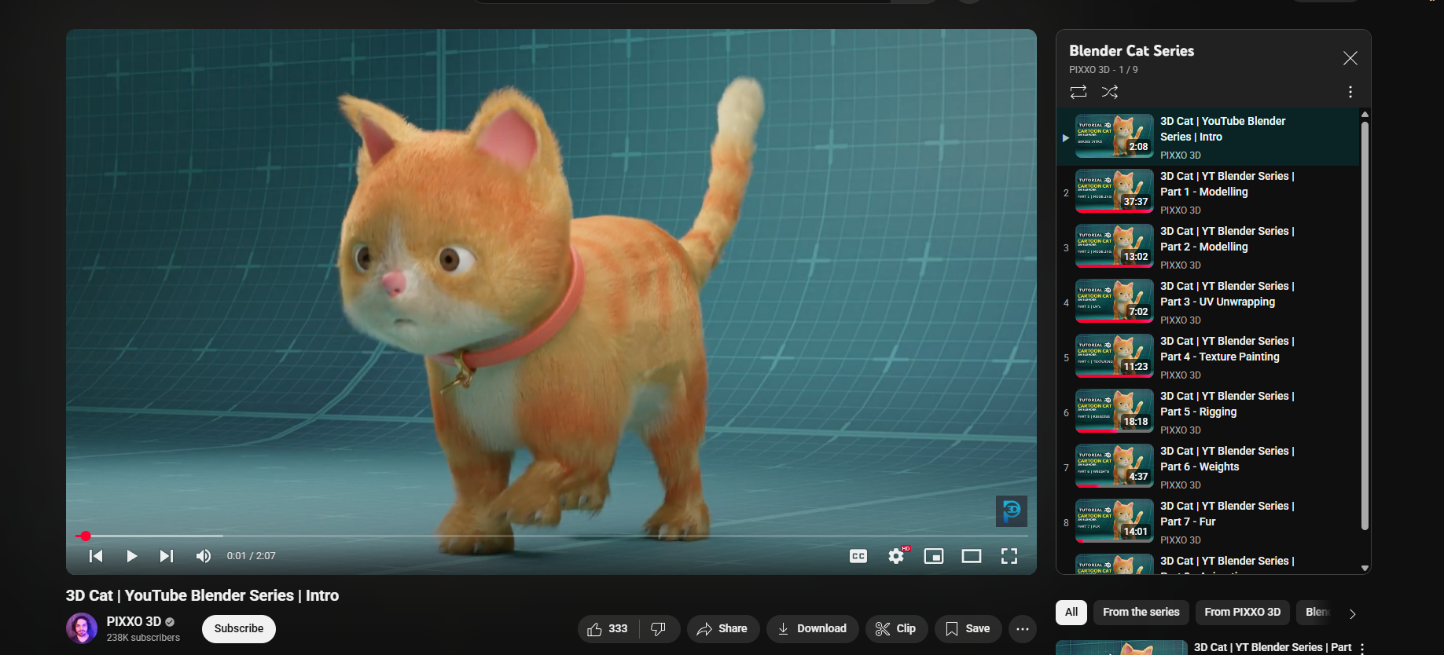

Figure 1 Research on character modelling

## Character Rigging

For rigging the character this guide was taking as reference. Research into joint creation and orientation, setup of Inverse Kinematics(IK), use of control curves and constraints, finally leading to skinning of the model.

Youtube Link: <https://www.youtube.com/watch?v=eucOLC2sOmk>

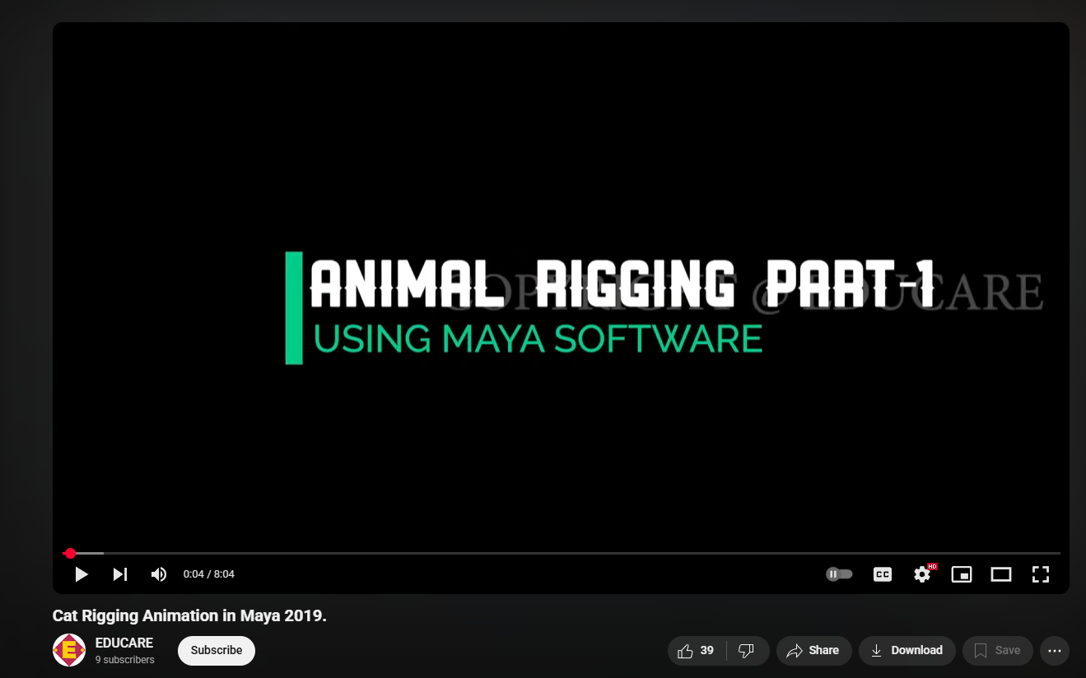

Figure 2 Research on Character rigging

## Character Texturing

This video was taken as reference for Character texturing research. Learning how to UV unwrap the 3D model, then painting base colors into adding minor details such as fur patterns and facial features were researched.

Youtube Link: <https://www.youtube.com/watch?v=WDsRtJTc_48>

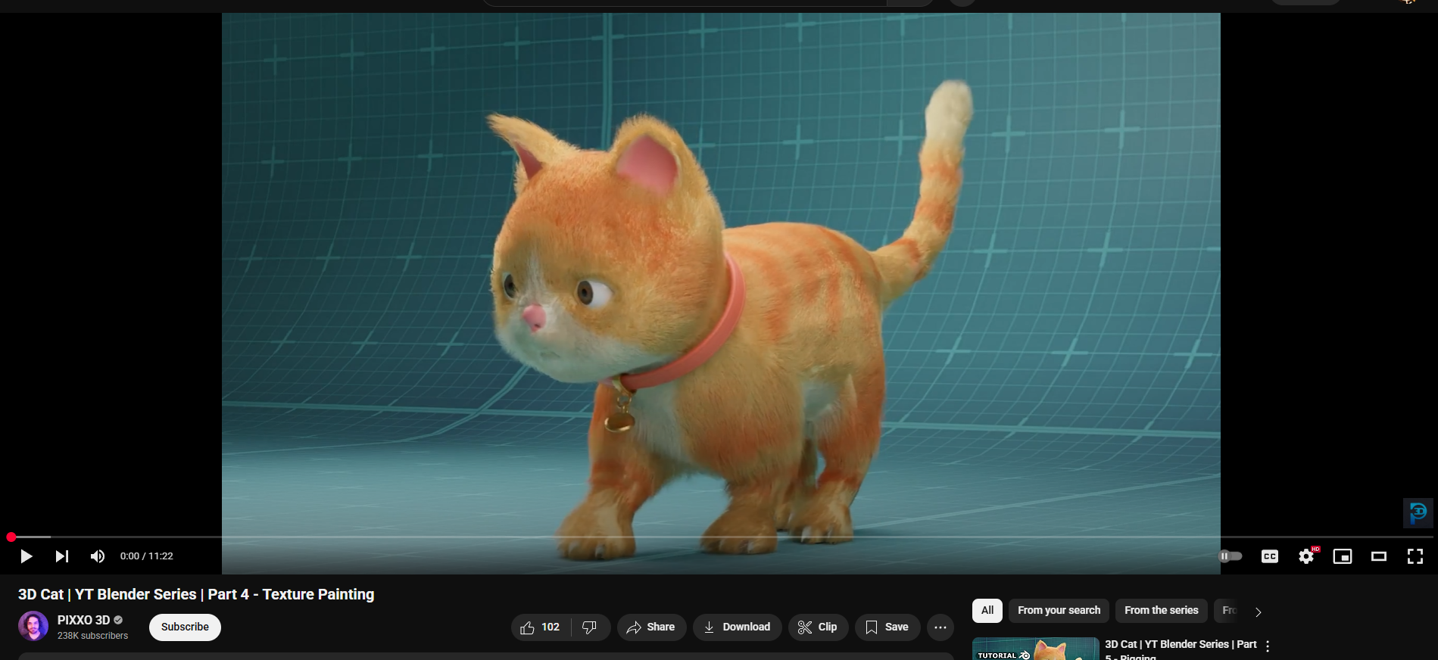

Figure 3 Character Texturing Research

## XGen Hair Research

This video was used to research on how groom able hair is created in Maya with the use of XGen. Research into XGen Interactive Grooming, setting up the groom, creating guides to serve as the foundation for the hair’s direction and flow, adding modifiers such as clump, noise.

Youtube Link: <https://www.youtube.com/watch?v=x0w4XpZqSCA>

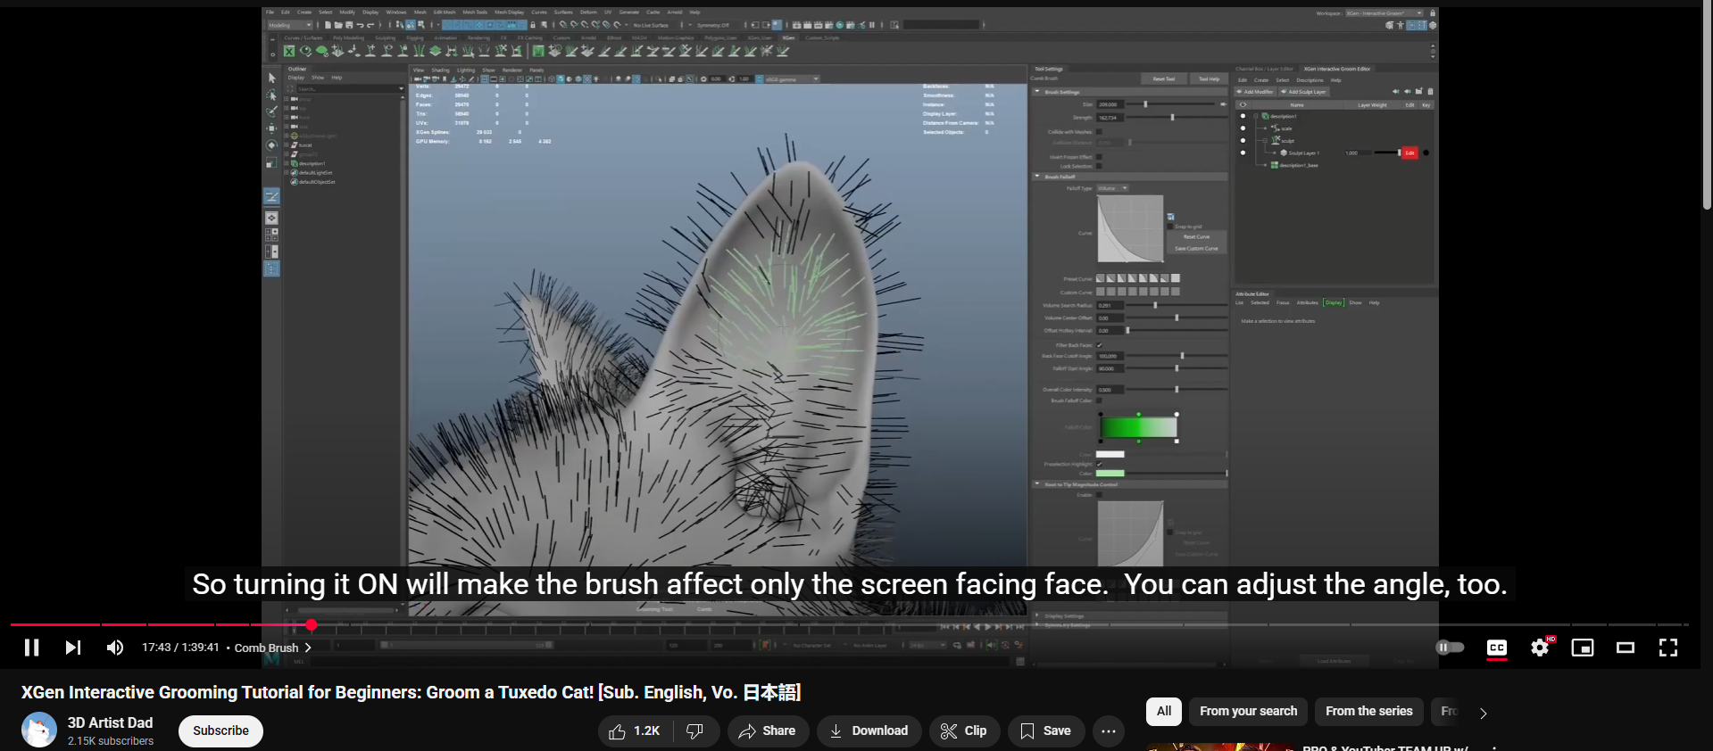

Figure 4 Xgen Hair Research

## Environment Modelling

For environment modelling this video was taken as a reference. Research into modular design and the importance of designing building components such as walls, windows, doors, and roofs as modular pieces allowing for the efficient assembly and reusability across various projects. The use of grid alignment and snapping and demonstration of techniques for UV unwrapping modular components to optimize texture useage.

Youtube Link: <https://www.youtube.com/watch?v=56xMeqWXjSg>  
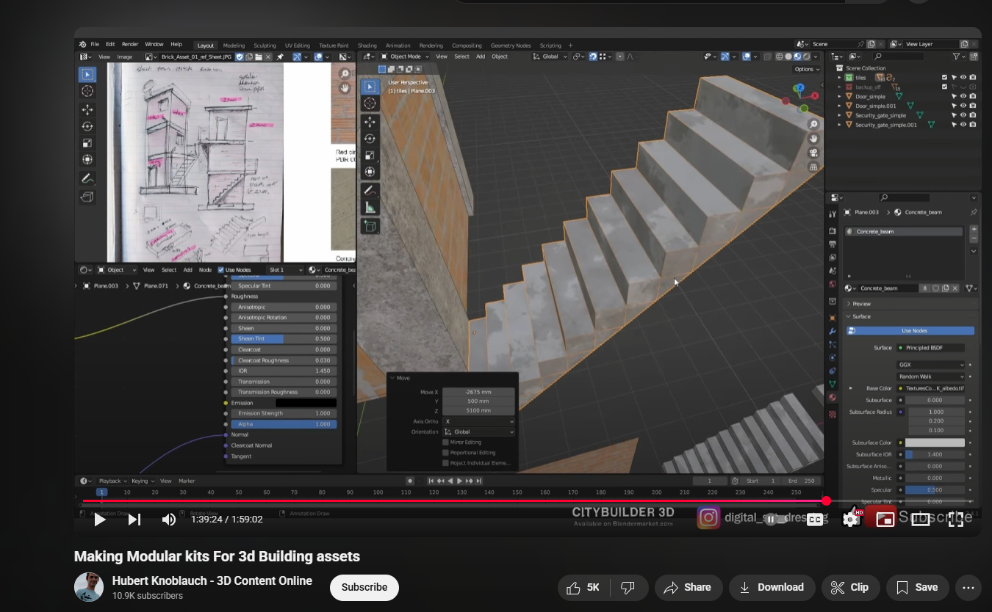

Figure 5 Environment Modelling Research

## Box Mapping

This video was used as research for Box Mapping in blender. Box Mapping projects a texture on a model from six directions (positive and negative X, Y, and Z axes) blending them to create a seamless appearance. This method is ideal on models where UV unwrapping would be time-consuming and unnecessary.

Youtube Link: <https://www.youtube.com/watch?v=vyNm3I16rHg>

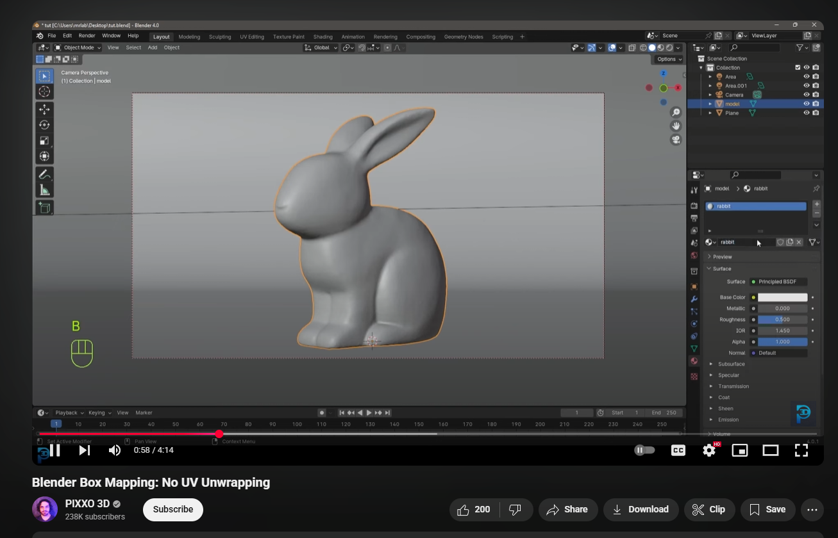

Figure 6 Box Mapping Research

## Character Animations

This video was used as reference for character animations.

Youtube Link: <https://www.youtube.com/watch?v=v7KANqGGis4>

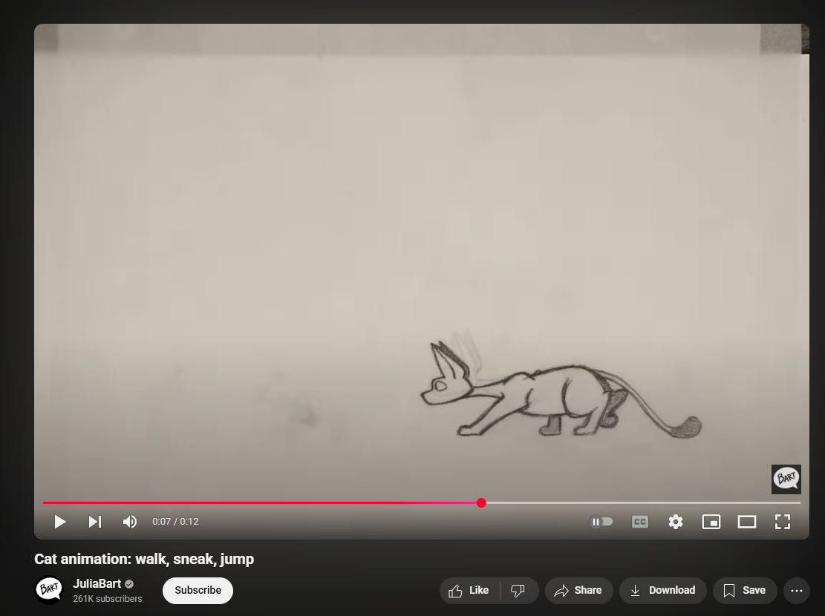

Figure 7 Character Animation Research

## 2D Image to 3D Model

This video was taken as reference to create 3D polygons from 2D images in blender. This method is useful for creating quick 3D representations of logos, patterns, or stylized artwork without manual modelling.

Youtube Link: <https://www.youtube.com/watch?v=BcjPCjxsCZo>

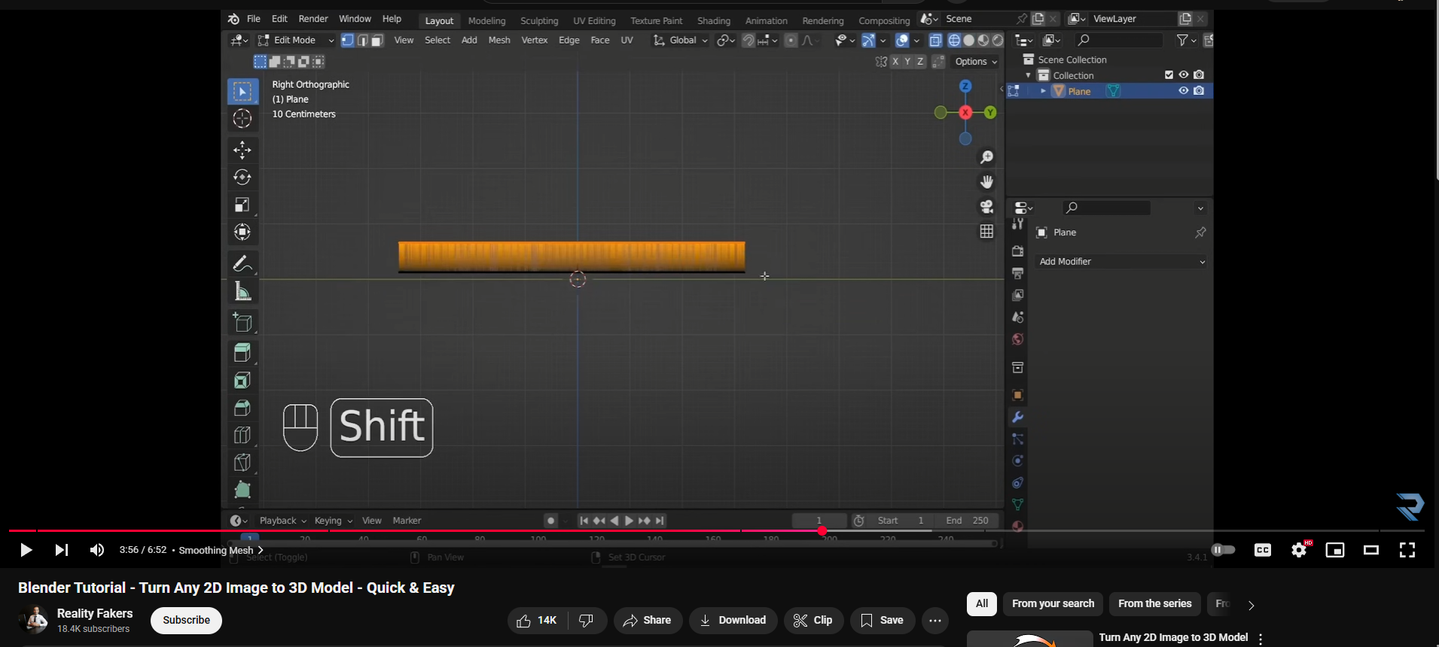

Figure 8 2D Image to 3D Model Research

## Creating Wires/Cables using Curves

This video was used to research into making wires/cables quickly using Curves. Research into using the EP Curve Tool to draw a path for a wire or cable and extruding a polygon (commonly a circle) along the curve to form the 3D geometry for a wire.

Youtube Link: <https://www.youtube.com/watch?v=4igTVJOEJw0>

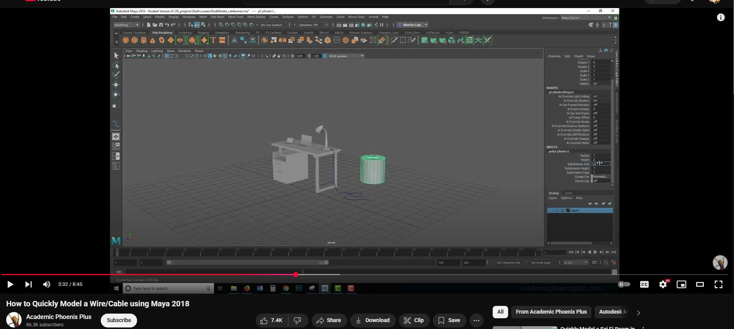

Figure 9 Creating Wires/Cables using Curves Research

## Creating Neon Signs

Research into a quick and easy way on how to create neon signs on blender using text

Youtube Link: <https://www.youtube.com/watch?v=8eNN2Ep3Rqs>

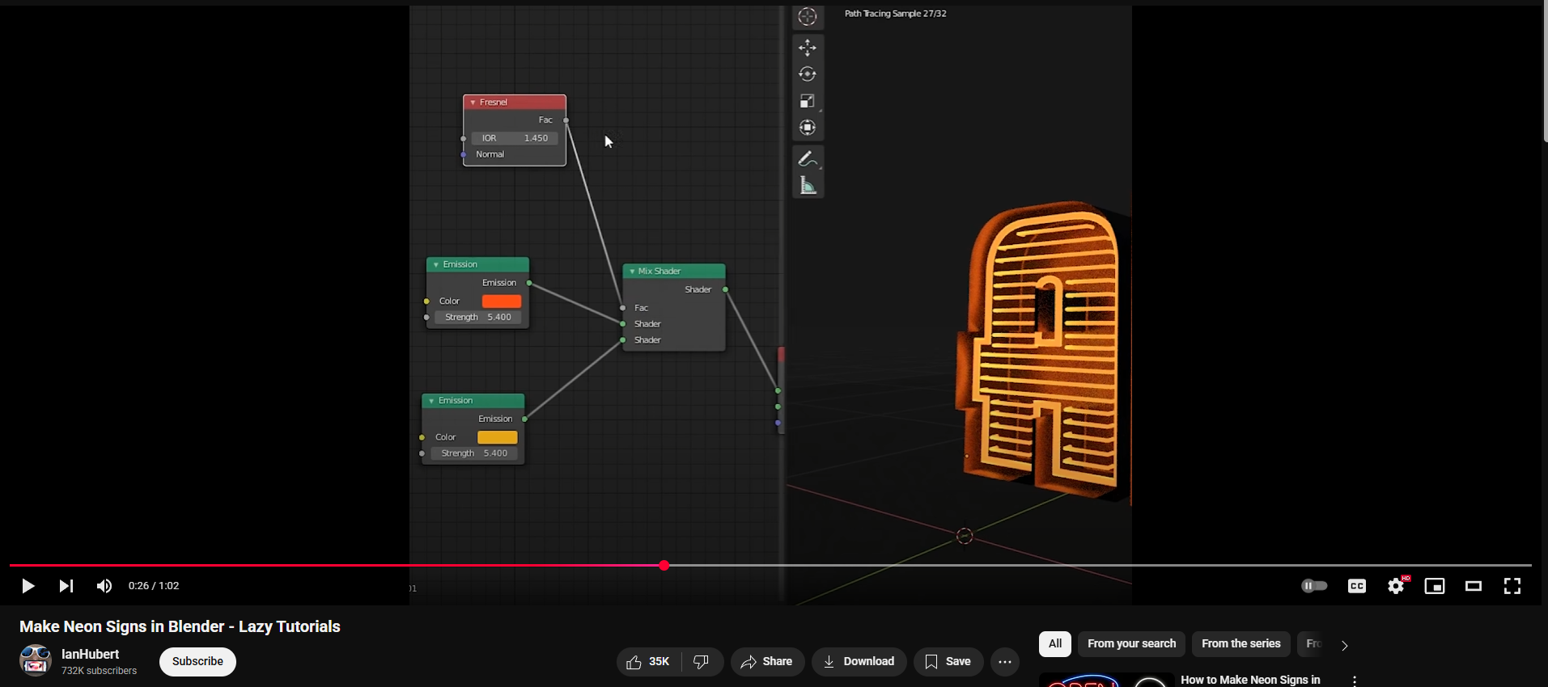

Figure 10 Research into creating neon signs

## Creating Fur with nHair

Research into how to create a simple hair system using nHair

Youtube Link: <https://www.youtube.com/watch?v=tNZcI_3iFUI>

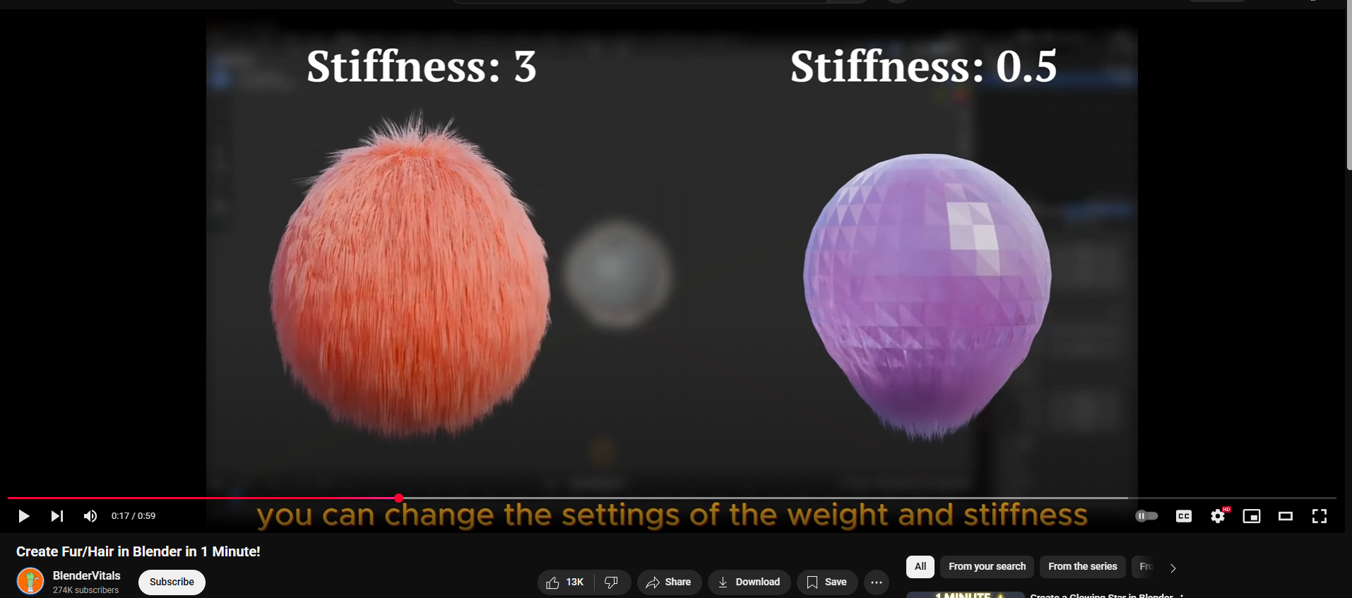

Figure 11 Research into creating hair with nHair

## Adding Glow to Objects

Research into adding glow to any object.

Youtube Link: <https://www.youtube.com/watch?v=WTFj9B6eFgk>

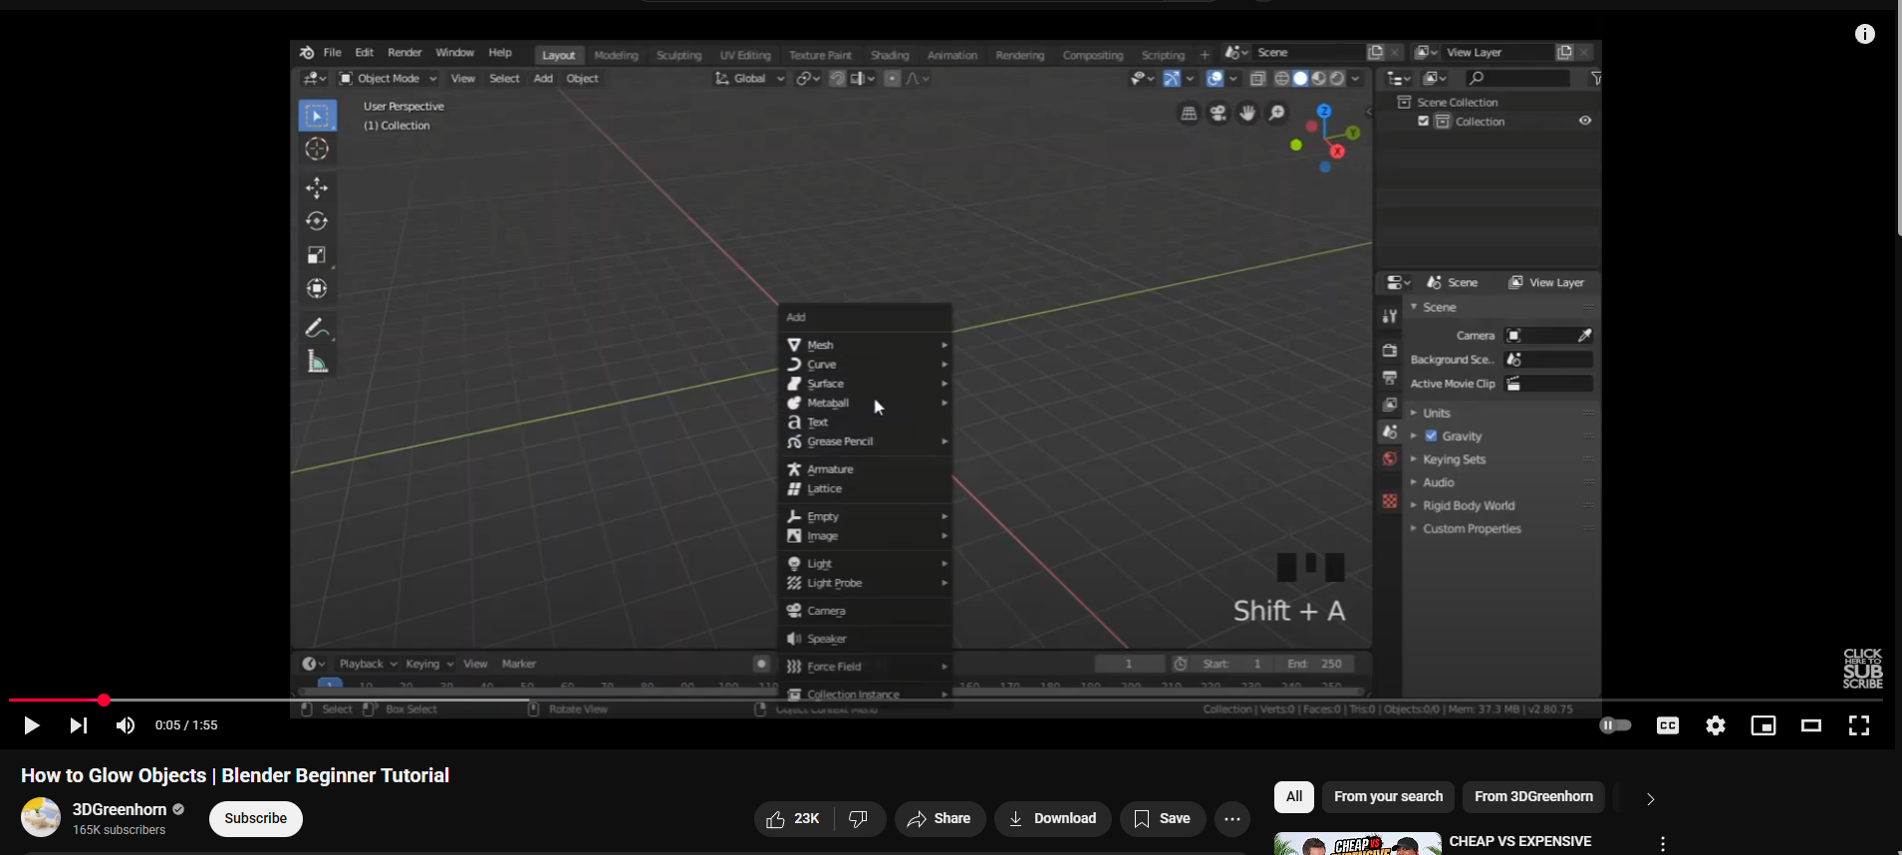

Figure 12 Research into adding glow to objects

# Project Plan

The project timeline had to be changed as the deadline was closer than expected. So, adjustments were according to that. Animation took shorter than expected while documenting everything took a while but since animation didn’t make as much time it was easier to meet deadlines.

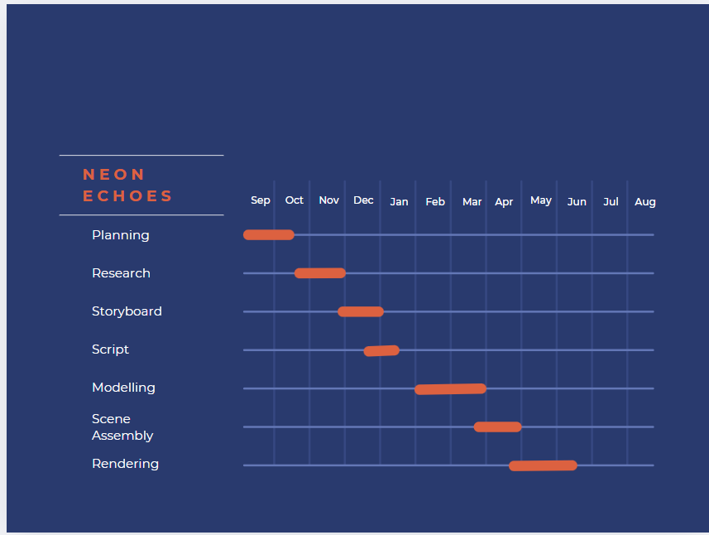

Figure 13 Old Gantt chart

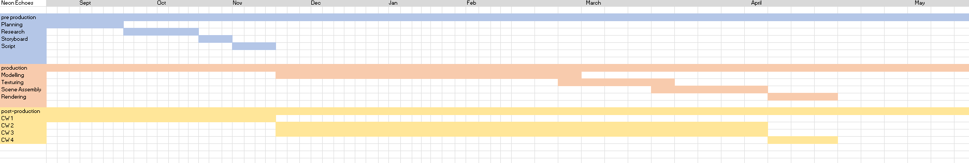

Figure 14 New gantt chart

# Pre-Production

## Concept and Script

The concept came into development after the indie game Stray. To know more about the environment, the vibes it gives off the trailer was watched and short playthrough was also done. The detail on the environment, the lighting, the behaviour and animations given to the character were looked upon, along with research on these topics.

Along with this additional research was done on **Wayfinding Theory**. With all these factors in mind a rough concept was created, a short 3D animation video showcasing an environment along with all the assets in a 3rd person perspective was the goal.

For additional references, the trailer for the movie Flow was also researched upon which is a masterpiece for visual storytelling. A dialogue-free animated adventure that follows a black cat navigating through a post-apocalyptic world.

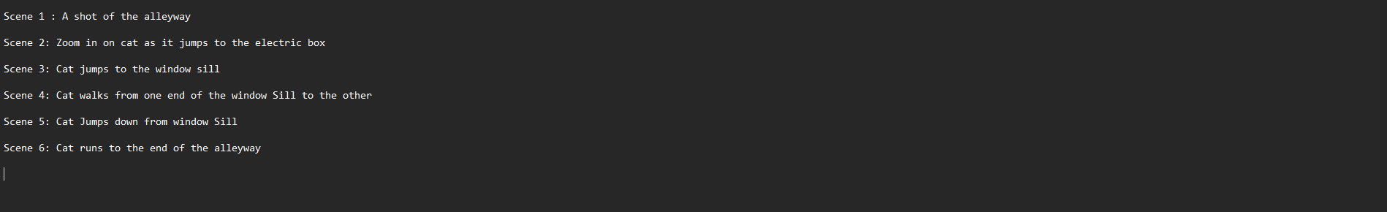

Figure 15 Rough Script

## Character Design

Character design is a key part of the project. The main requirement for the character was that it needed to be an animal. To achieve this, references of cats was collected along with front, side views.

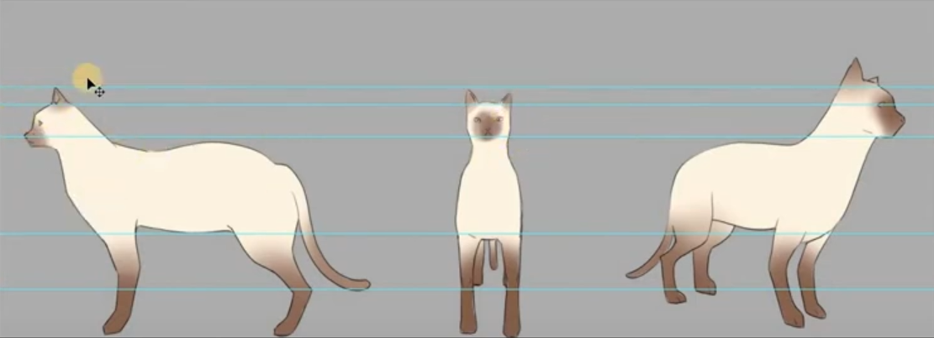

Figure 16 Cat Reference 1

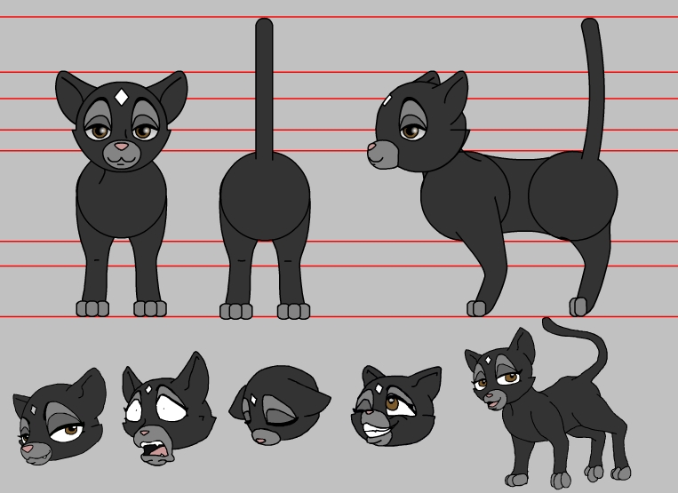

Figure 17 Cat Reference 2

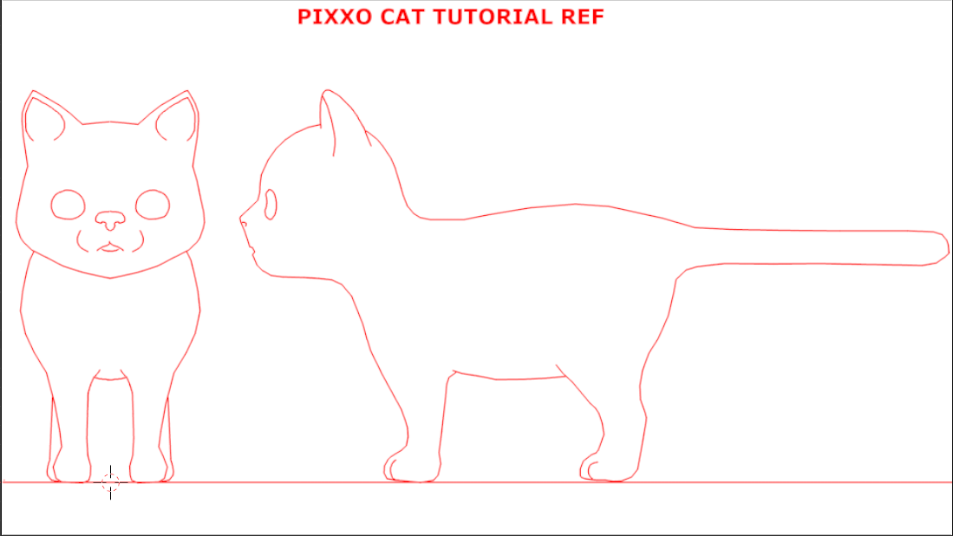

Figure 18 Cat Reference 3

## Environment Research

Environmental Research is a crucial part of the pre-production process, as it gives a clear vision on how the scene is supposed to look. It also gives a rough idea on the types of lightning needed, how to frame the scene. A post-apocalyptic theme was researched for this project.

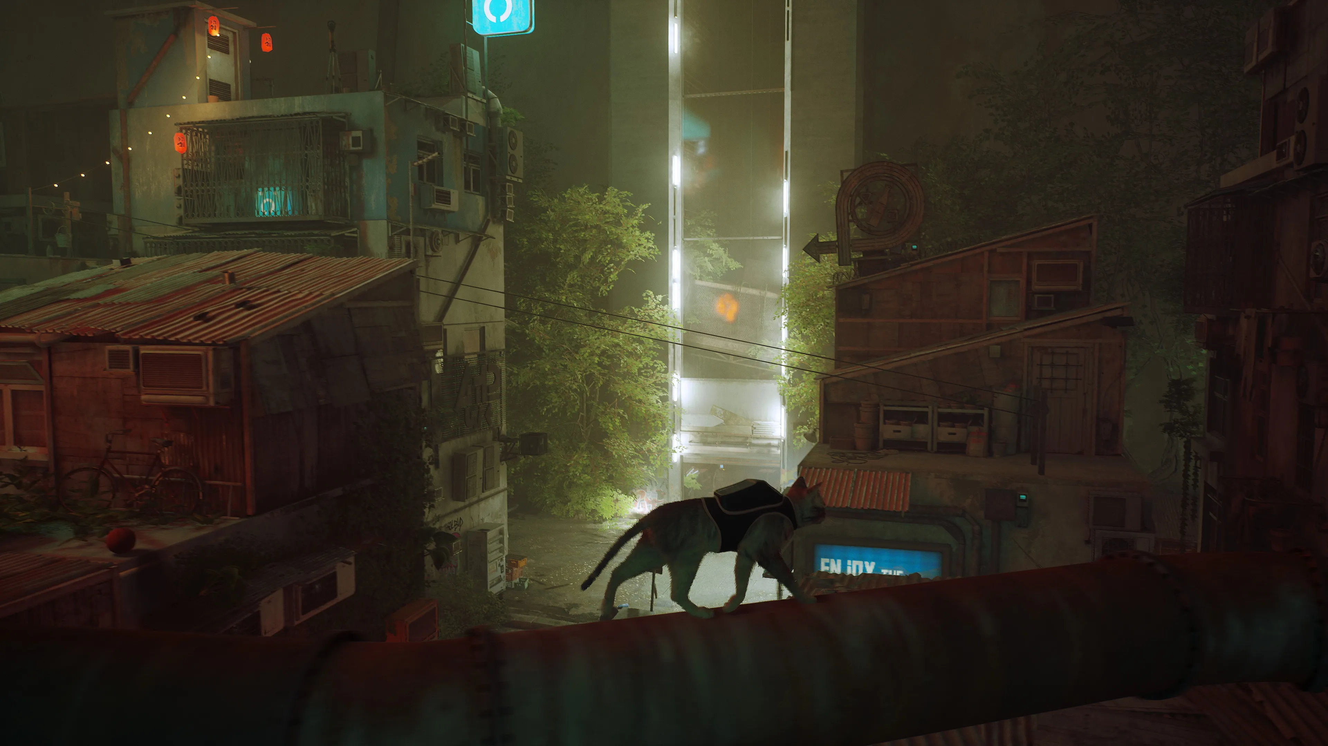

Figure 19 Environment Reference 1

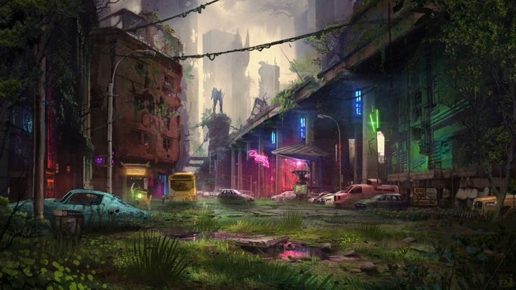

Figure 20 Environment Research 2

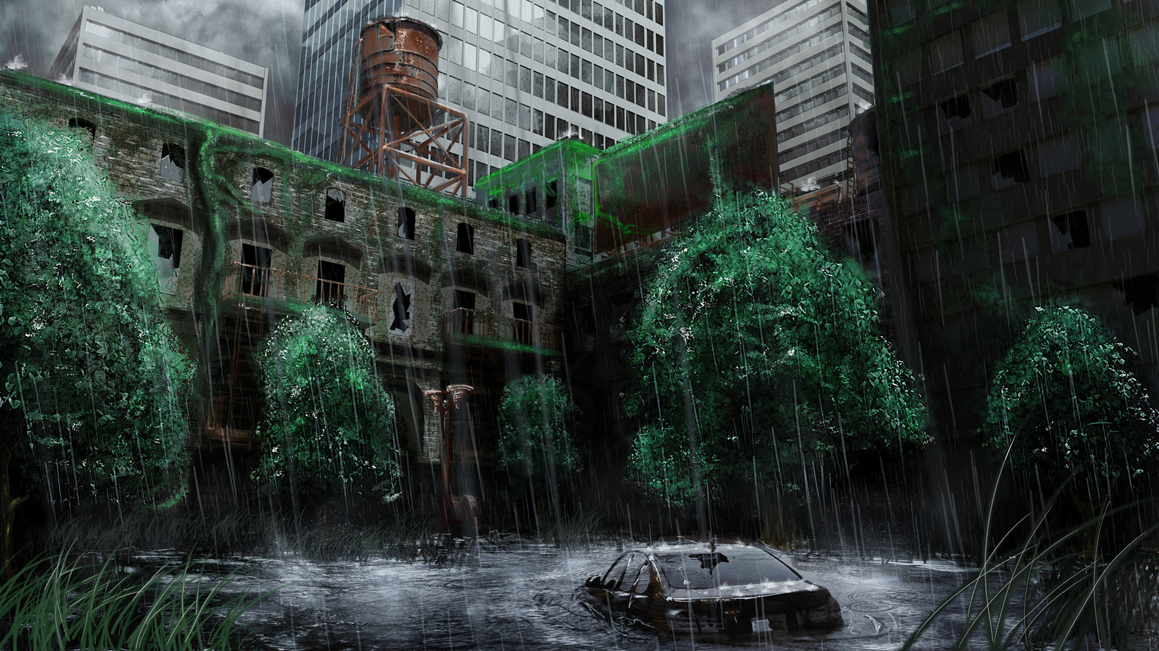

Figure 21 Environment Research 3

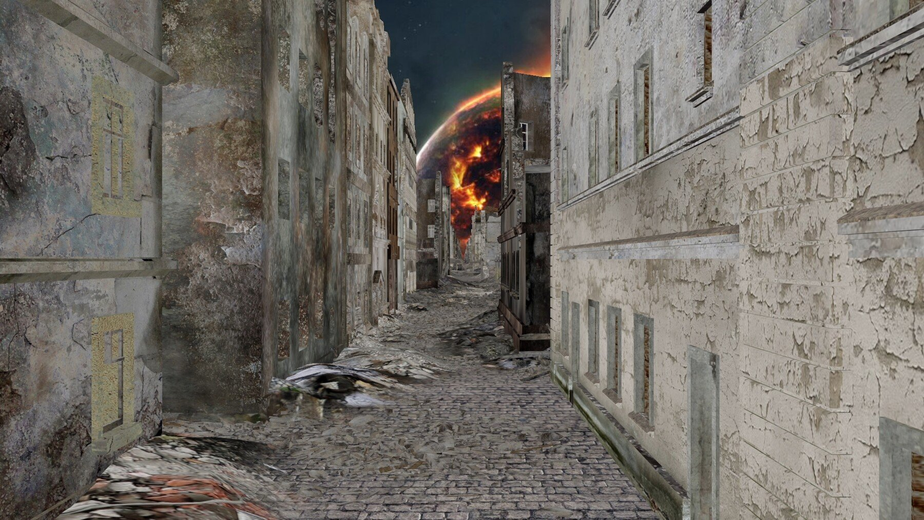

Figure 22 Environment Research 4

## Mood Board

A Mood board was created to determine the aesthetics of the project. It includes how the lighting is supposed to be, how the environment is supposed to look, the colors included in the scene.

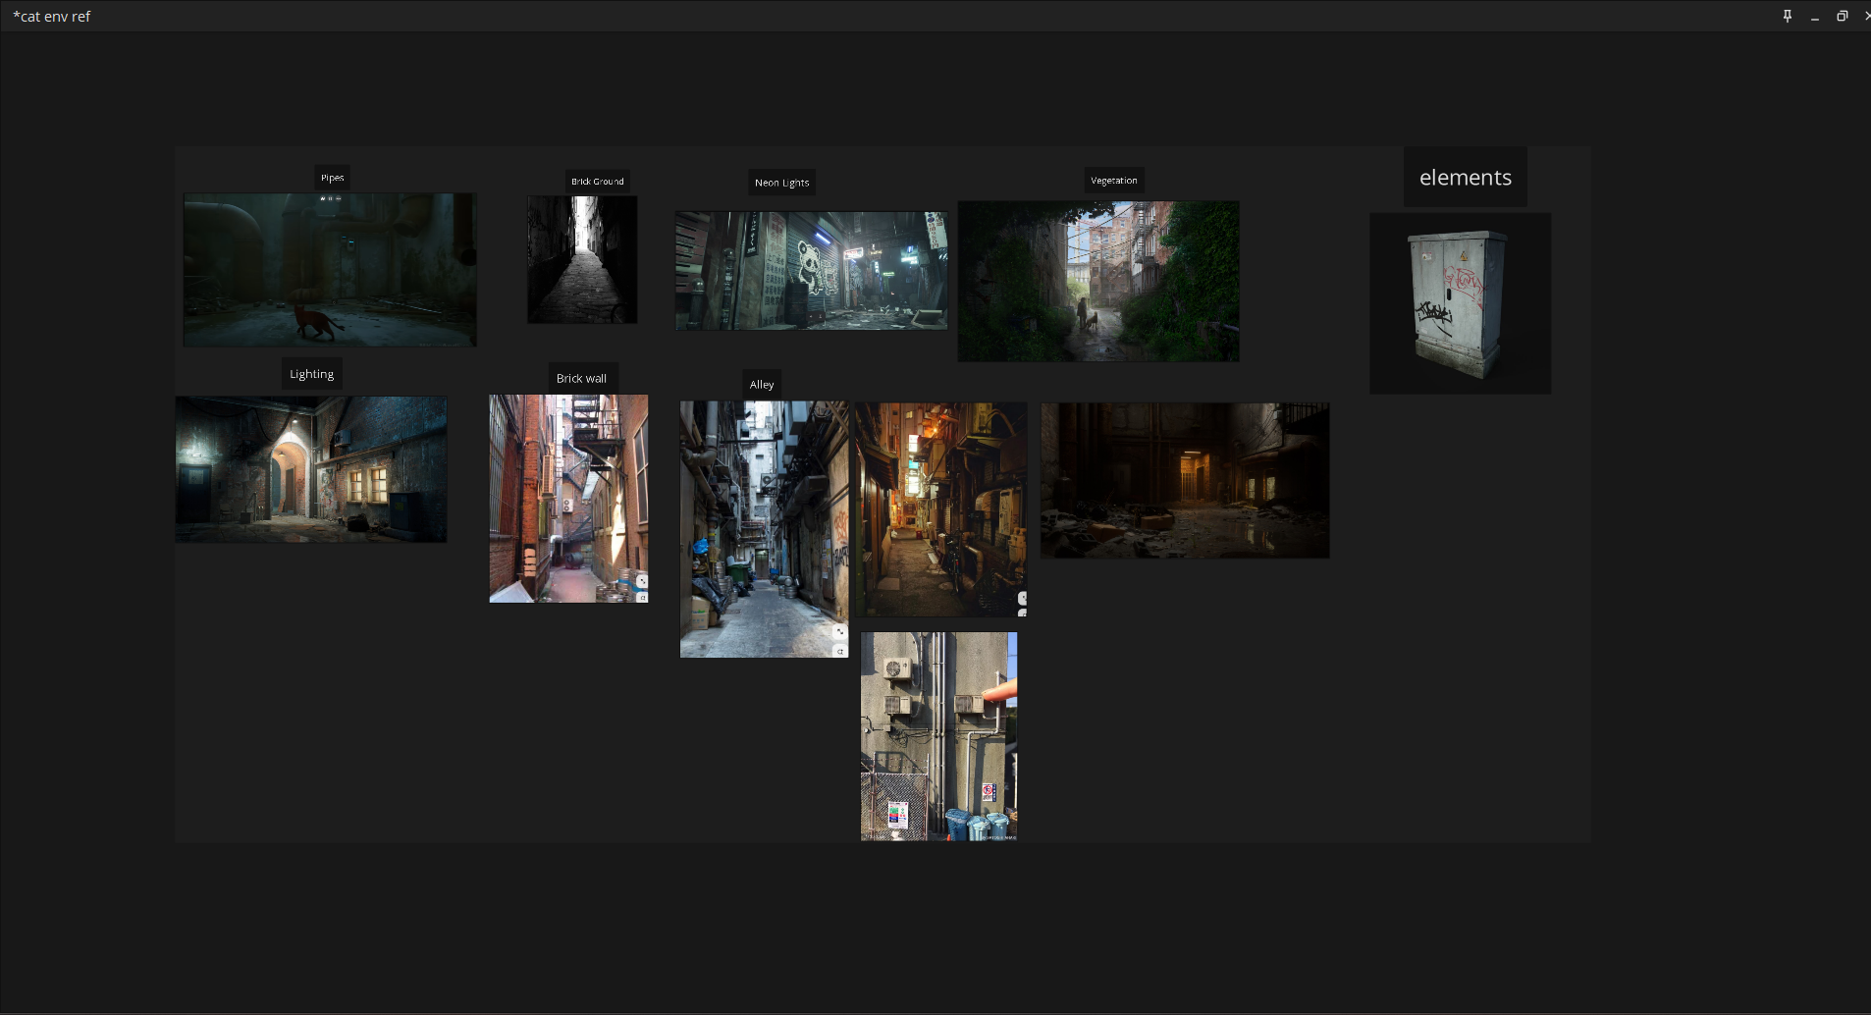

Figure 23 Mood Board

## Storyboard

# Production

## Project File Setup

An organized and neat folder structure is required for the project. A project file was setup to achieve this.

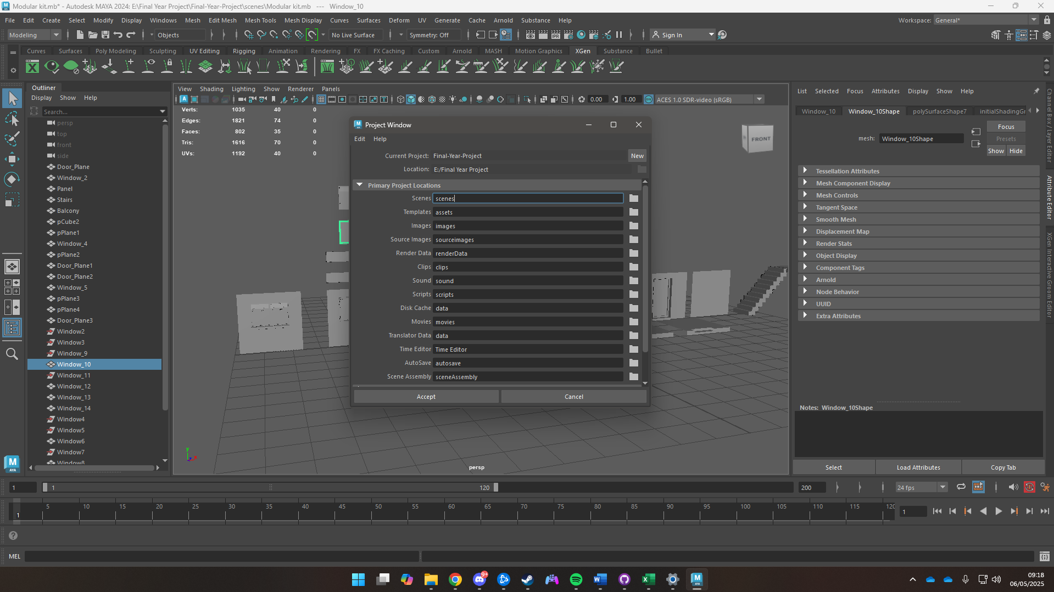

Figure 24 Setup Project Window

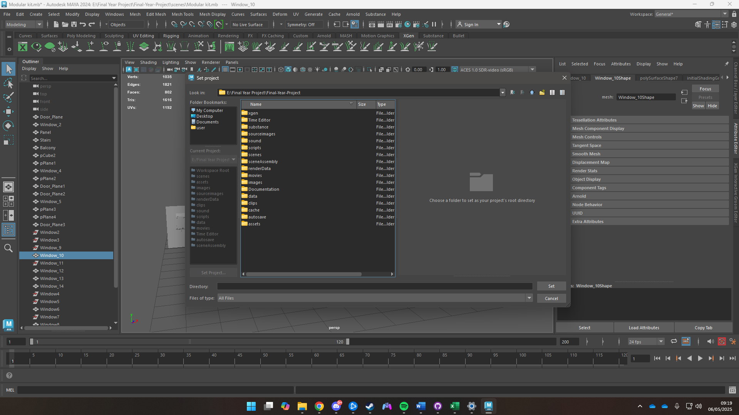

Figure 25 Set Project Window

## Character Modelling & Texturing

### Character

A Cube was used as the base of the entire character. To create the body vertices were moved to match the shape in the reference image. The cube was then extruded to match the size of the body and edge loops were added to give it proper shape. The average vertices tool was used to give the body a smooth look. Then one half of the body was deleted then mirrored to give it a symmetrical look.

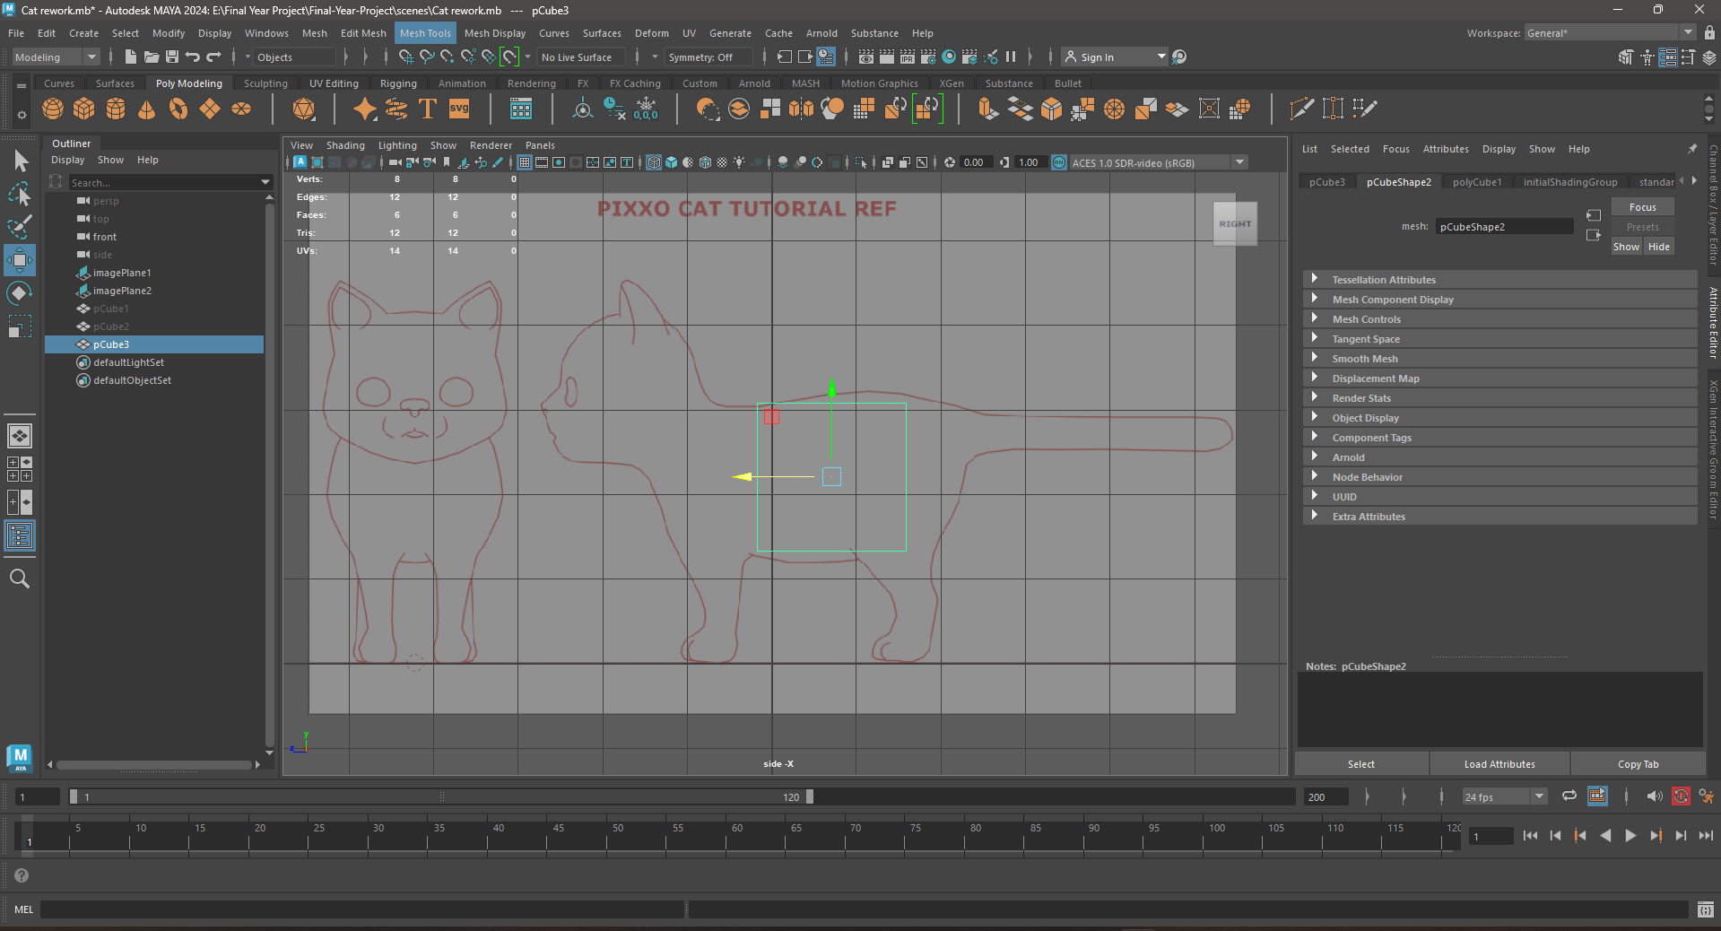

Figure 26 Cube as the base of the body

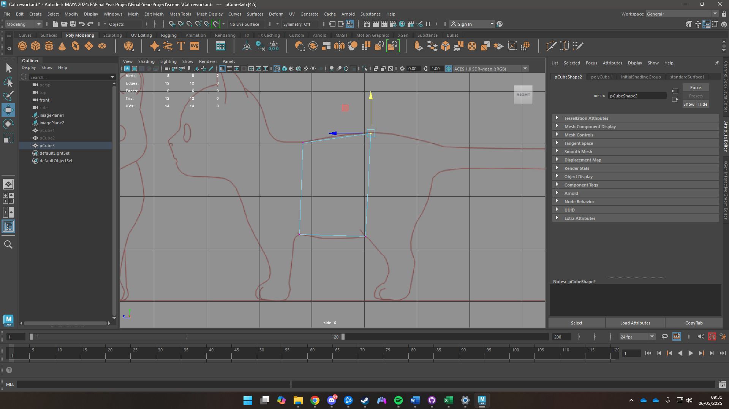

Figure 27 Moving vertices to create a rough shape of the body

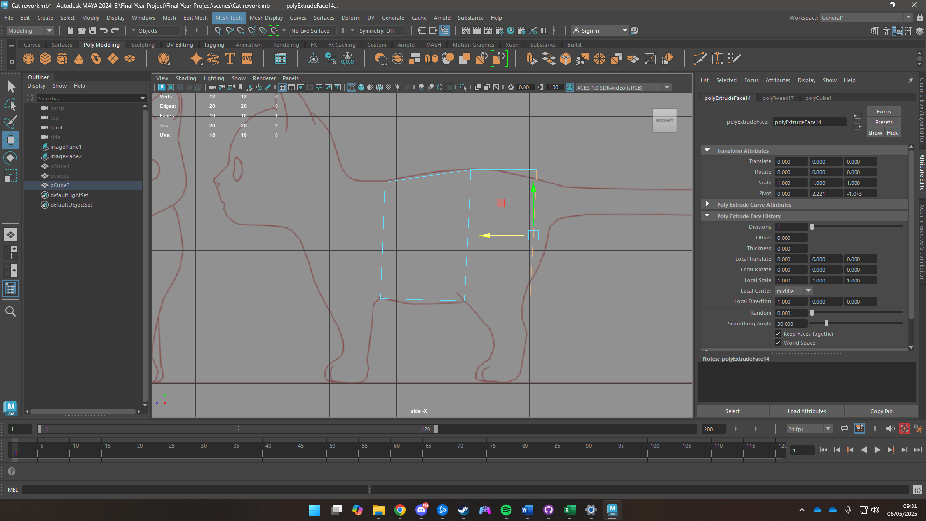

Figure 28 Extruding faces

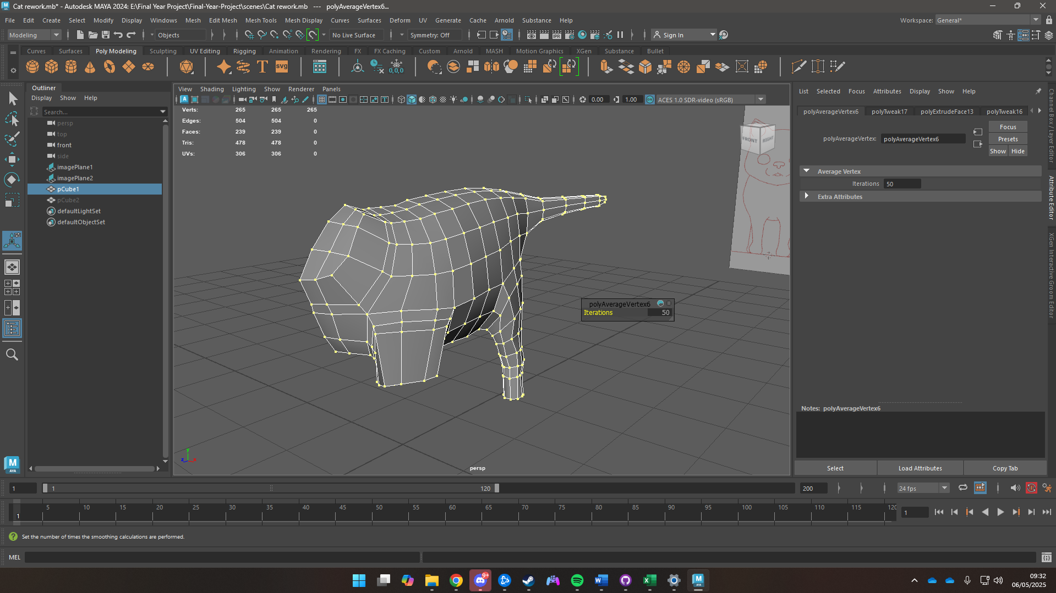

Figure 29 Use of average vertices tool

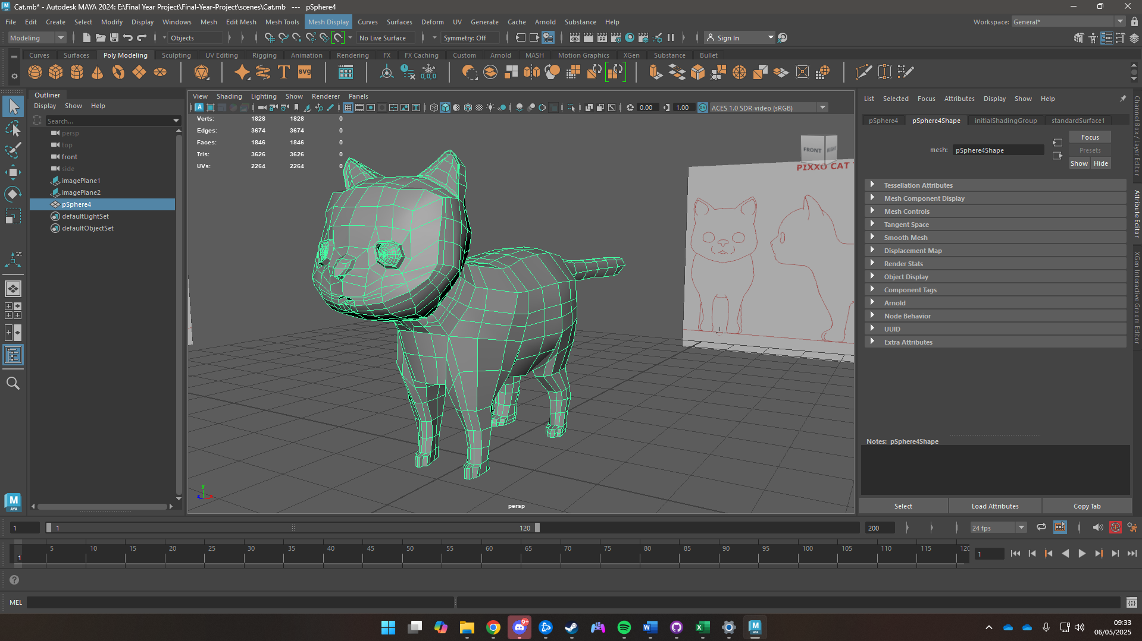

Figure 30 Rough Character model

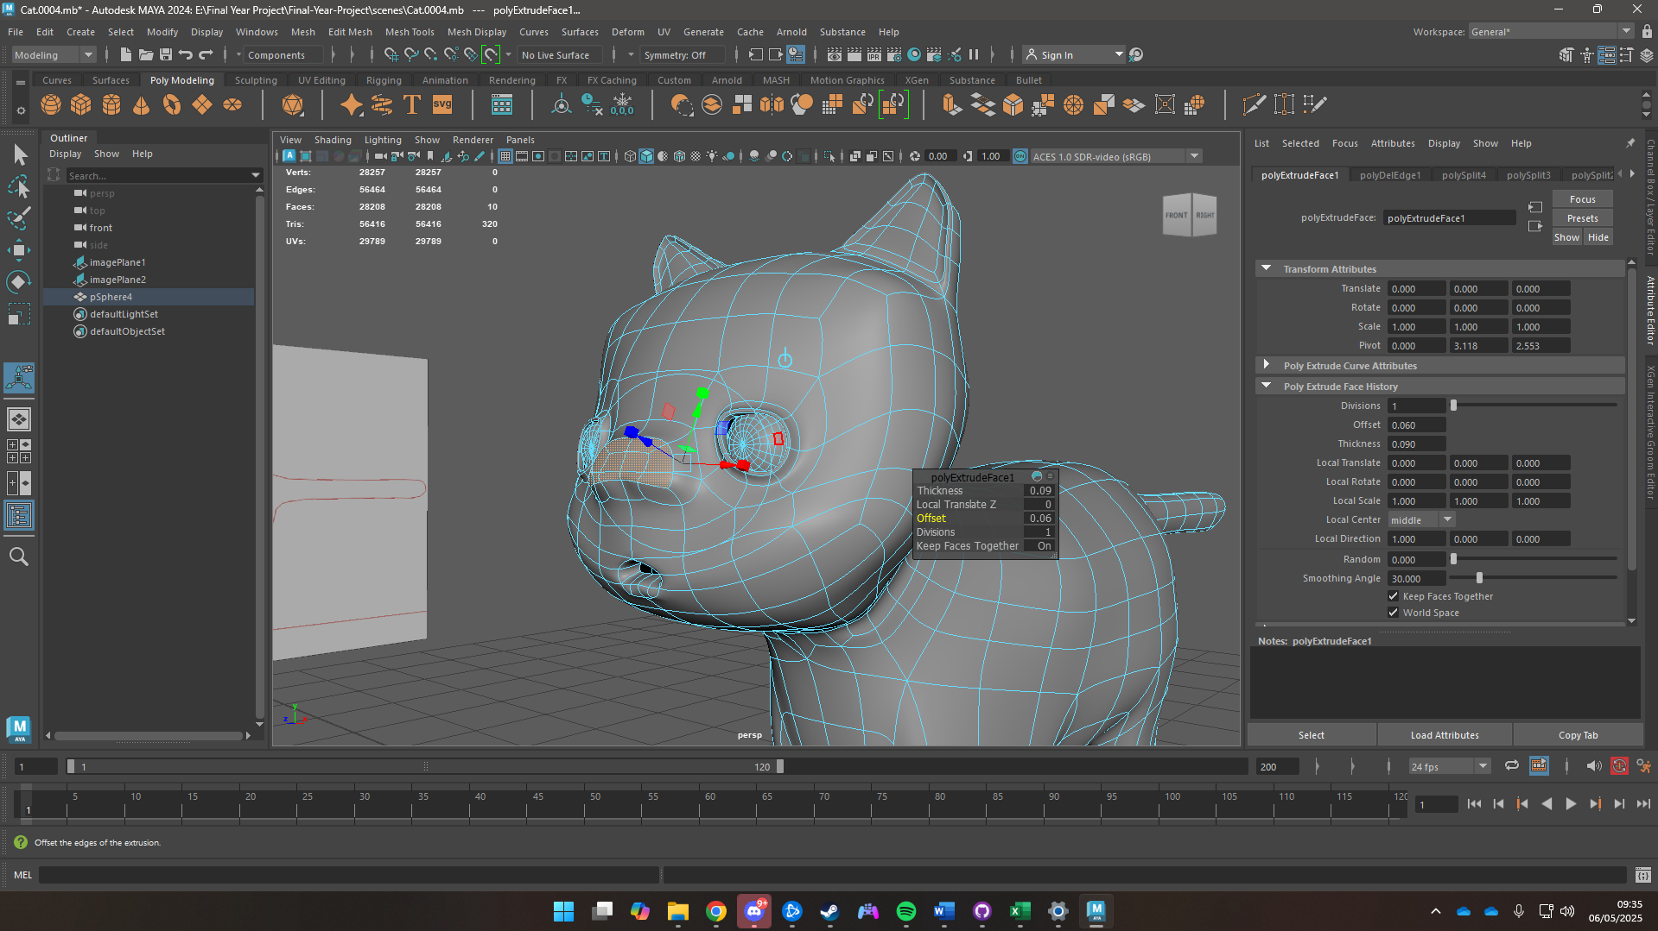

Figure 31 Modelling the nose

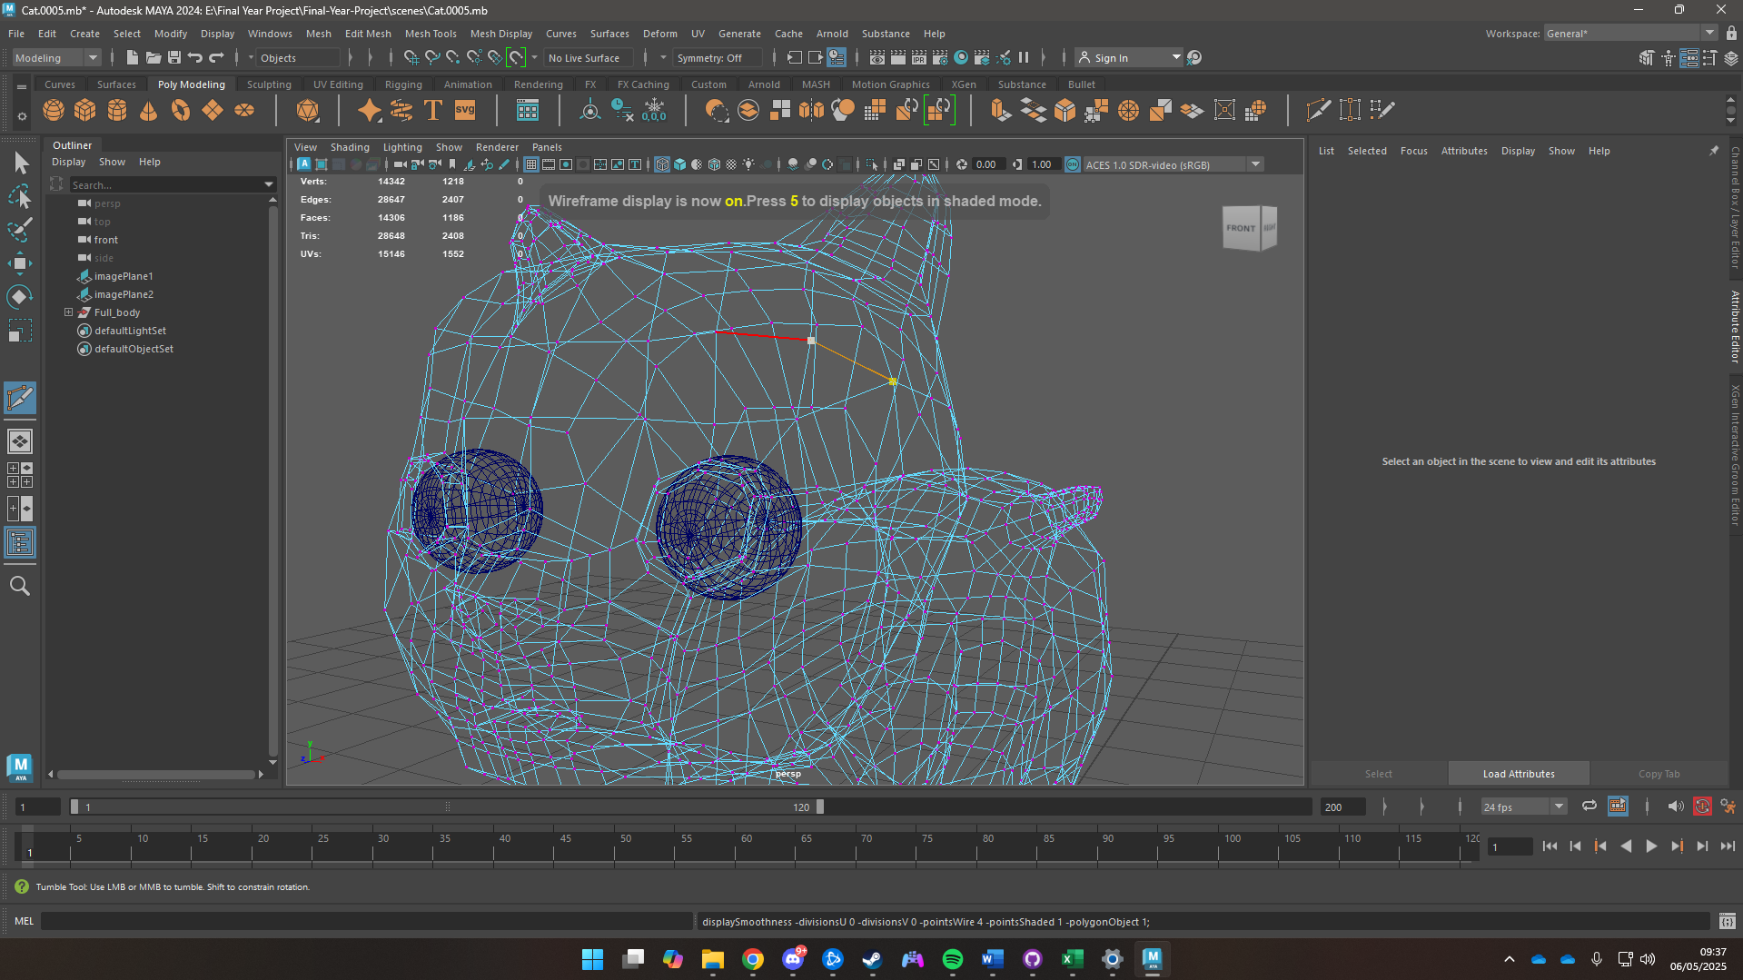

Figure 32 Adding loops for proper topology

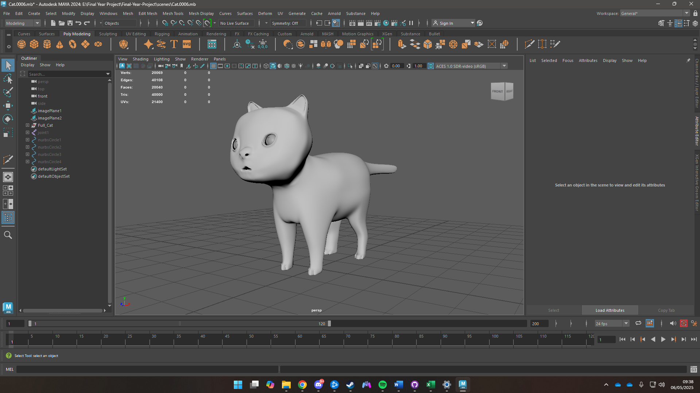

Figure 33 Completed Character

### UV Unwrapping Character

To UV map the character, cut tool was used to separate the body into sections and sew tool was also used to sew edges that were causing problems while unwrapping. The body was then exported as a .fbx file for Substance Painter

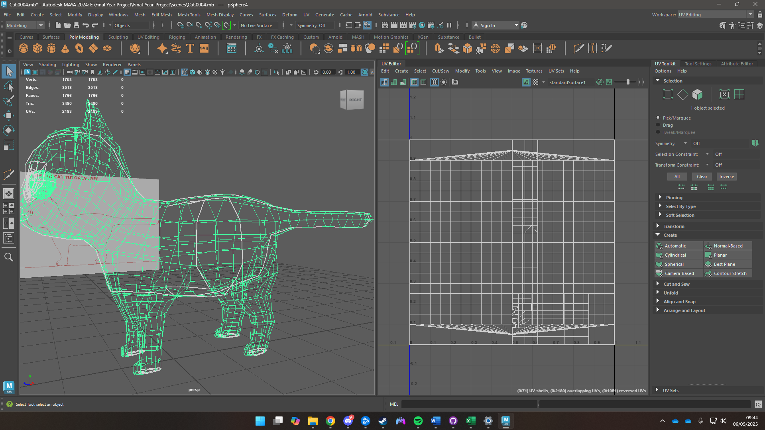

Figure 34 Uncut UV

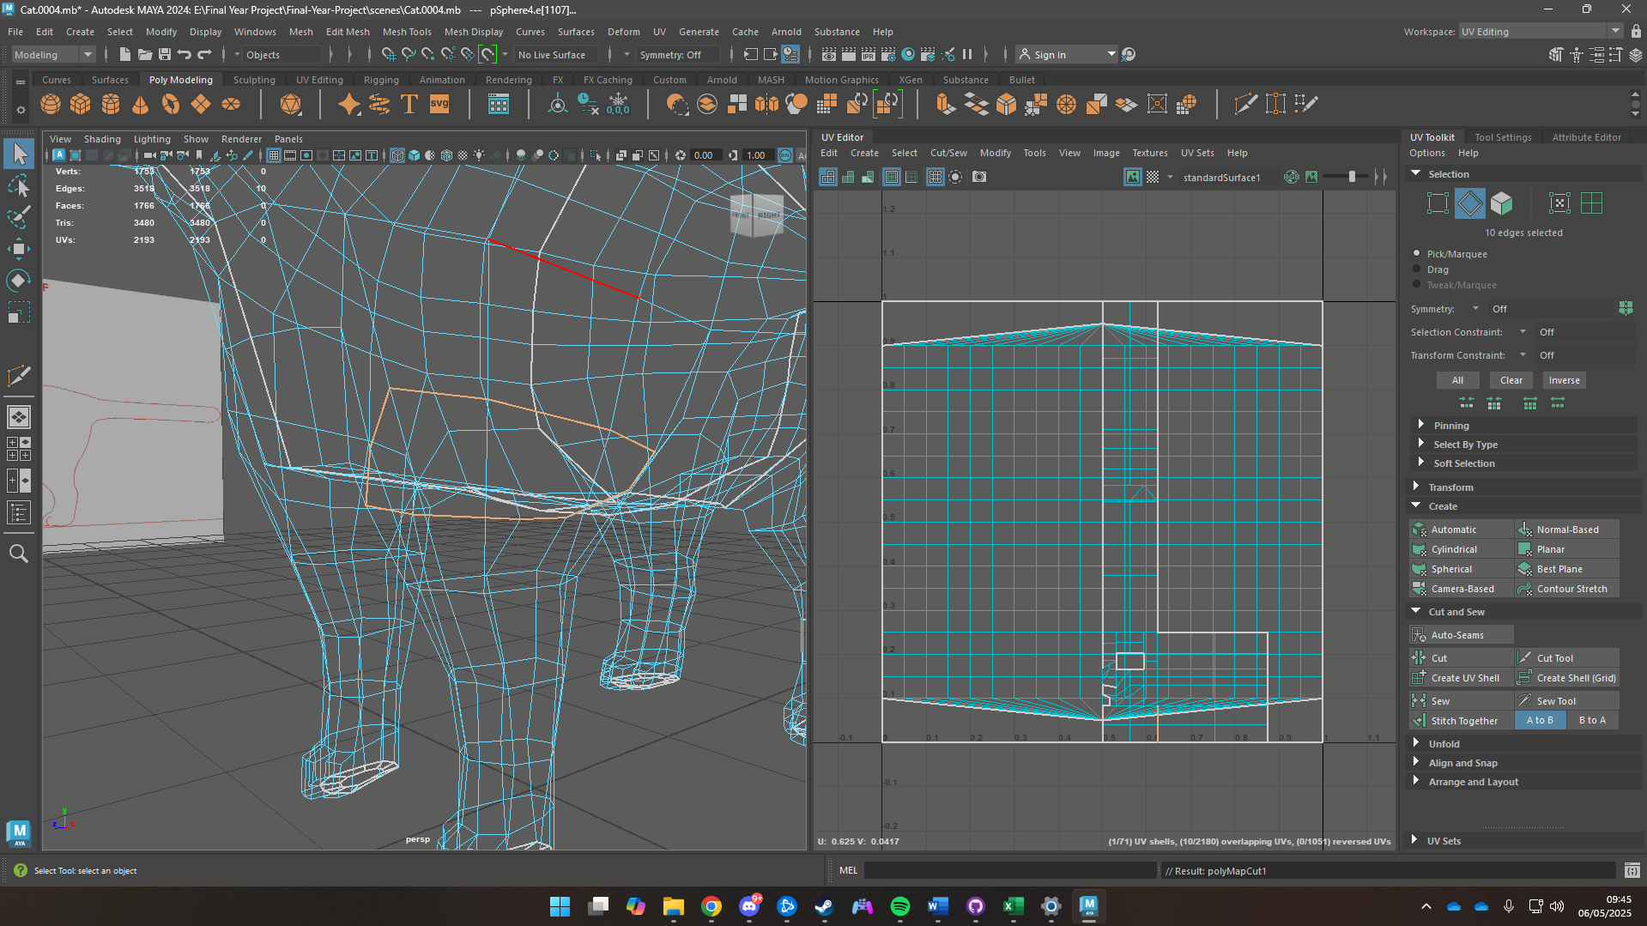

Figure 35 Use of Cut Tool

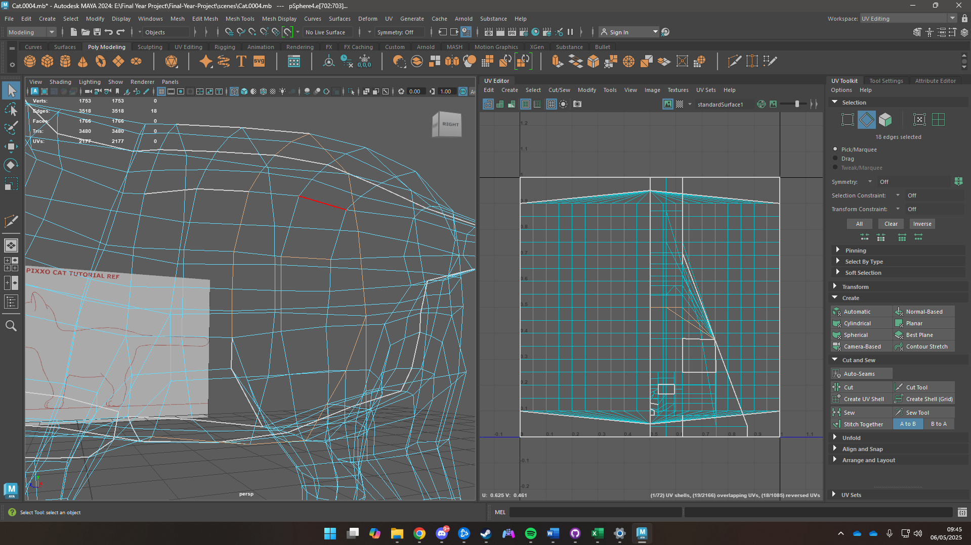

Figure 36 Use of Sew tool

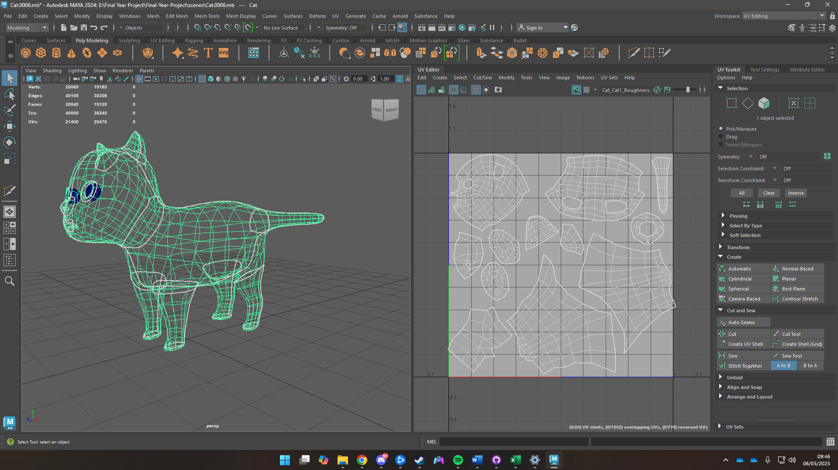

Figure 37 UV Unwrapped Character

### Texturing

The .fbx file was imported into Substance Painter where the mesh was first baked then the textures were hand painted in different layers. First the character was painted all black then a 2nd layer was created where white spots were added to the model.

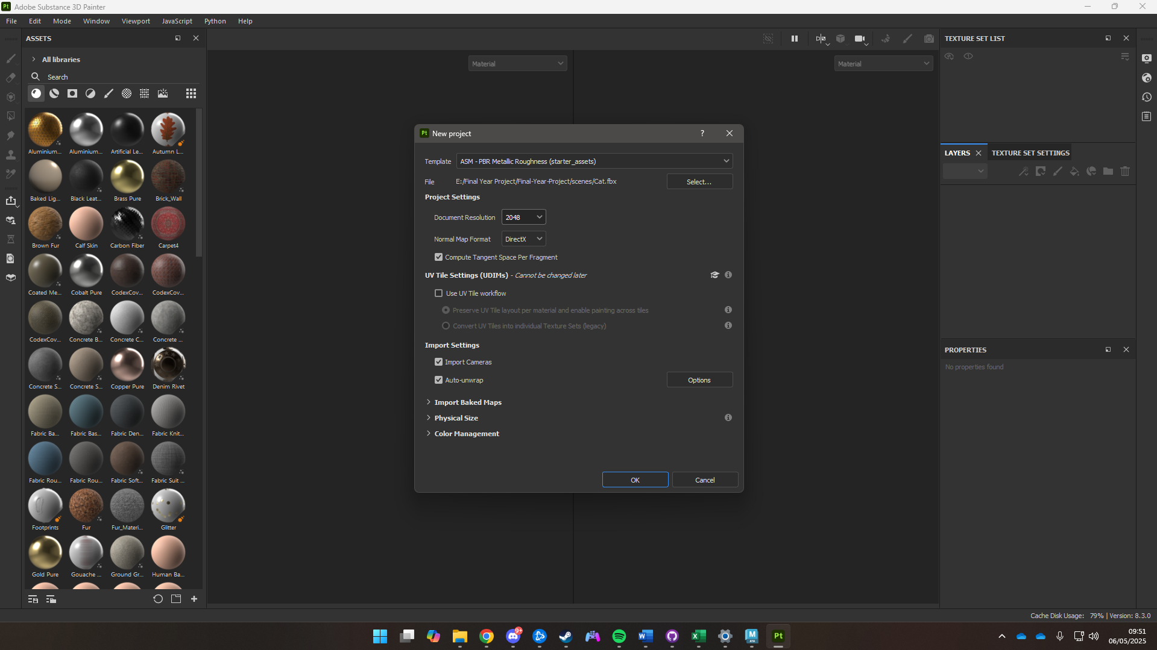

Figure 38 Importing the fbx file into substance painter

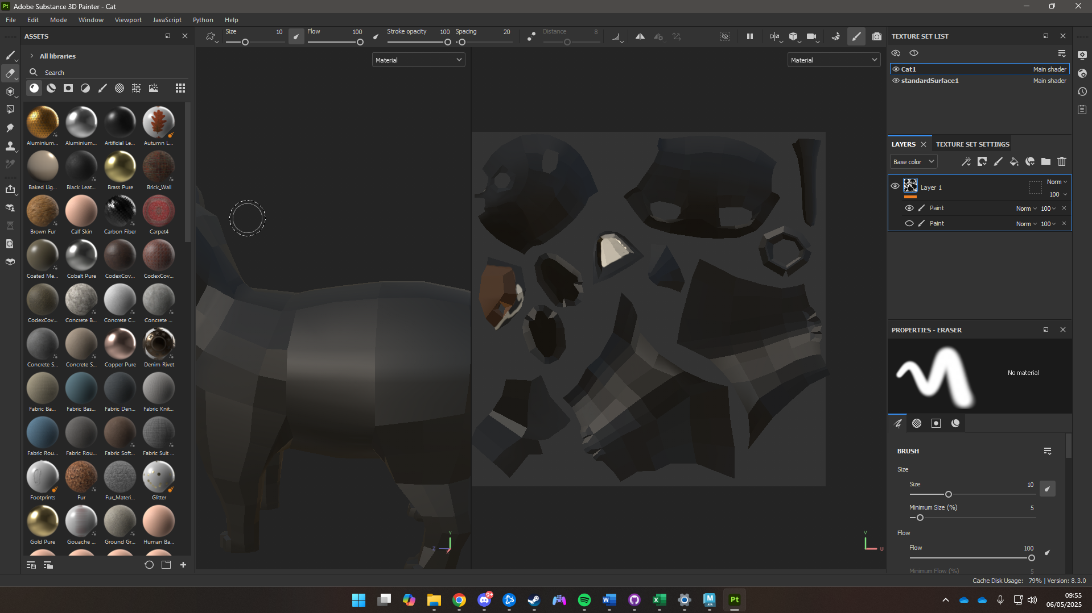

Figure 39 Painting the character black

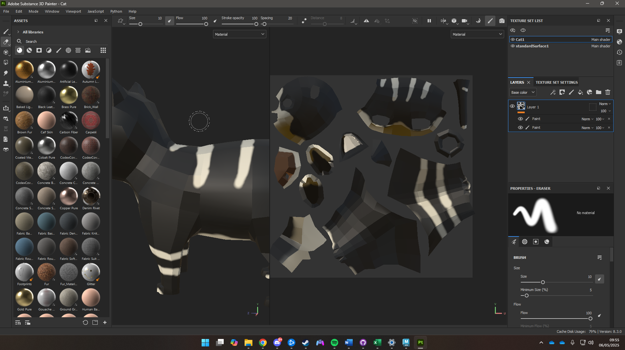

Figure 40 Adding details

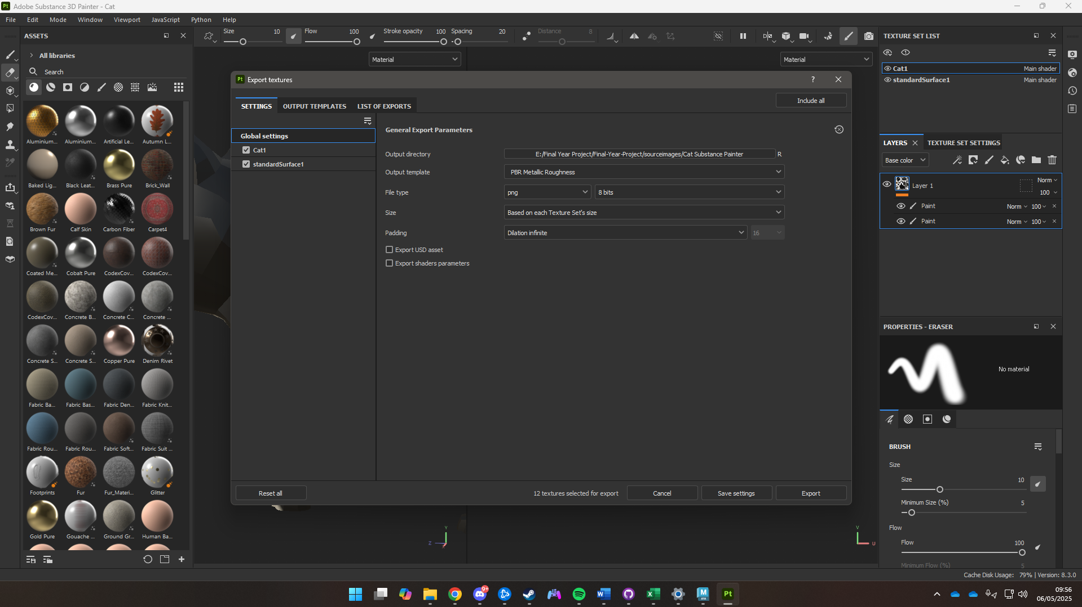

Figure 41 Exporting Textures

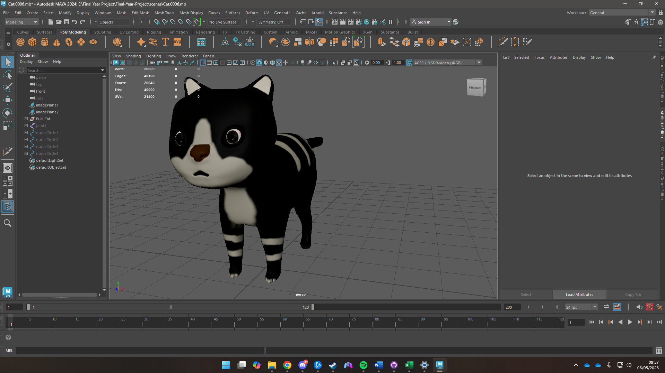

Figure 42 Textured Cat in Maya

### Fur

To create the fu XGen was used. Interactive splines were first created then its density was increased. It was then groomed for a smooth look, along with the addition of clumps and noise to make it look more natural. It was then given a black texture to match with the color of the skin on the character.

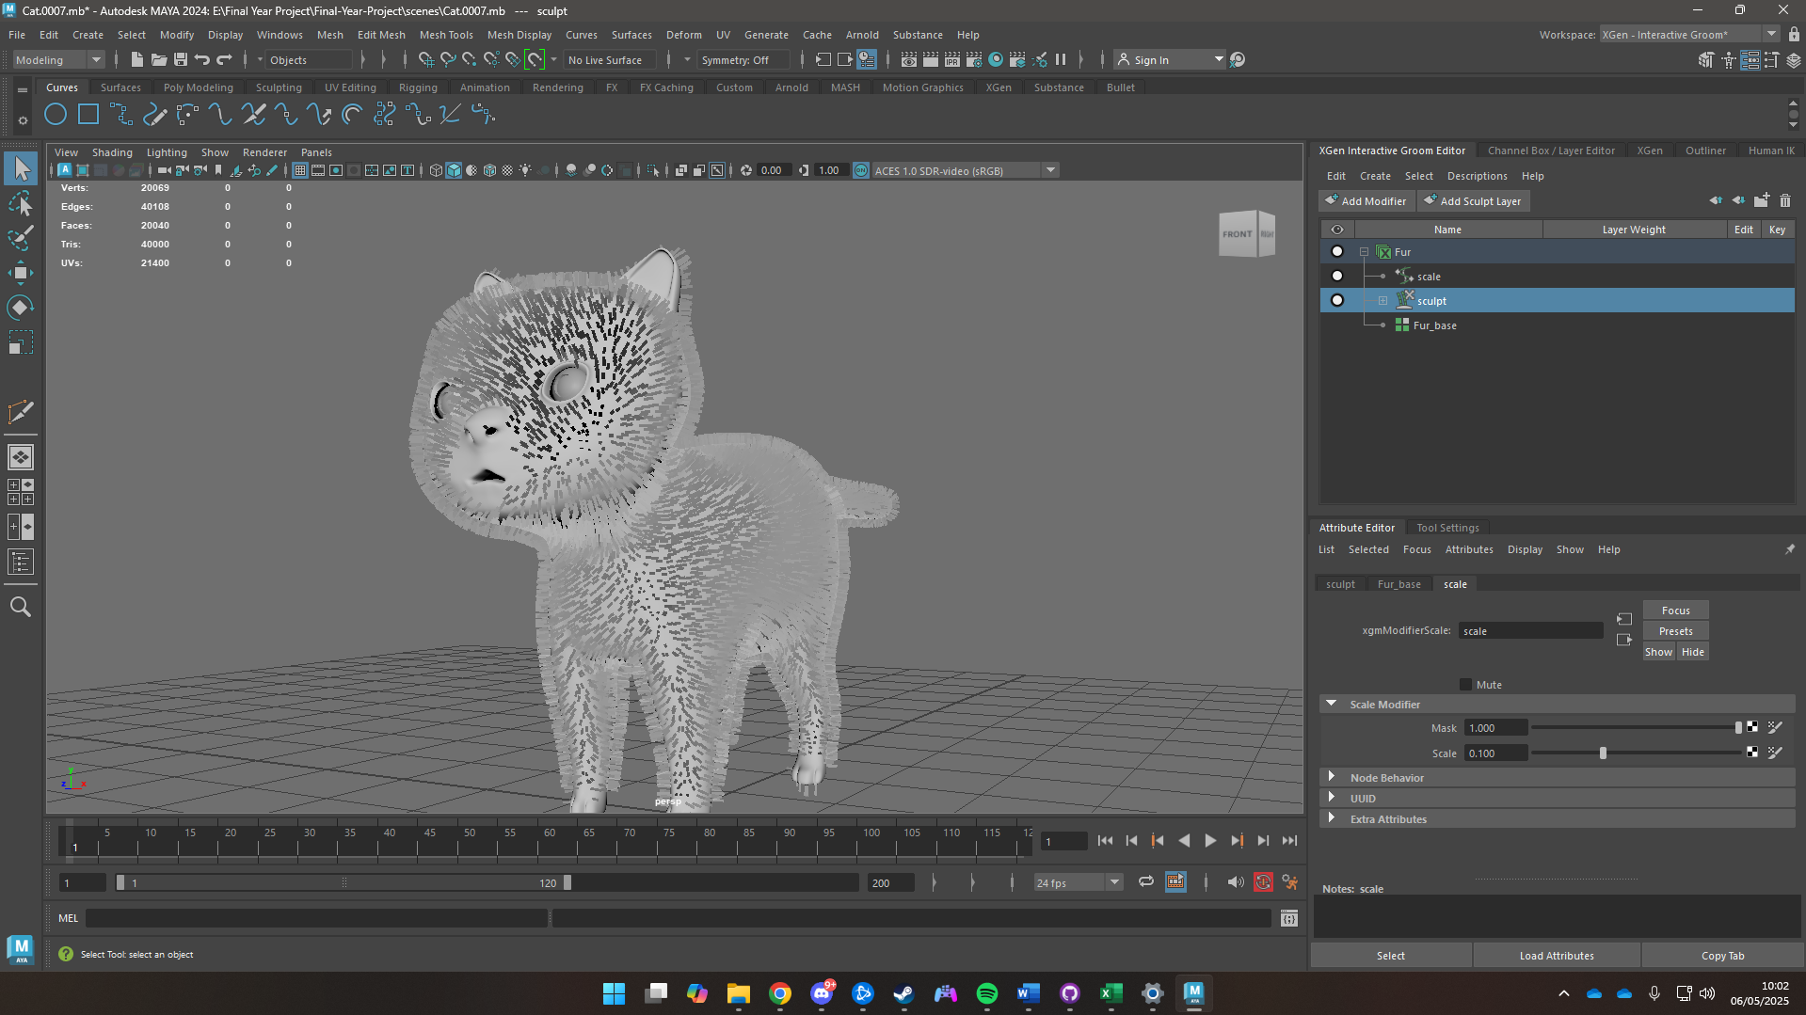

Figure 43 Creating interactive splines

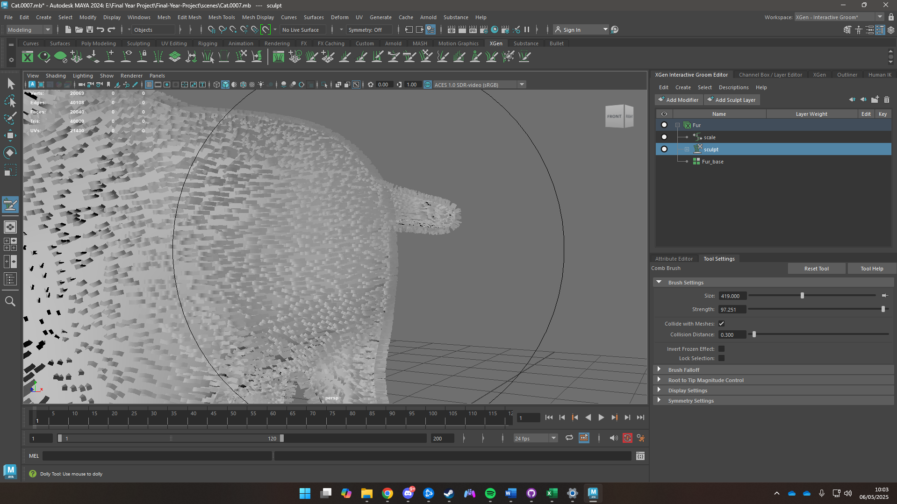

Figure 44 Grooming the splines

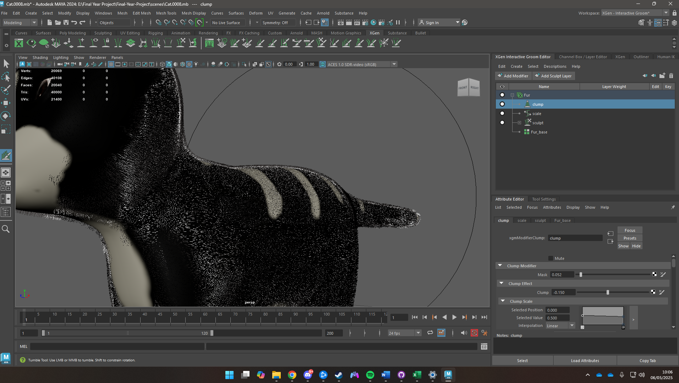

Figure 45 Adding Clumps

### Rigging

The process of rigging, first bones were set all the way from the butt of the character to the neck. Then, a chain of bones for a singular leg was created and move to its spot on the mesh parented to the main bone and mirrored for the other leg. IK handles were then created for the foot, the same process was then repeated for the fore legs. A singular bone chai was then created for the tail and parented to the main bone.

For the head a 3-bone chain was created from the neck to the top of the skull. Bones were then created for the eyes, ears and chin then parented to the main head bone.

Curves were then created and then linked to the bones to function as controllers during animation.

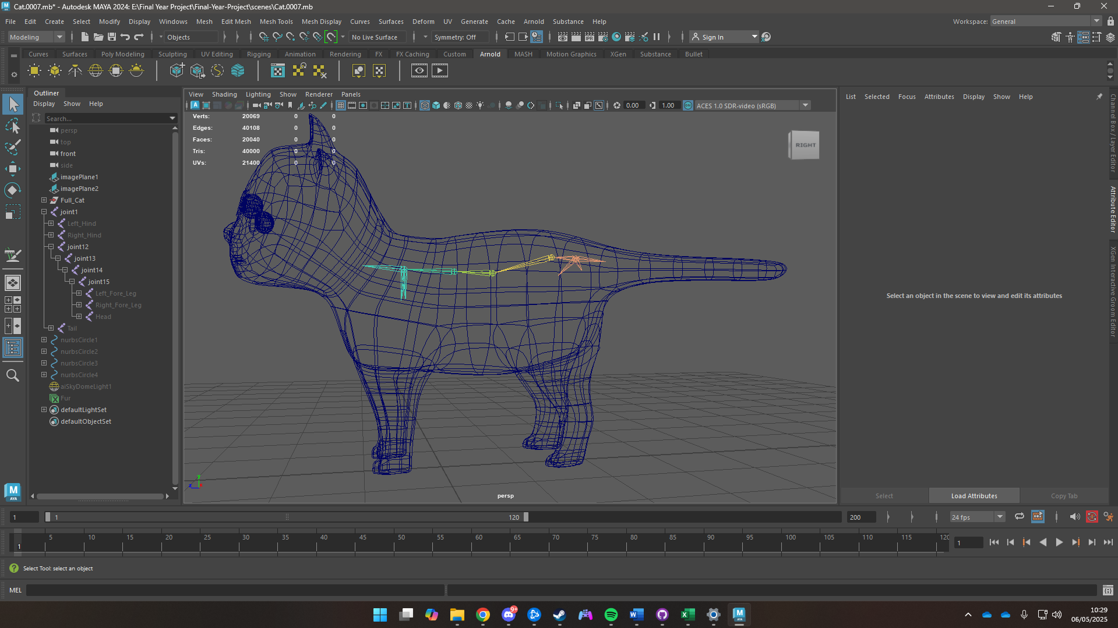

Figure 46 Creating Bones

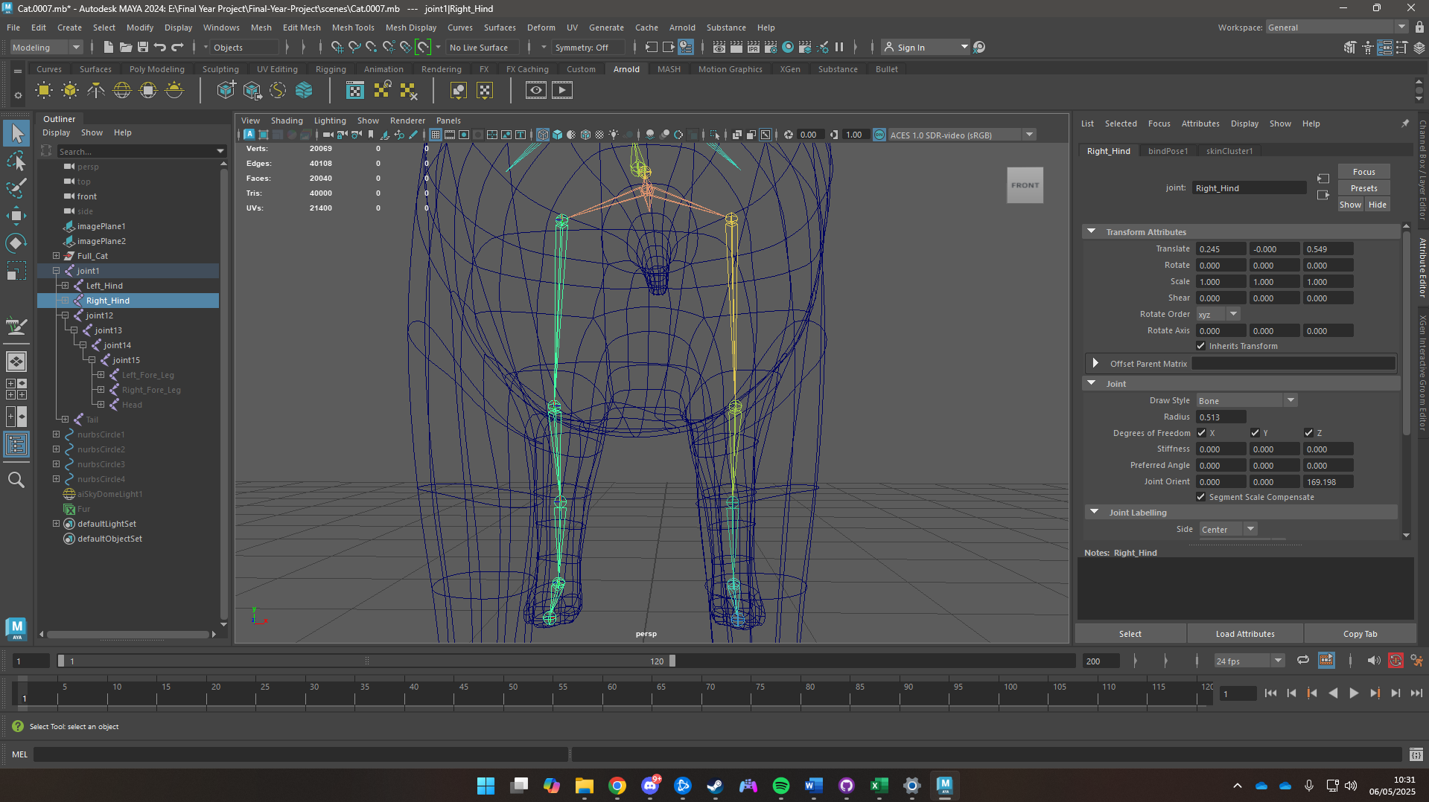

Figure 47 Creating Leg Bones

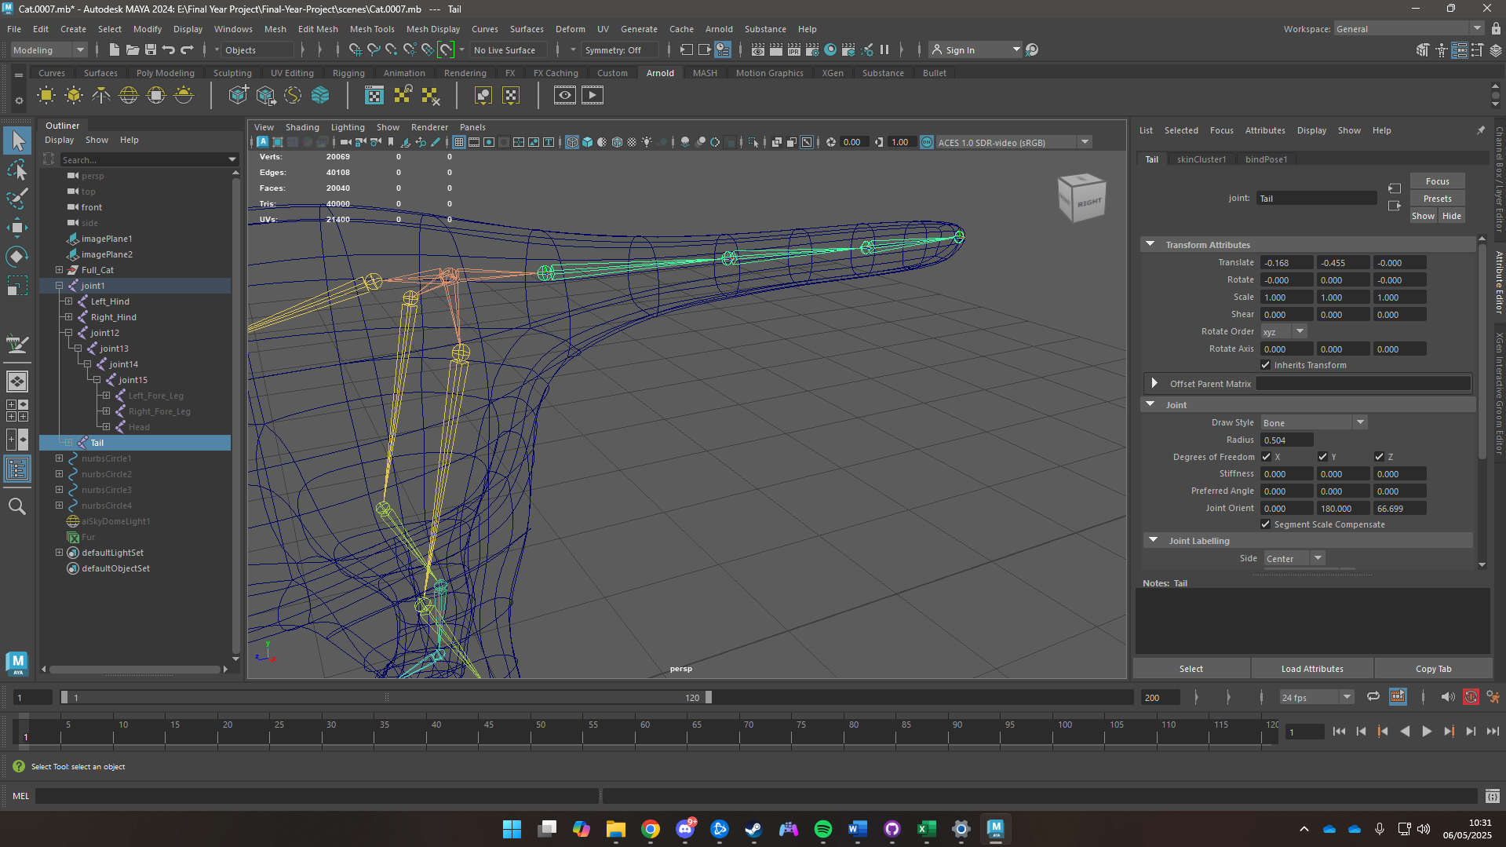

Figure 48 Creating Tail Bone

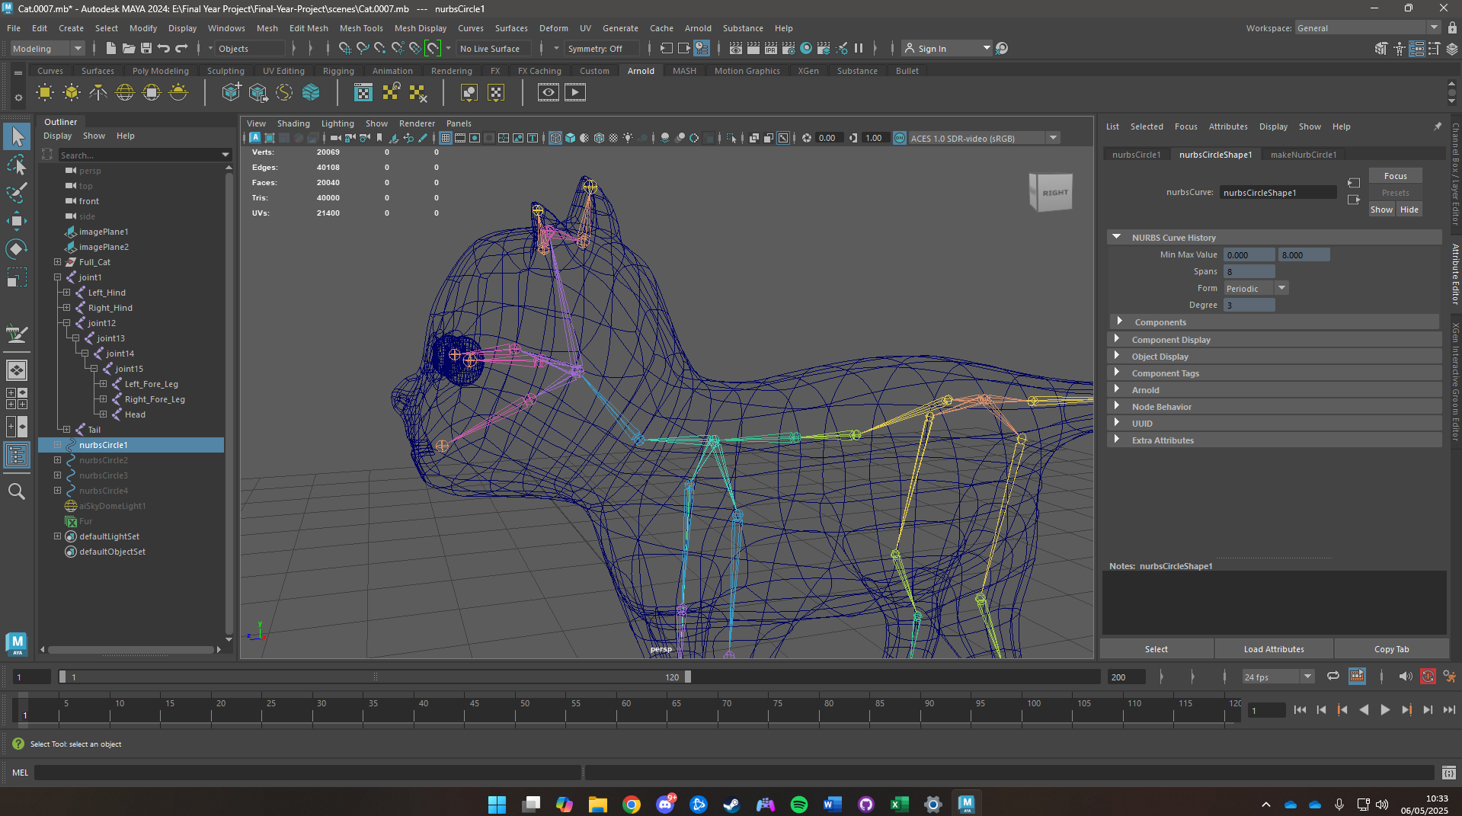

Figure 49 Creating Head Bones

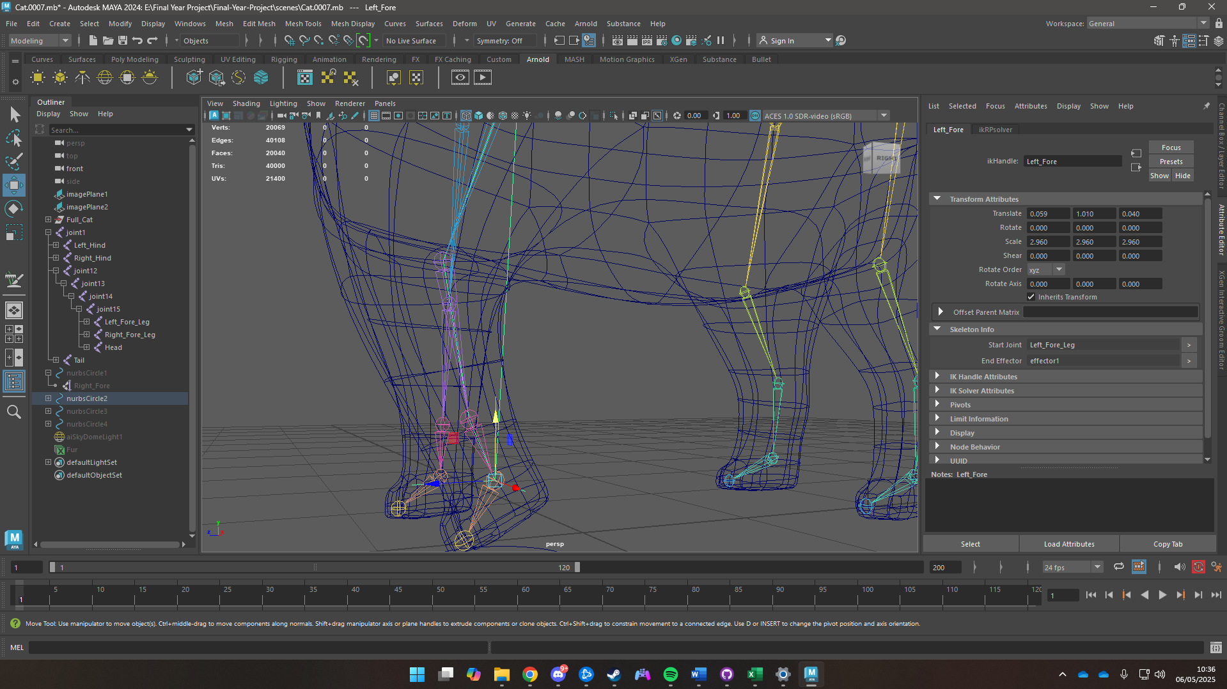

Figure 50 Creating IK Handles

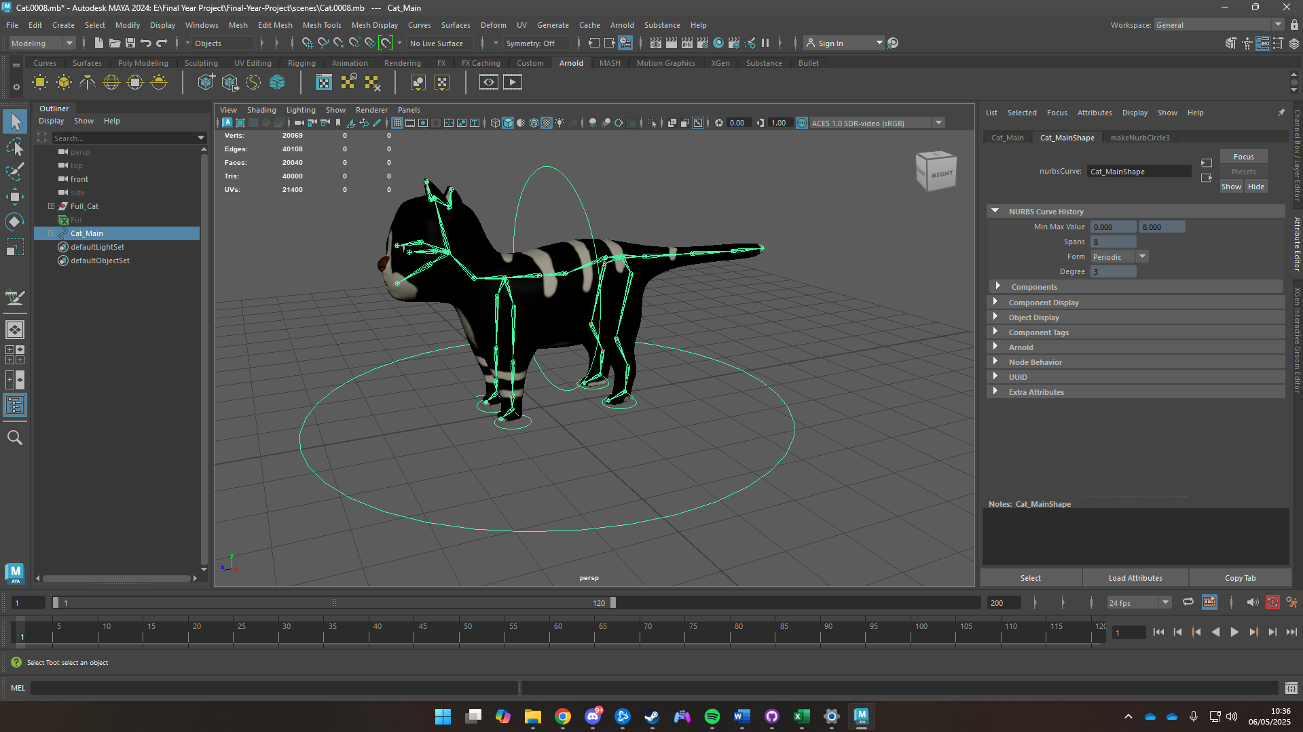

Figure 51 Adding Controllers

## Environment Modelling

### Modular Kit

A modular kit was created using planes. Extrude tool was used to create indents with offsets to create windows and doors. Brick and concrete textures were given to the planes.The planes were then snapped together to create different structures.

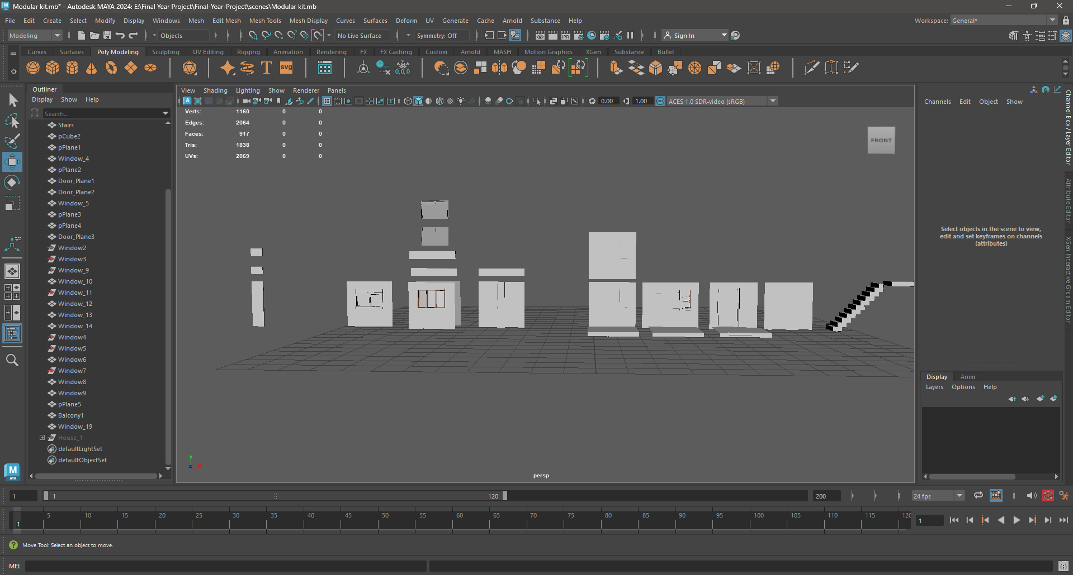

Figure 52 Modular Kit

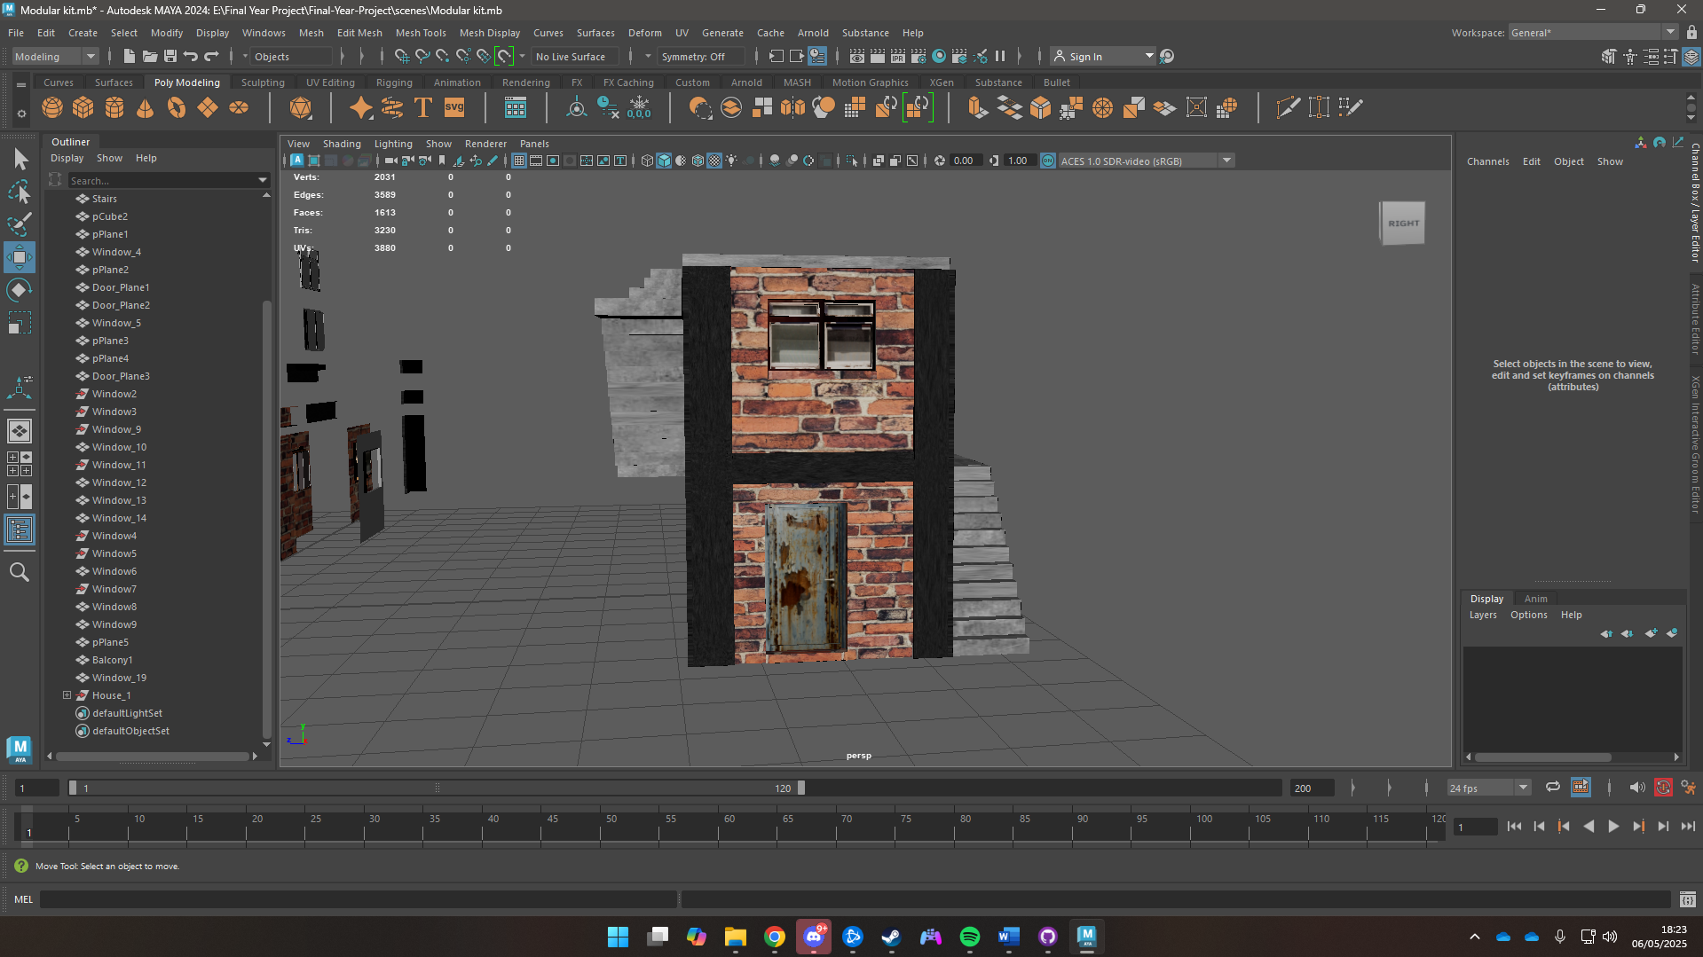

Figure 53 House made from modular kit

### Air Conditioner

To create the air conditioner first the 2D image was imported into blender then it was 3D projected to create a rough mesh. Then it was adjusted, and the air conditioner was created.

First a plane is created

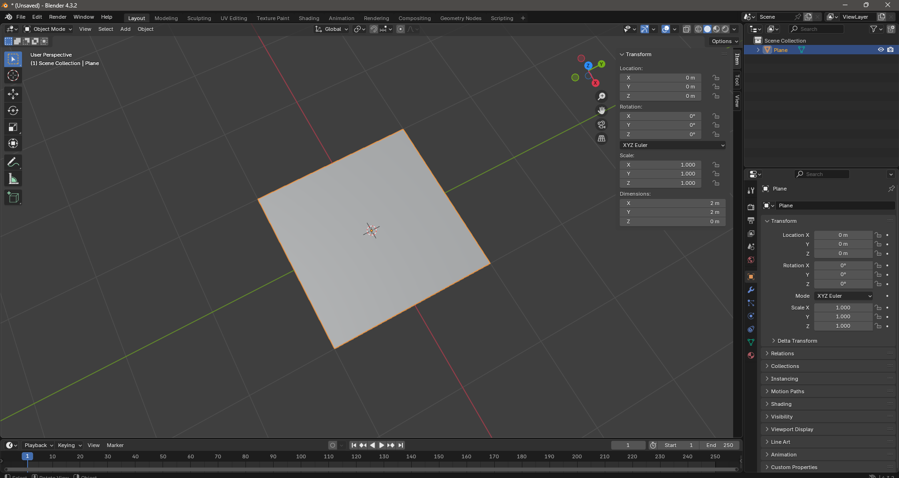

Figure 54 A Plane is created

Then the dimensions of the image to be projected is taken

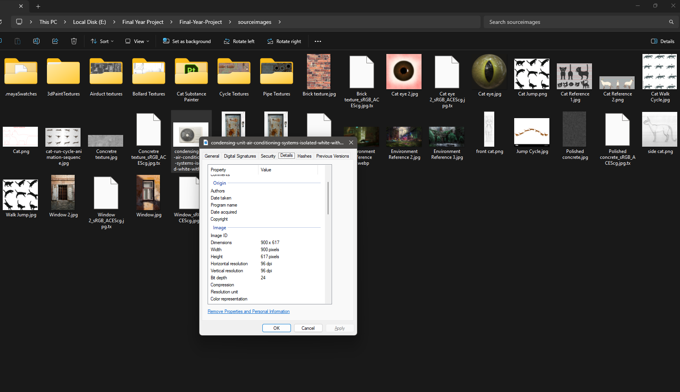

Figure 55 Dimensions of image to be projected

The dimensions of the image are then implemented on the plane

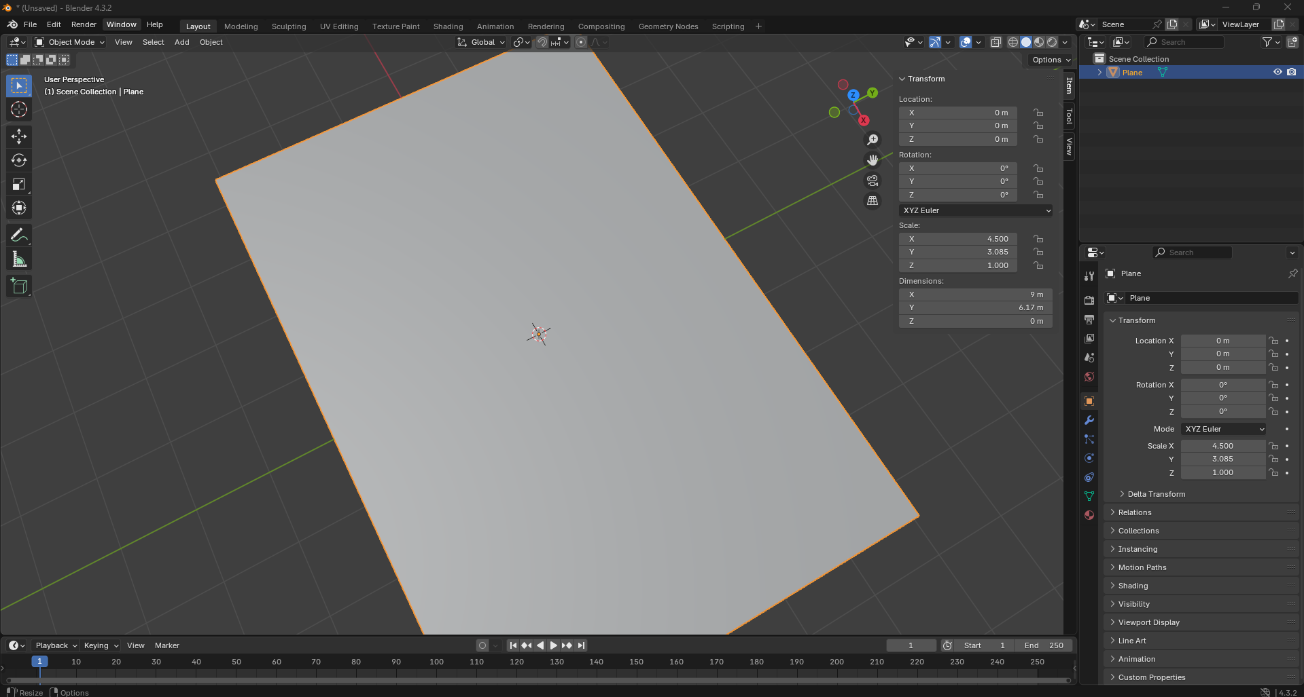

Figure 56 Implementing dimensions

Subdivisons are then added to the plane

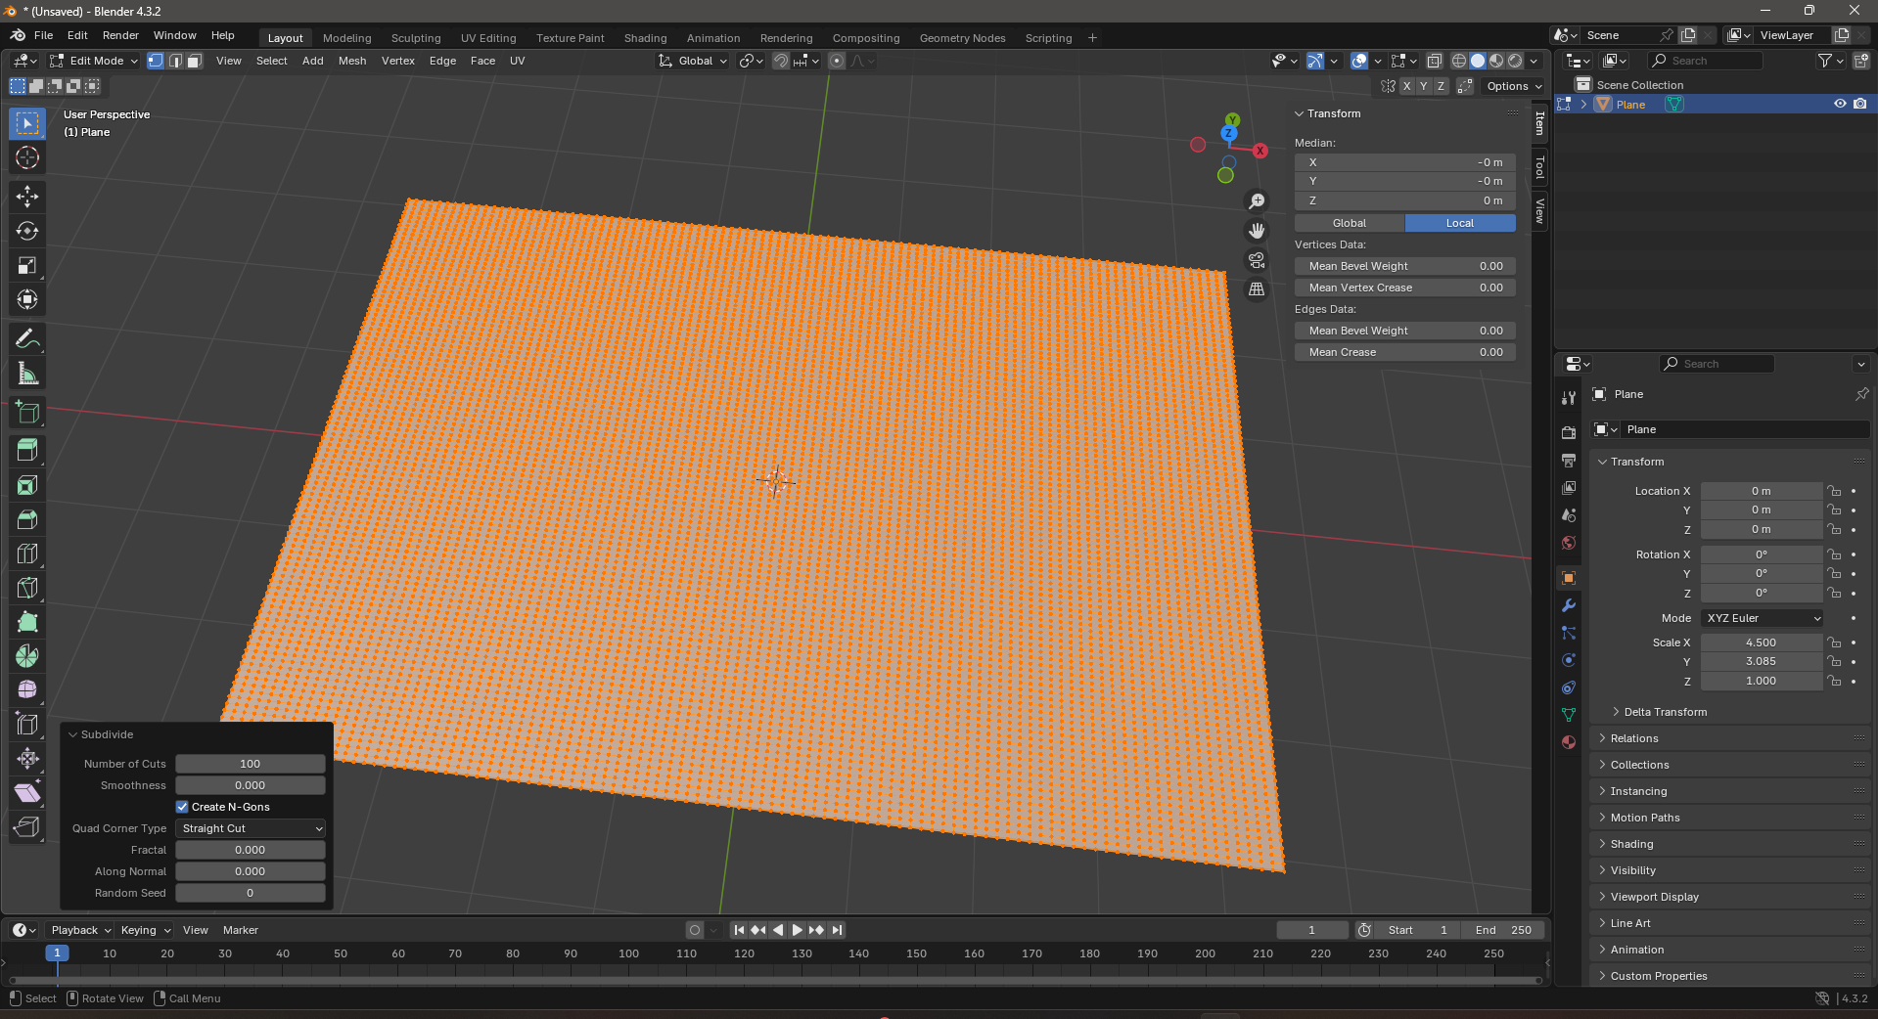

Figure 57 Subdivisions added

Then a displace modifier is added

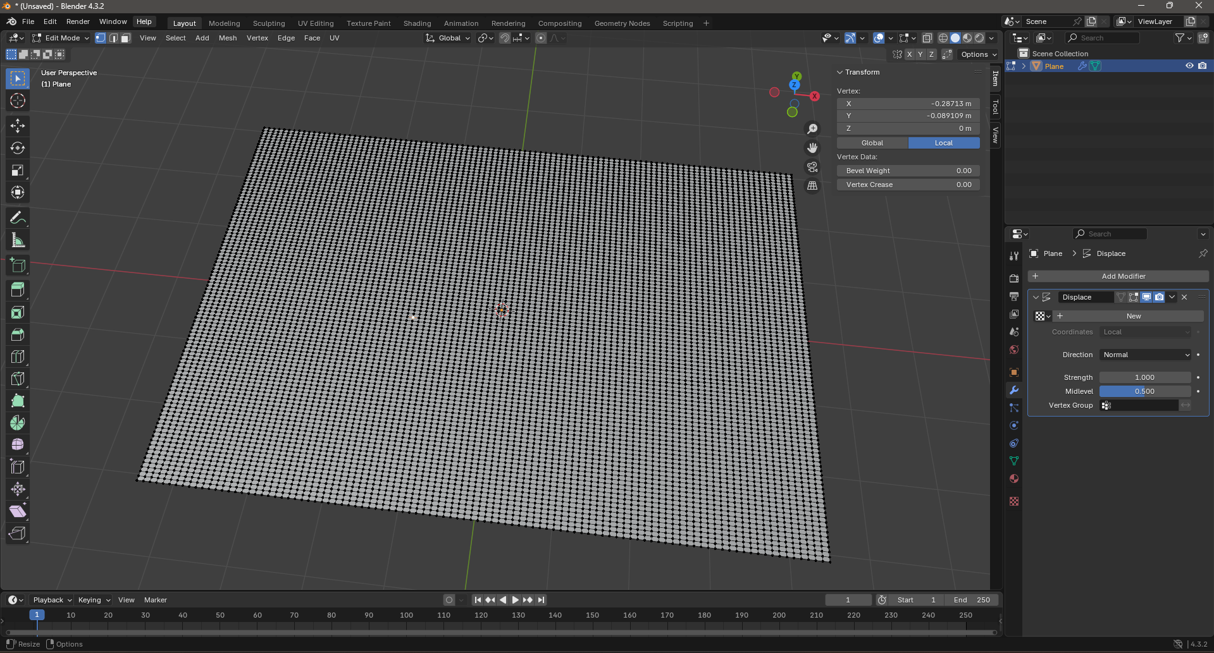

Figure 58 Adding Displace modifier

Projected model after image was added to the displacement modifier

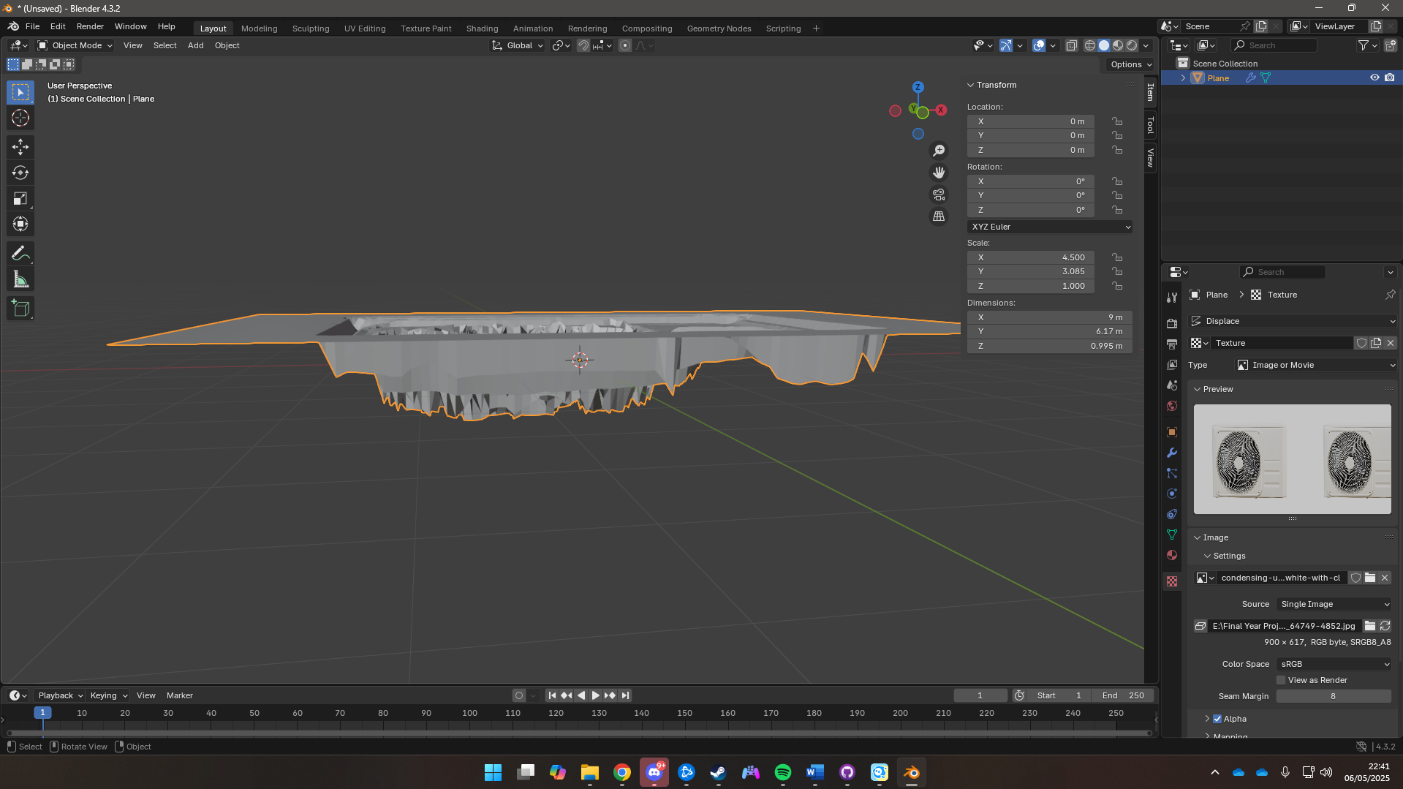

Figure 59 Projected Model

The Rough Projected model was then cleaned up to create an air conditioner

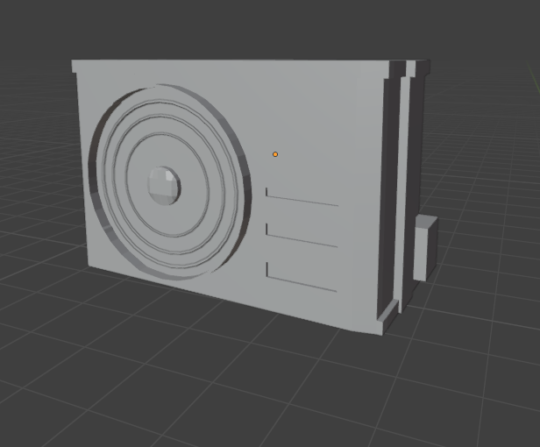

Figure 60 Completed Air Conditioner

### Electric Box

The electric box was created in blender. First a cube was brought in and scaled to match a rectangular cabinet shape. Edge Loops were then added to create door panels.

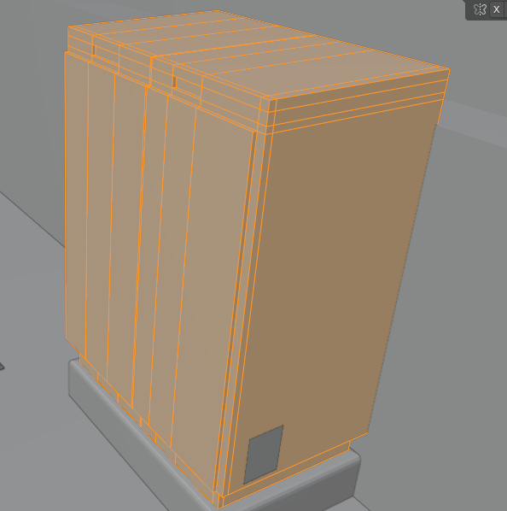

Figure 61 Electric Box Topology

A smaller rectangular box was added below the electric box to act as the base for the box.

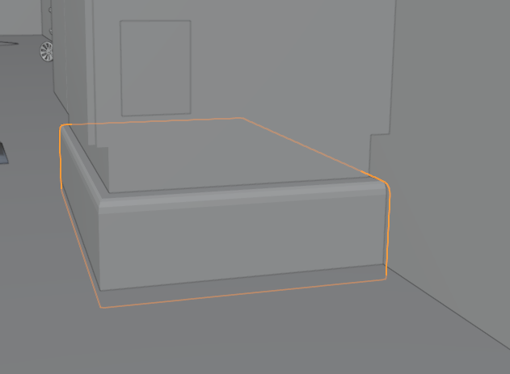

Figure 62 Electric Box Stand

The .fbx of the Electric box was then exported and imported into substance painter where textures were given.

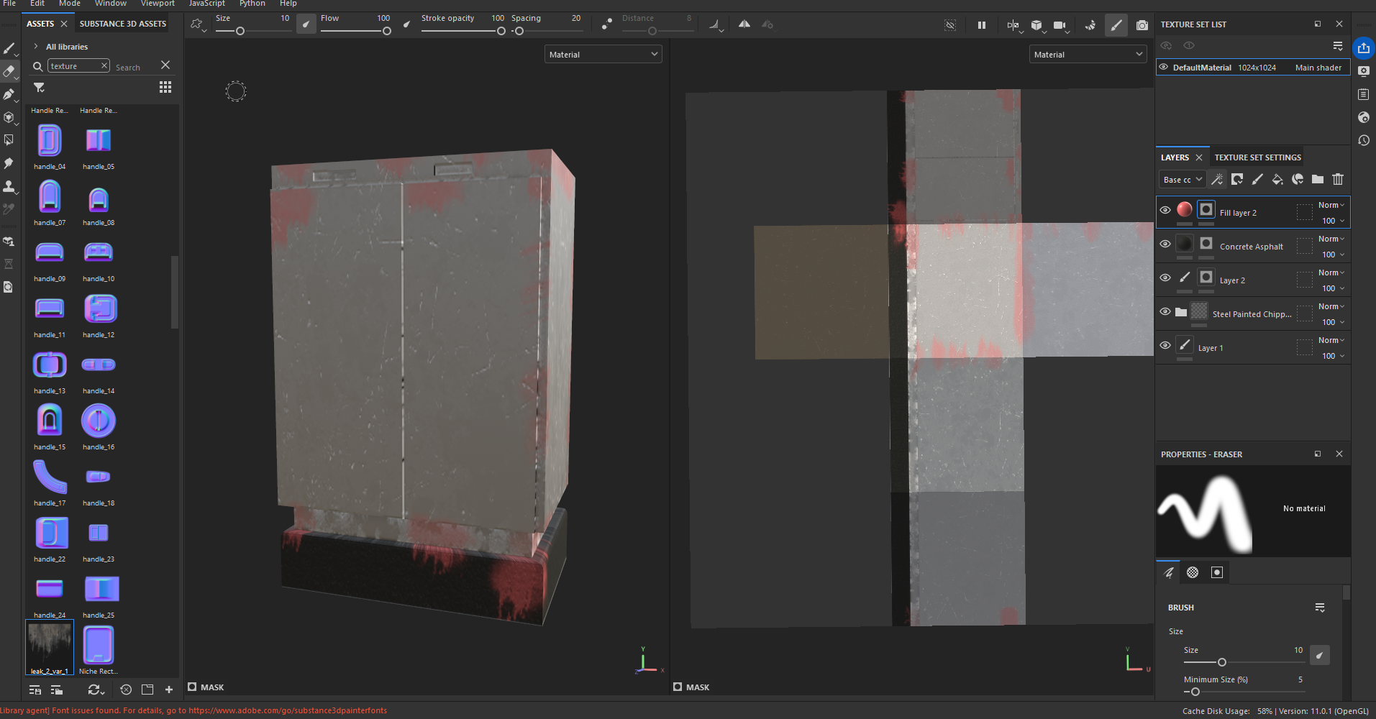

Figure 63 Texturing Electric Box

Minor details were also added

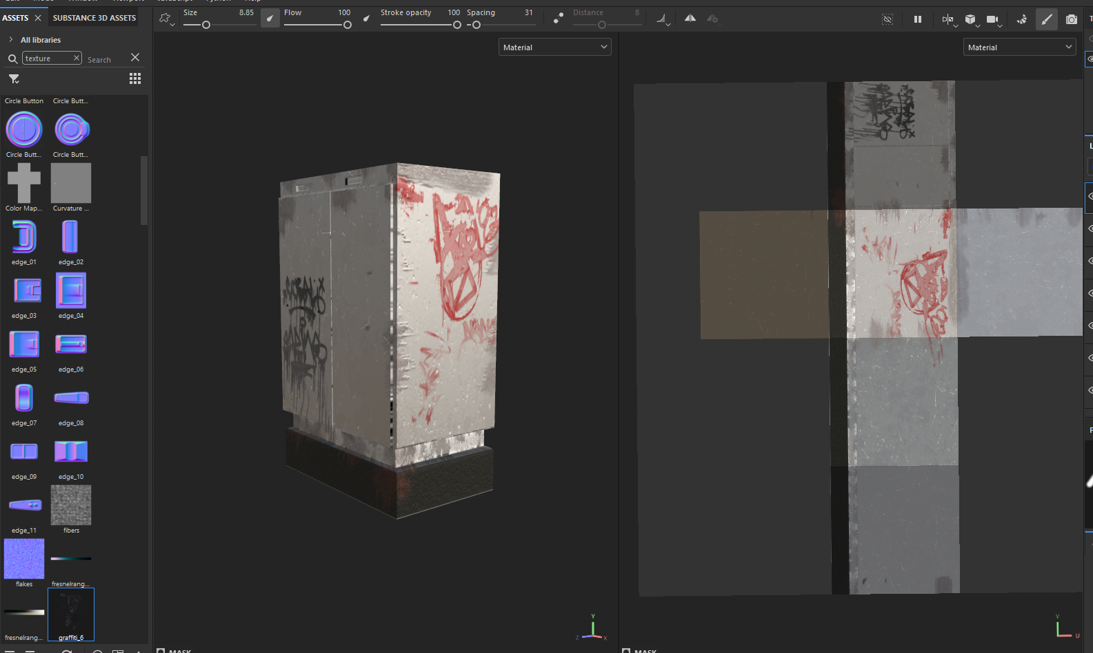

Figure 64 Adding Minor Details to the Electric box

### Trash Dumpster

To create a trash dumpster first a good reference image is needed.

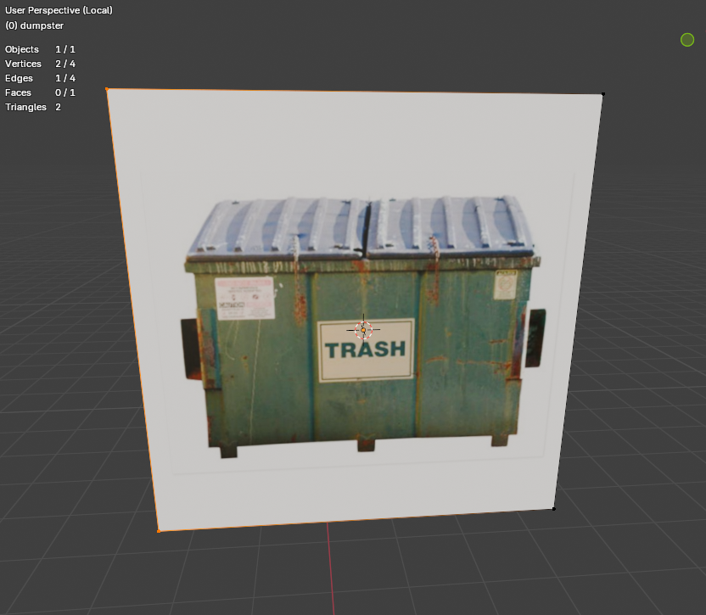

Figure 65 Dumpster reference image

Then a cube is taken and scaled to the proportions of the dumpster in the image and is then projected via camera mapping.

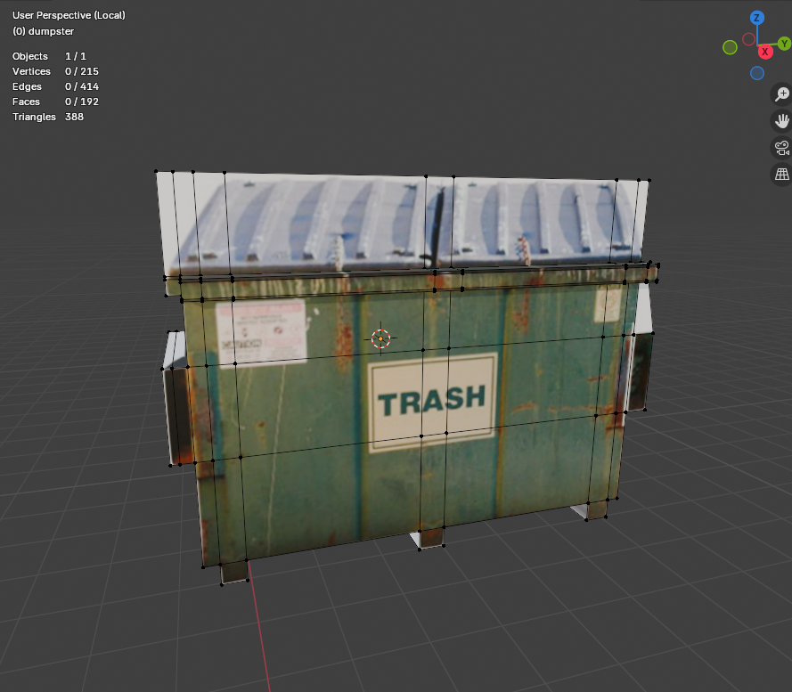

Figure 66 Projected Trash Dumpster

The mesh is then cleaned up to get a proper looking trash dumpster.

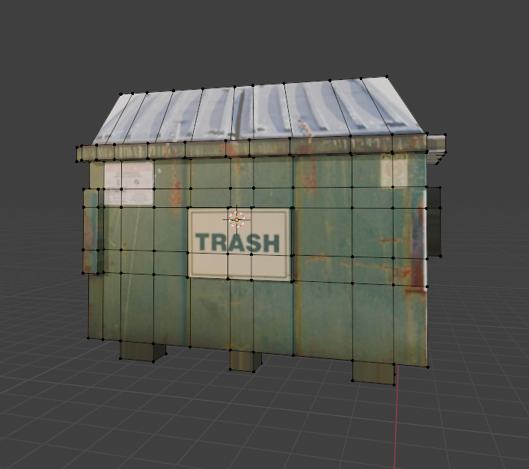

Figure 67 Cleaned up trash dumpster

For the textures the planes were given a base color and alpha while a royalty free graffiti was added

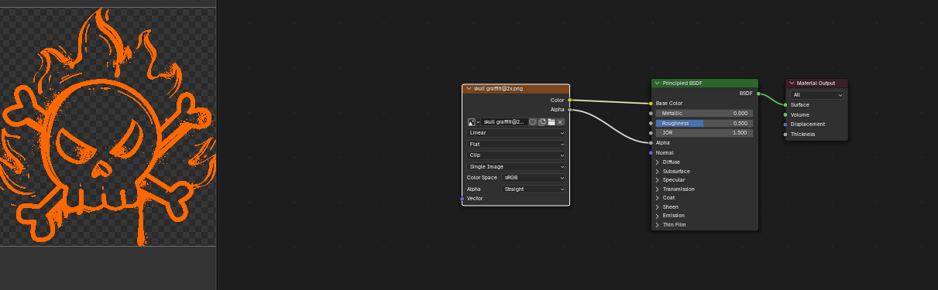

Figure 68 Texturing Trash Dumpster

A shrinkwrap modifier was used to project it as a decal

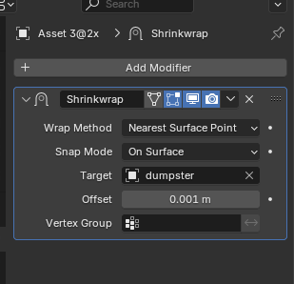

Figure 69 Use of shrink wrap modifier

This is the fully textured Trash Dumpster

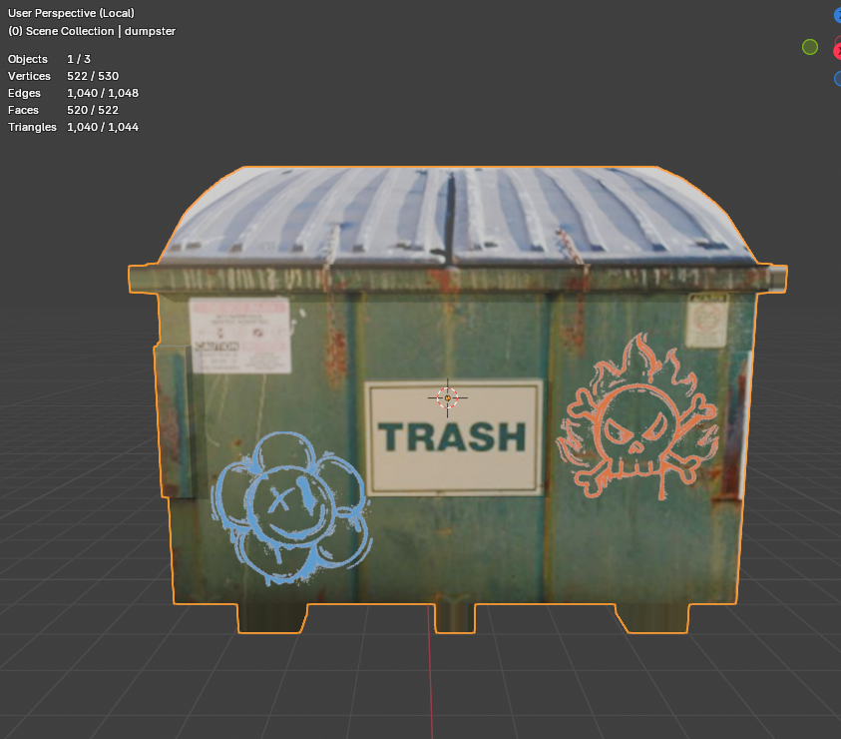

Figure 70 Fully Textured Trash Dumpster

### Window

To create a simple window, first faces were selected where the window is supposed to be.

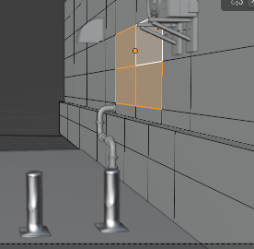

Figure 71 Selecting Faces for a window

The extrude tool was then used multiple times to reduce the thickness and offset the faces to create a realistic looking window

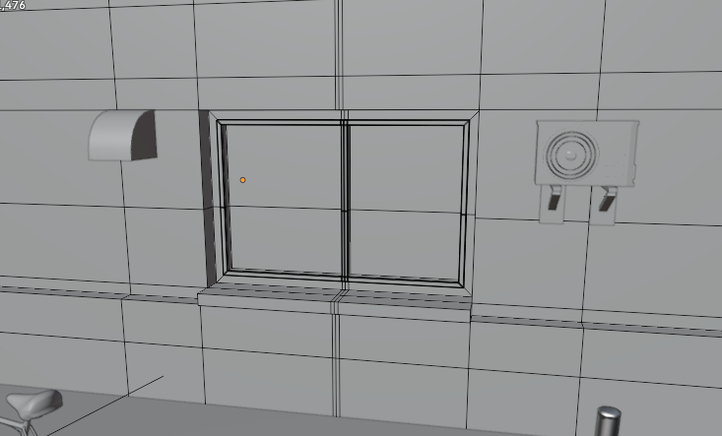

Figure 72 Window

### Wires

To create realistic looking wires. The EP Curve Tool was used to first create a NURBS Curve by jotting down points.

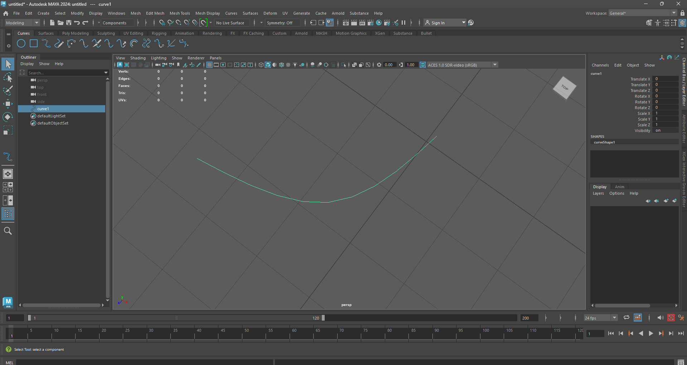

Figure 73 Creating a curve using EP Curve Tool

A Cylinder is then taken and its subdivisions reduced

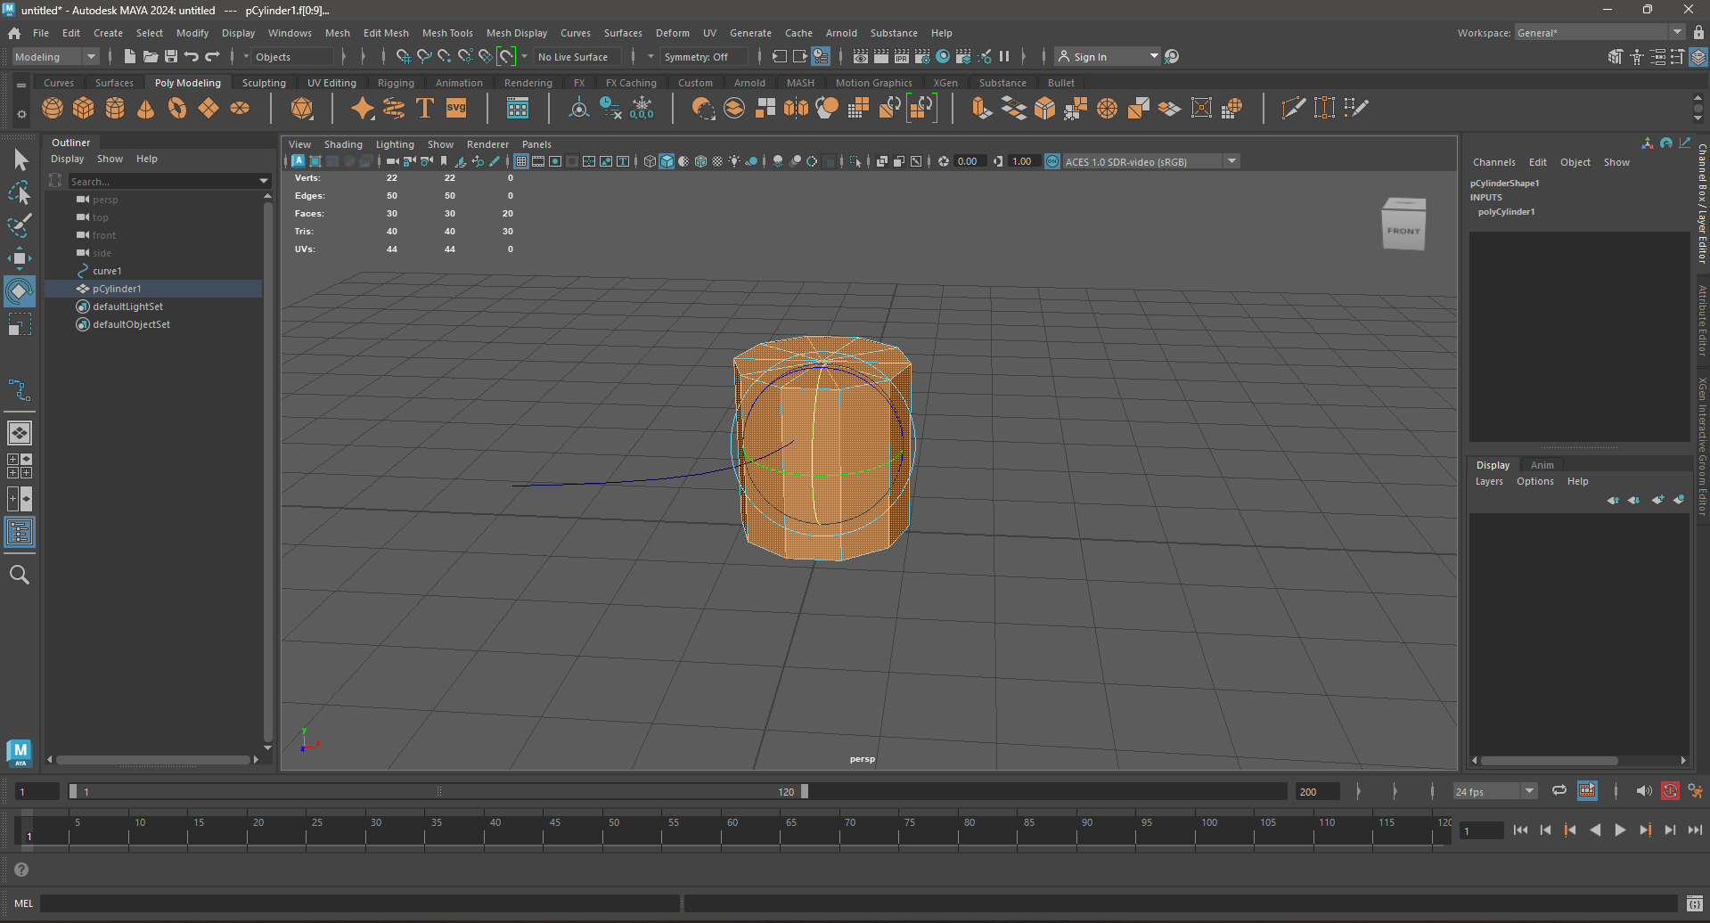

Figure 74 Taking a cylinder

All faces of the cylinder are deleted except one side to give a circular looking polygon then it is placed on the curve

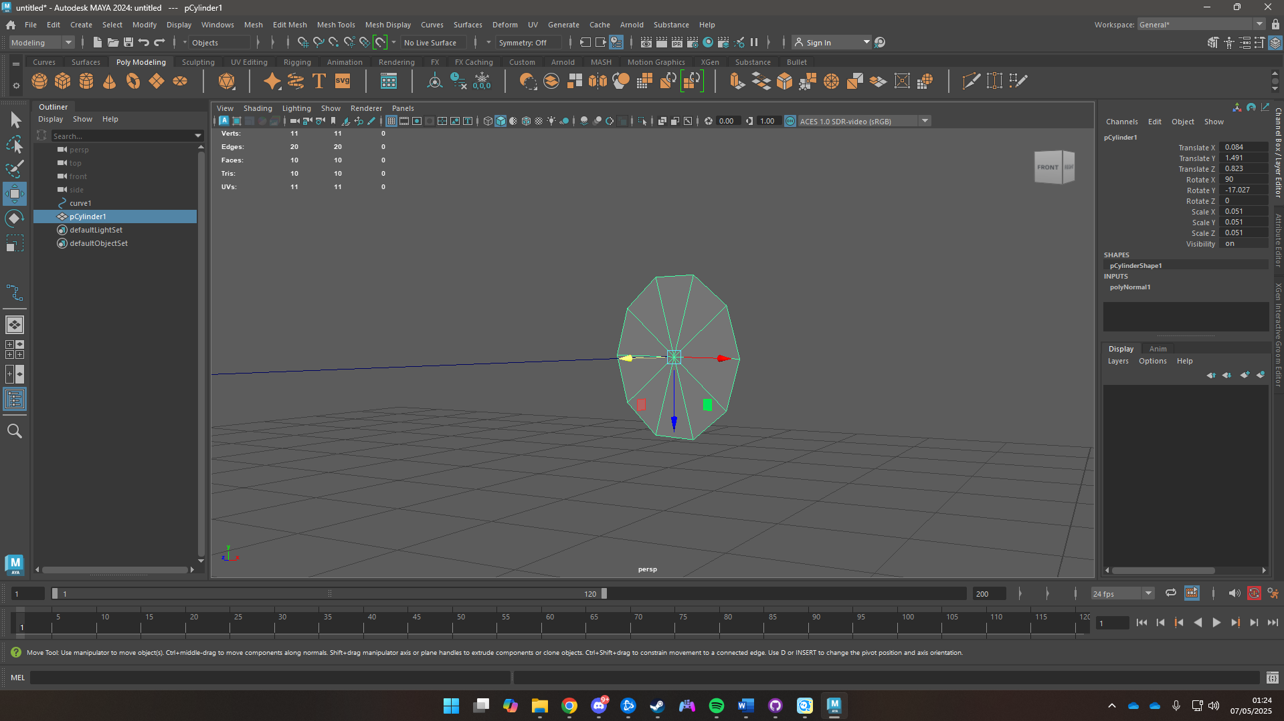

Figure 75 Circular polygon on curve

The Polygon is then extruded along the curve.

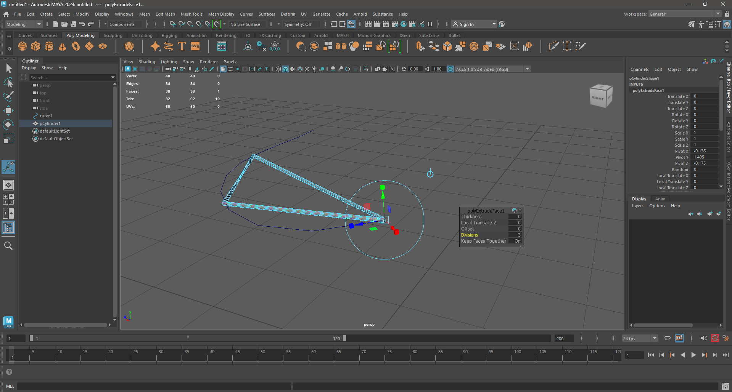

Figure 76 Extruded Polygon Along Curve

Divisions are then added to curve the polygon along the curve

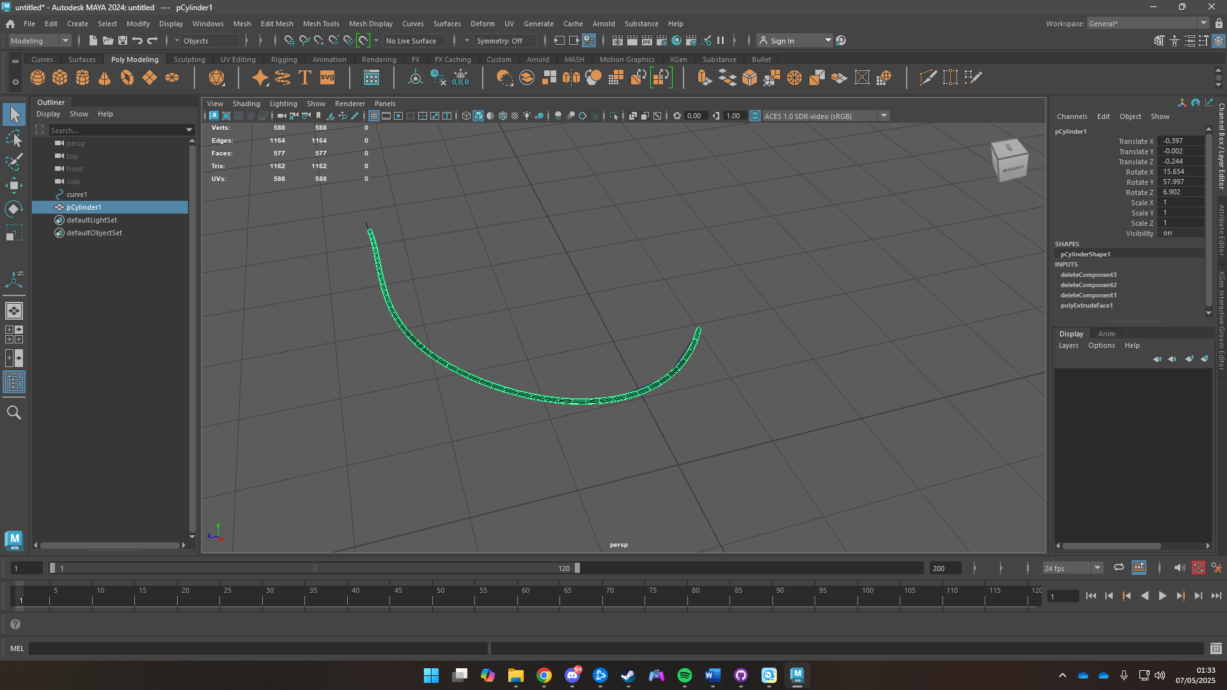

Figure 77 Created Wire

## Downloaded Assets

Assets such as cycle, pipes, airduct, bollard were downloaded from Quixel Bridge and Polyhaven. The HDRI was also downloaded from Polyhaven

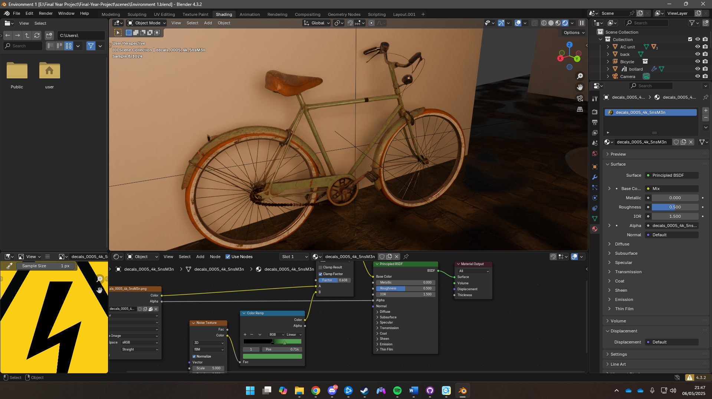

Figure 78 Imported Cycle from Quixel Bridge

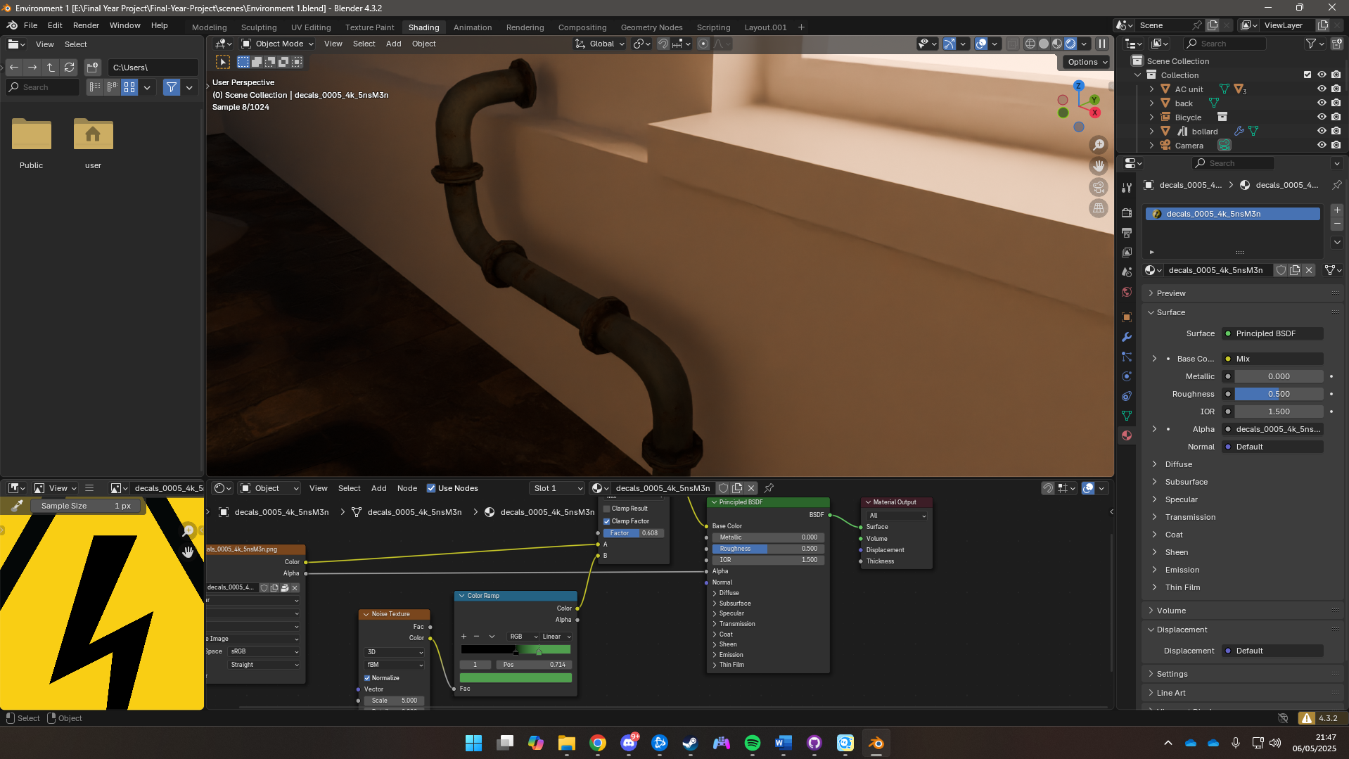

Figure 79 Pipes imported from Polyhaven

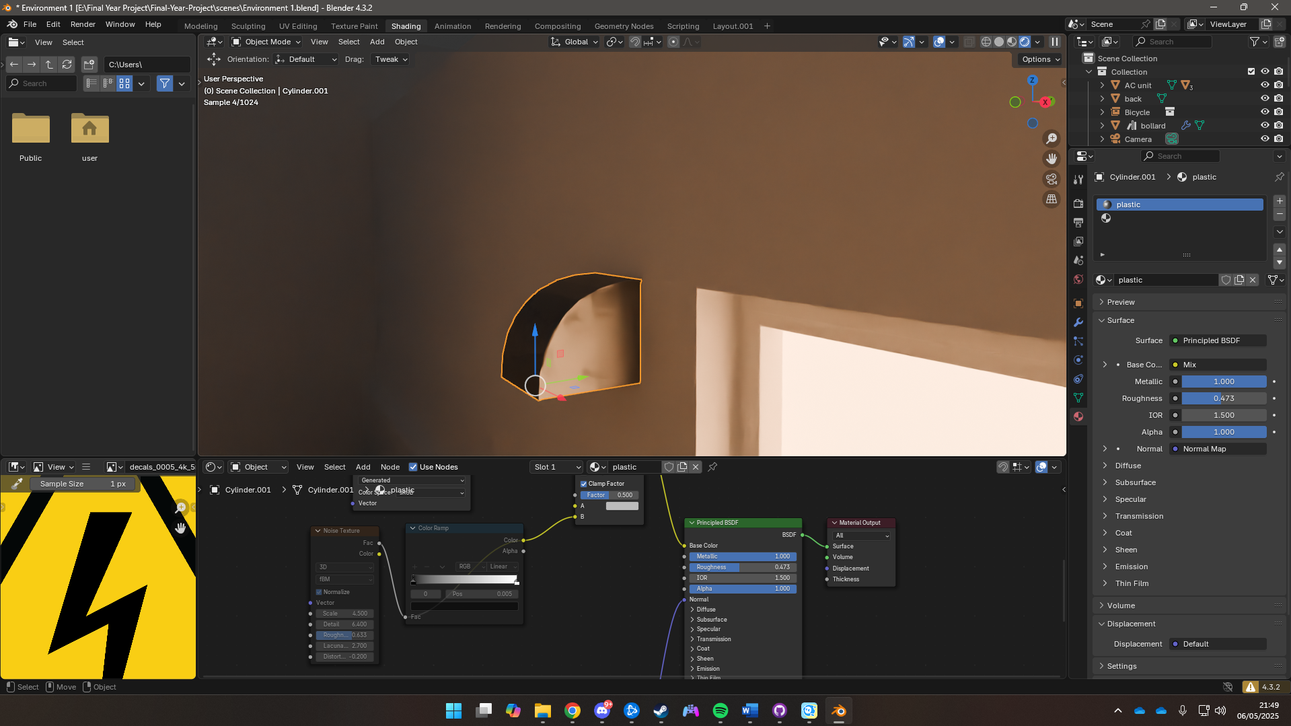

Figure 80 Airduct imported from Polyhaven

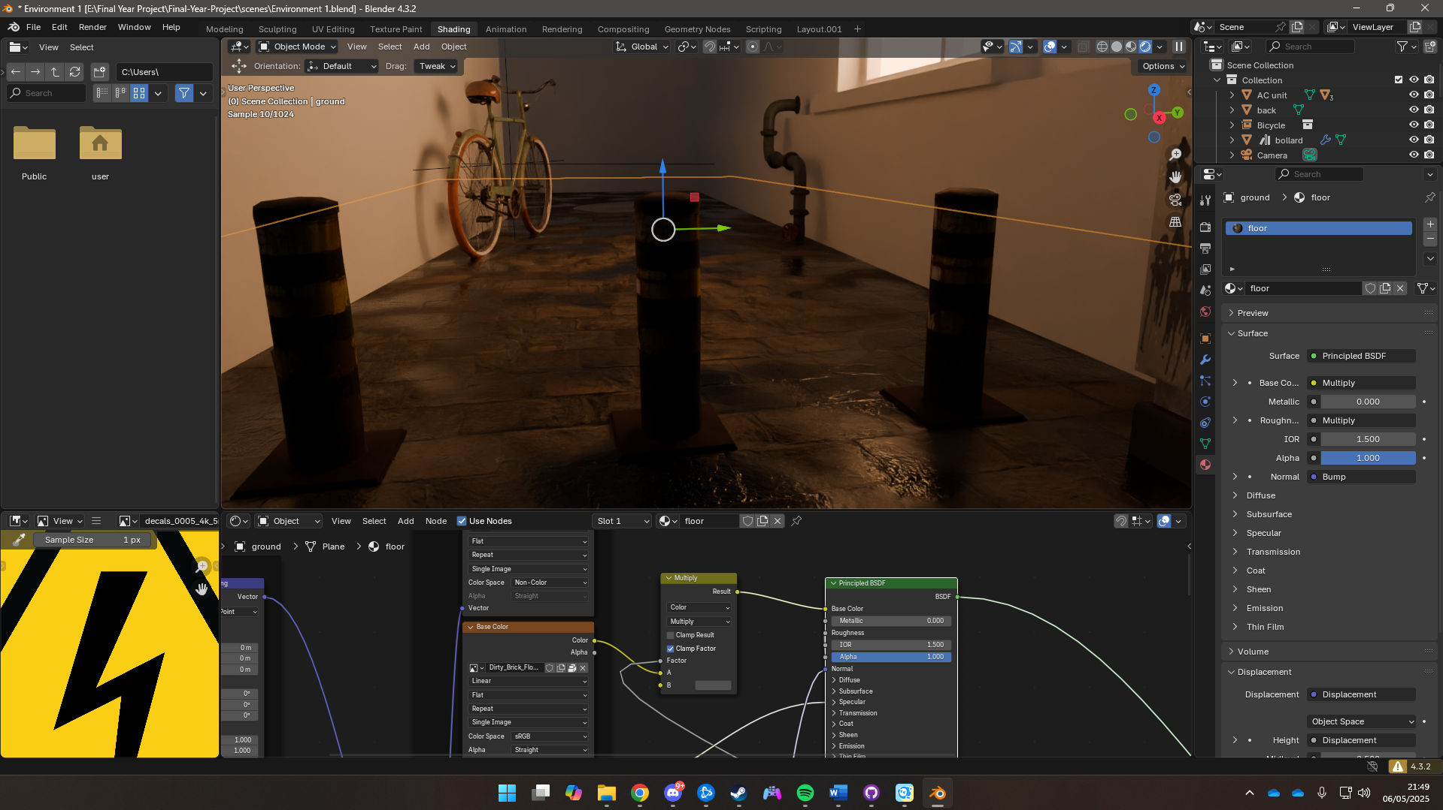

Figure 81 Bollard Imported from Polyhaven

## Scene Assembly

The scene was assembled by importing all the assets into a singular file and placing them according to the mood board. Creating a rough block of how the scene is supposed to look.

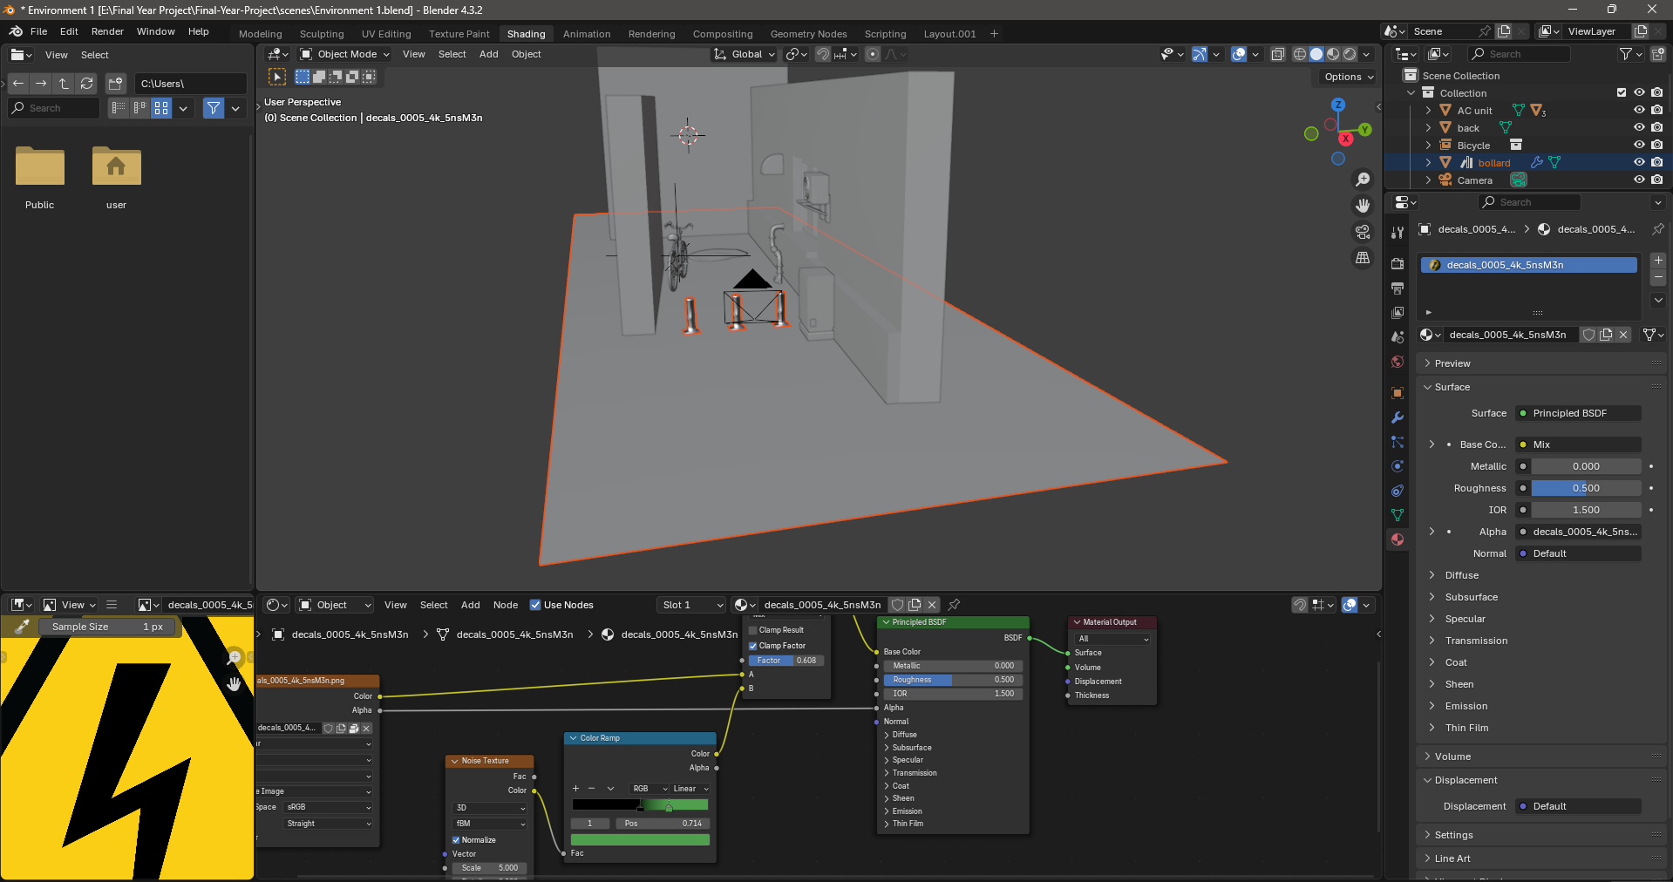

Figure 82 Rough Concept of Scene

Later minor details were added such as trash cans and garbage bags

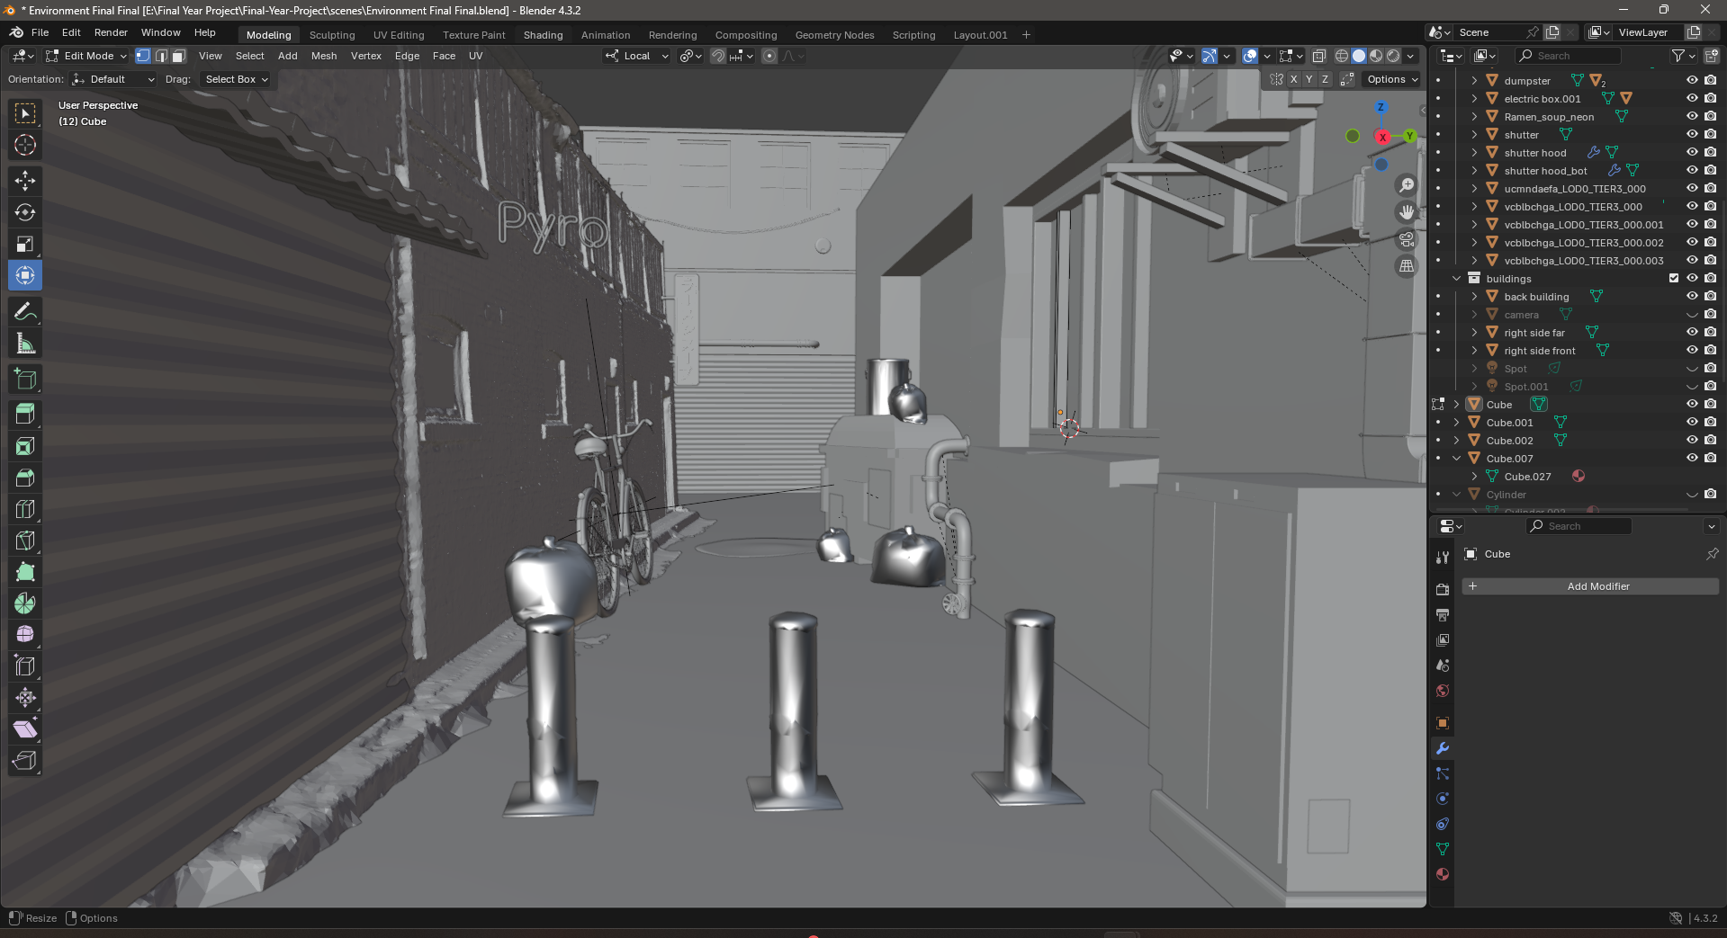

Figure 83 Minor Details added

Even further details were added to the scene such as neon signs, spotlights, tube lights.

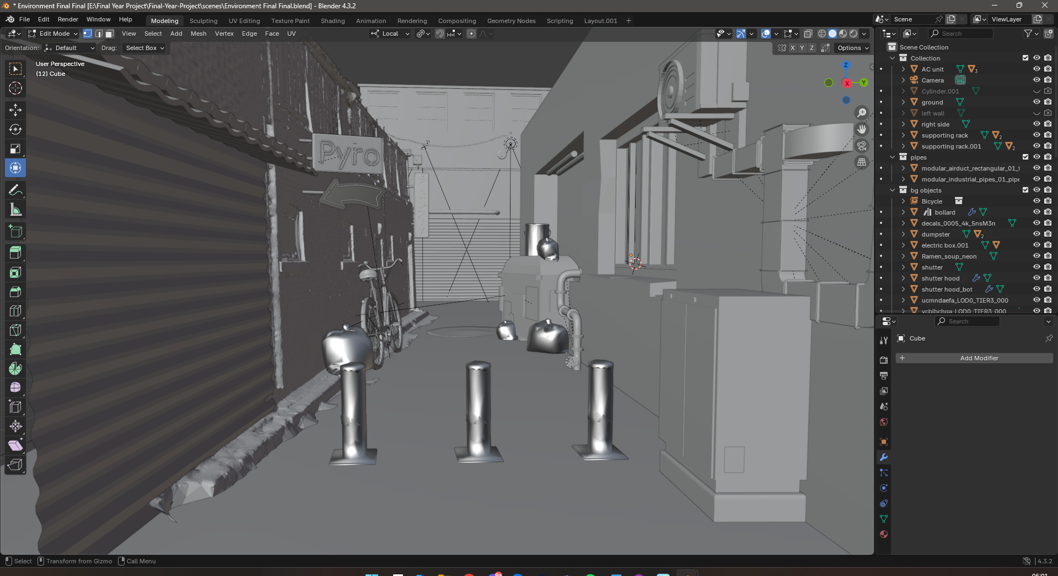

Figure 84 Final Scene Assembly

This is the render view of the scene with all textures and lighting enabled

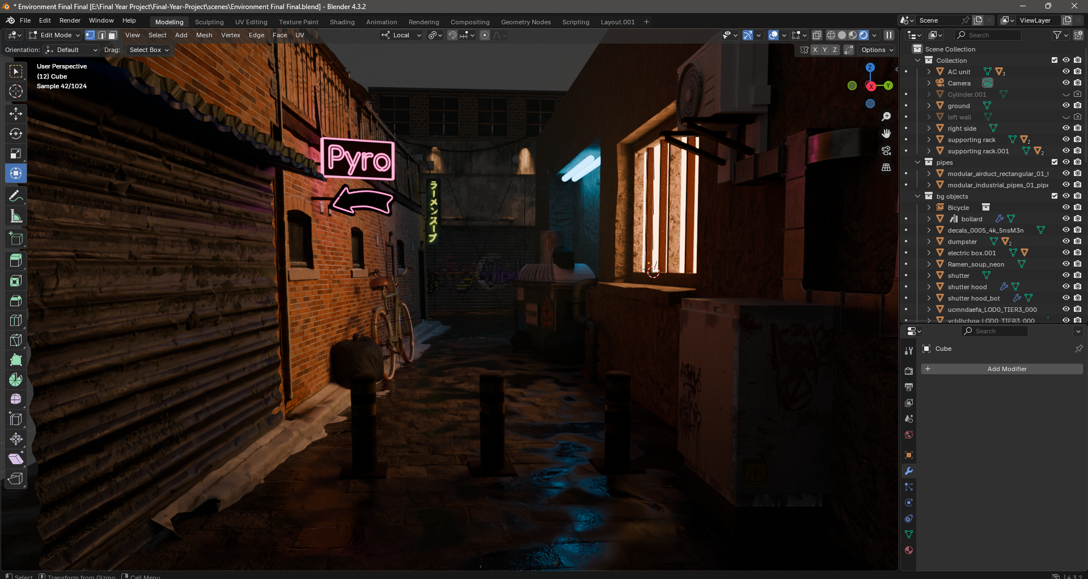

Figure 85 Rendered Scene

## Animation

Various animation cycles were created for this project. Pose references were collected then imported into maya to create keyframes by moving controllers

### Walk Cycle

To create a walk cycle that mimics the natural movement of a cat it requires thorough studying of catwalk references and understand the walk cycle of a cat which is in a four-beat walk cycle. Knowing the contact and passing poses in the appropriate key frames.

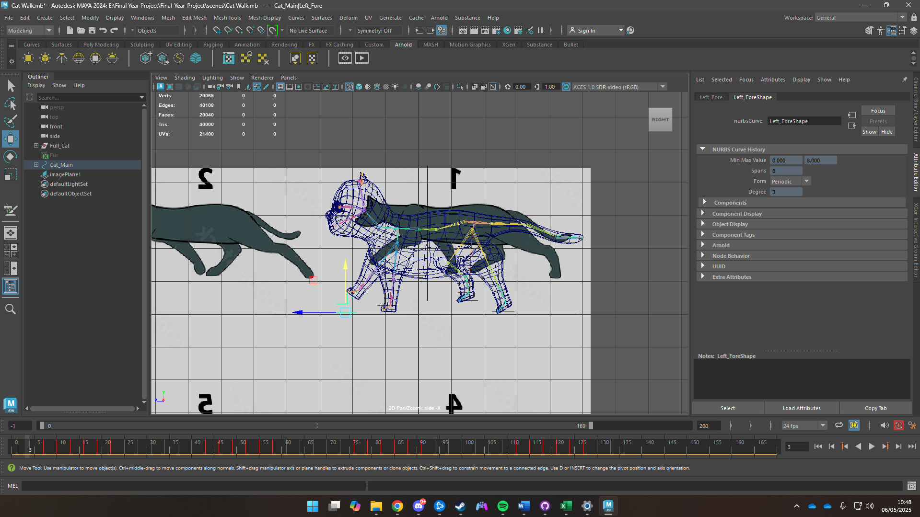

Figure 86 Creating Walk Cycle by adding Keyframes

### Run Cycle

A run cycle for a cat involves fast and powerful motions which normally includes all four feet to be off the ground. It requires the studying of cats running in slow motion.

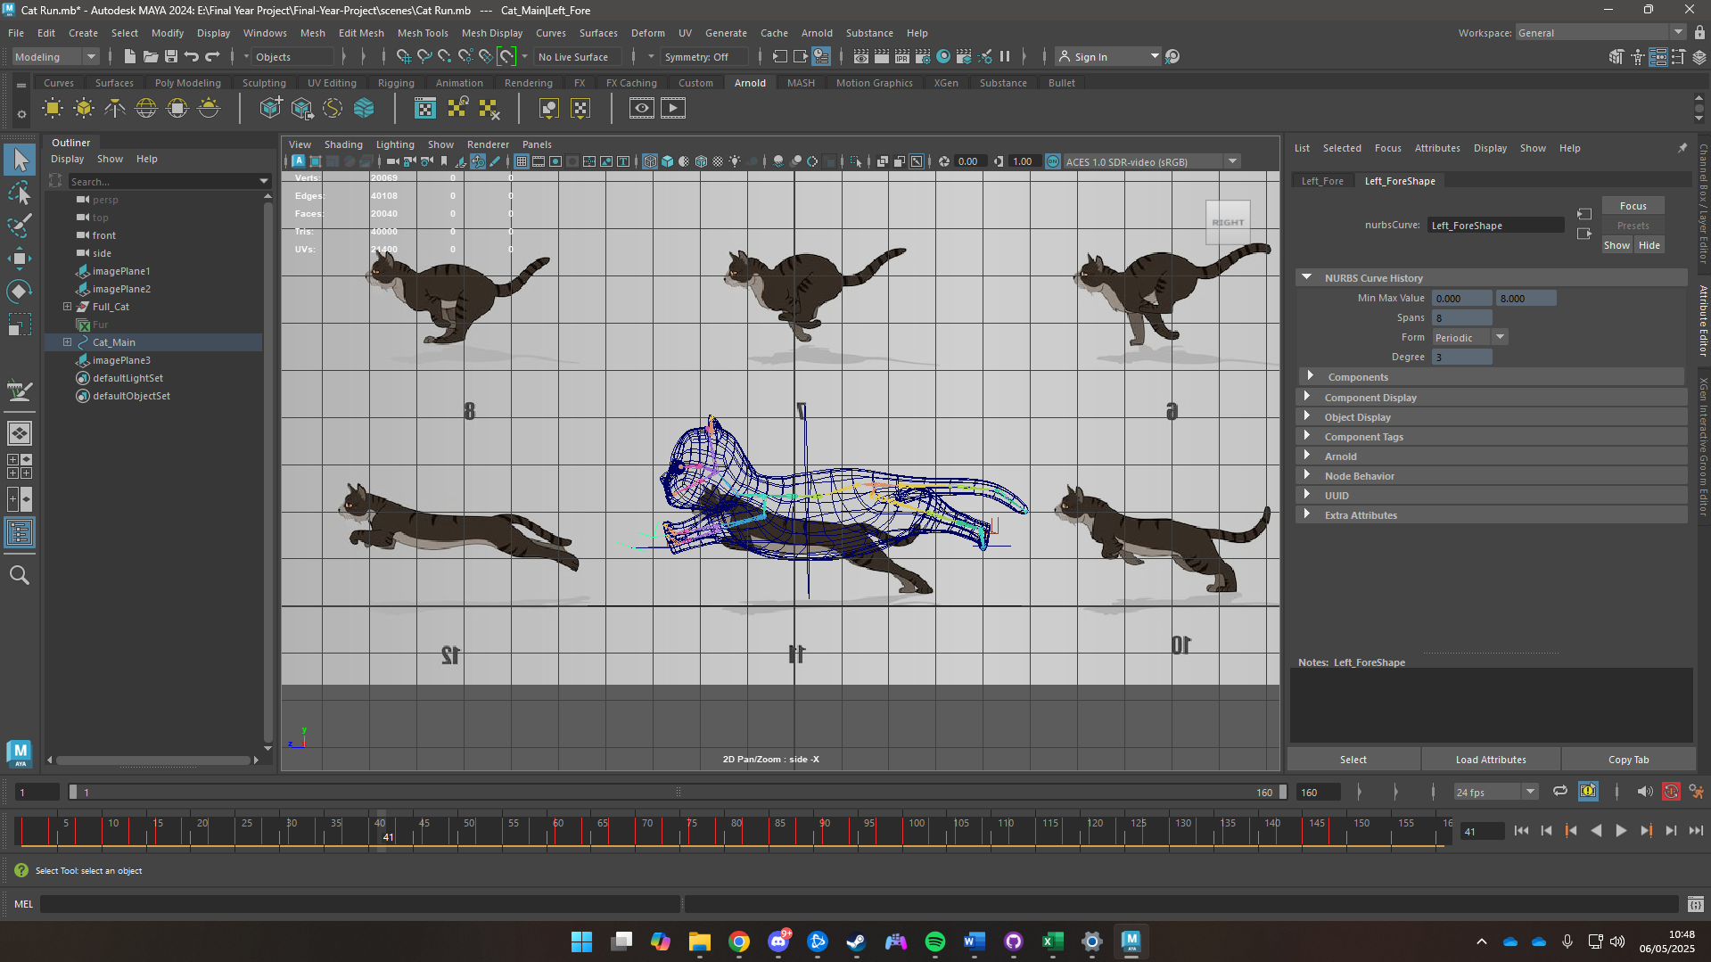

Figure 87 Creating a run Cycle

### Short Jump

A short jump cycle for a cat involves animating anticipation, take-off, airborne phase, landing, and recovery phases. Since cats are agile timing and the arc they jump in are crucial to create a smooth animation.

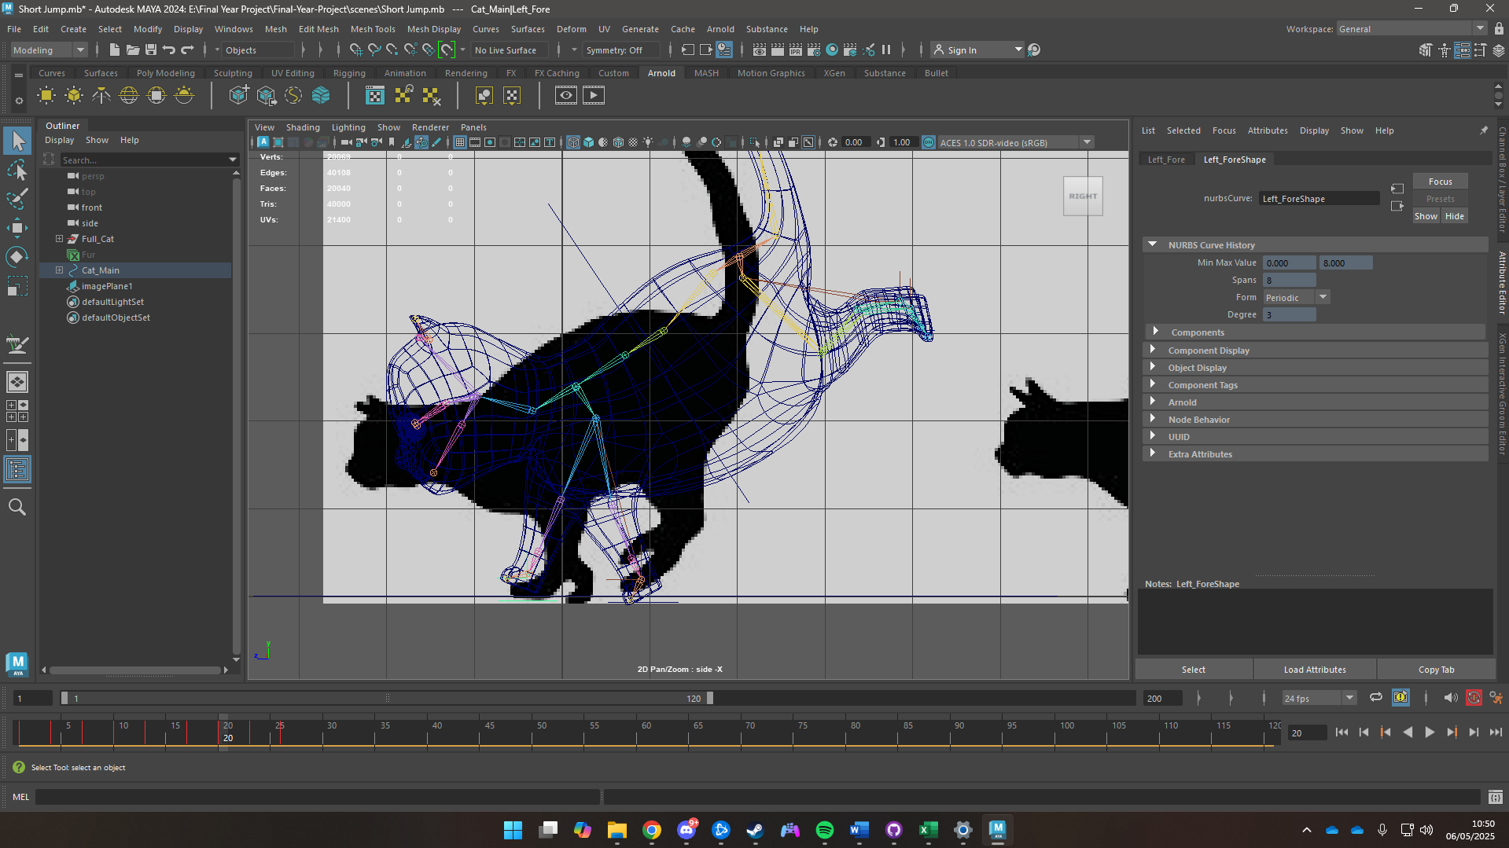

Figure 88 Creating a short jump

### Long Jump

A long jump for a cat is more dramatic than a short jump. It requires a greater sense of power, distance, stretch, and control. It requires a through study about videos of cats leaping long distances knowing the deep anticipation, the explosive take-off, the mid-air arc, the impactful landing and the balanced recovery.

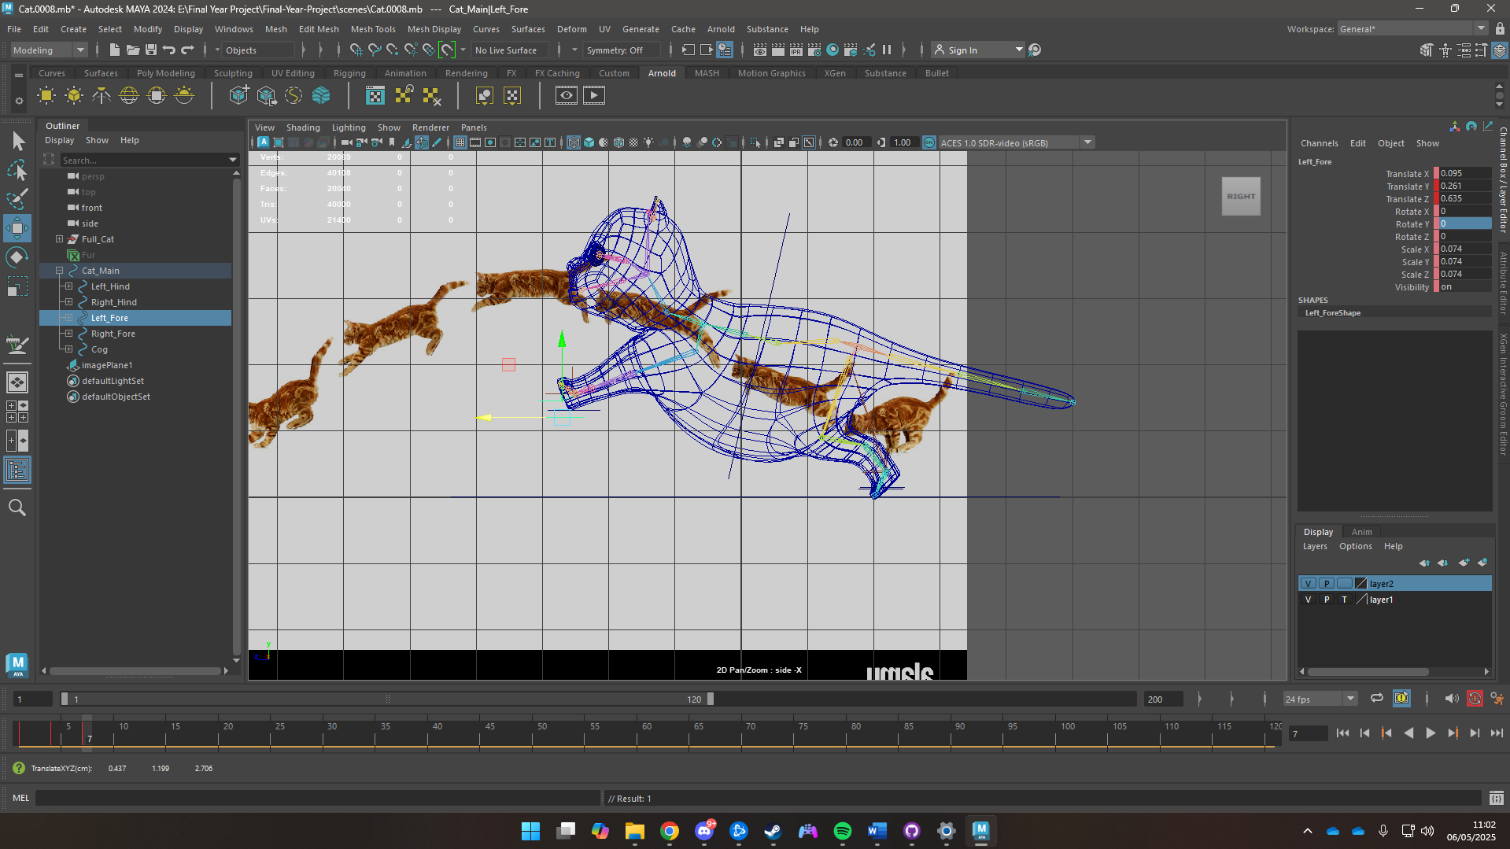

Figure 89 Creating a Long Jump Cycle

## Lighting

### Window Emissions

The windows were given an emissive tint leading a yellowish glow

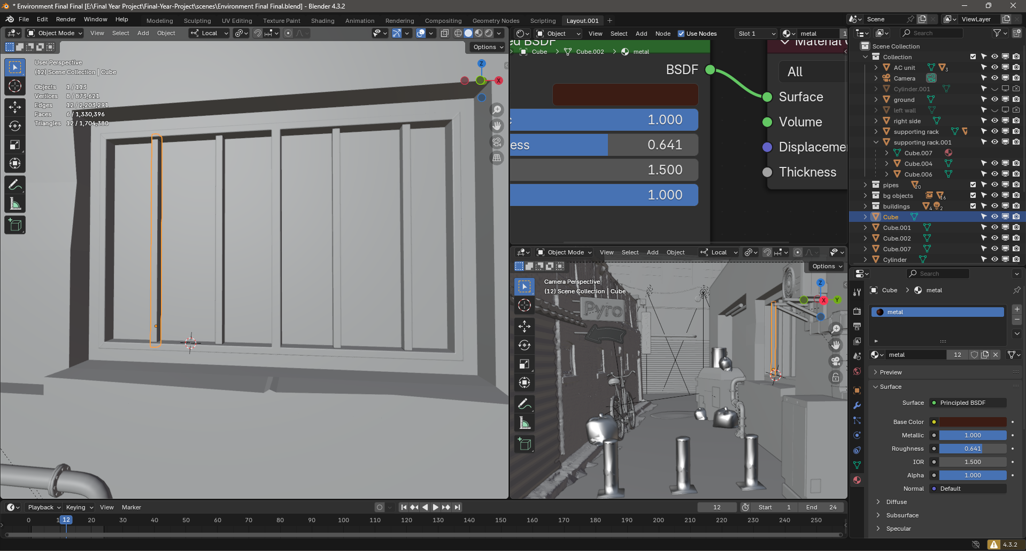

Figure 90 Untinted Windows

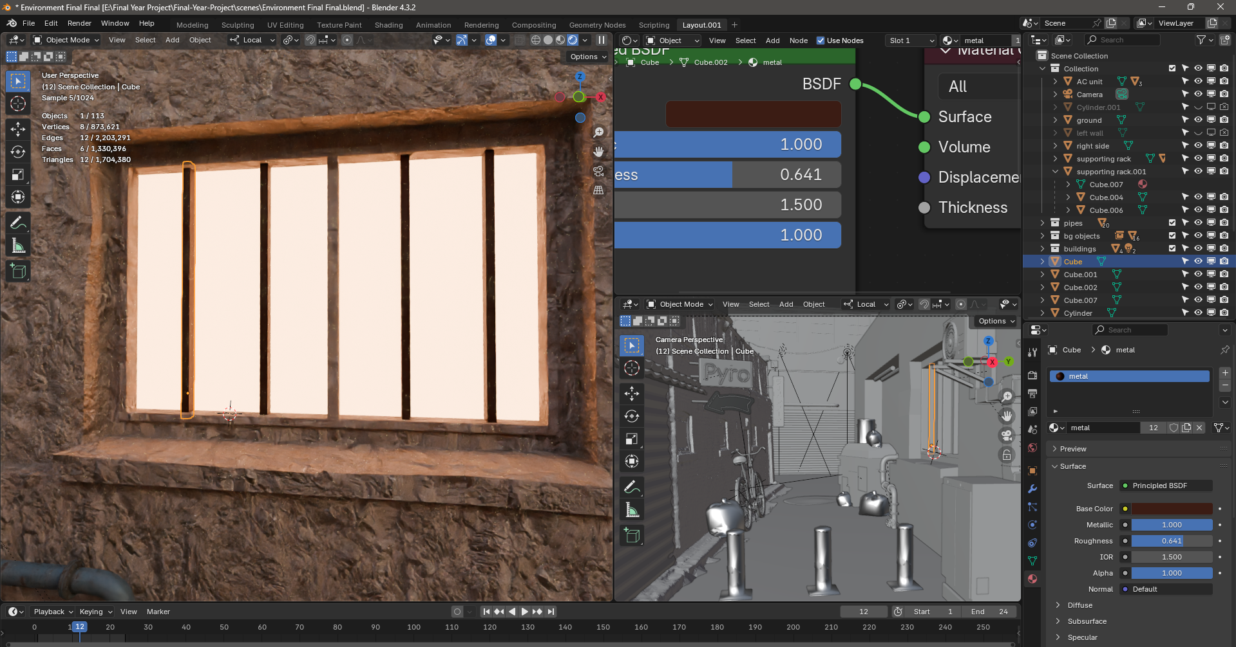

Figure 91 Windows with emissive tint

### Tube Lights

The tube lights were also given an emissive blue glow to light up the scene

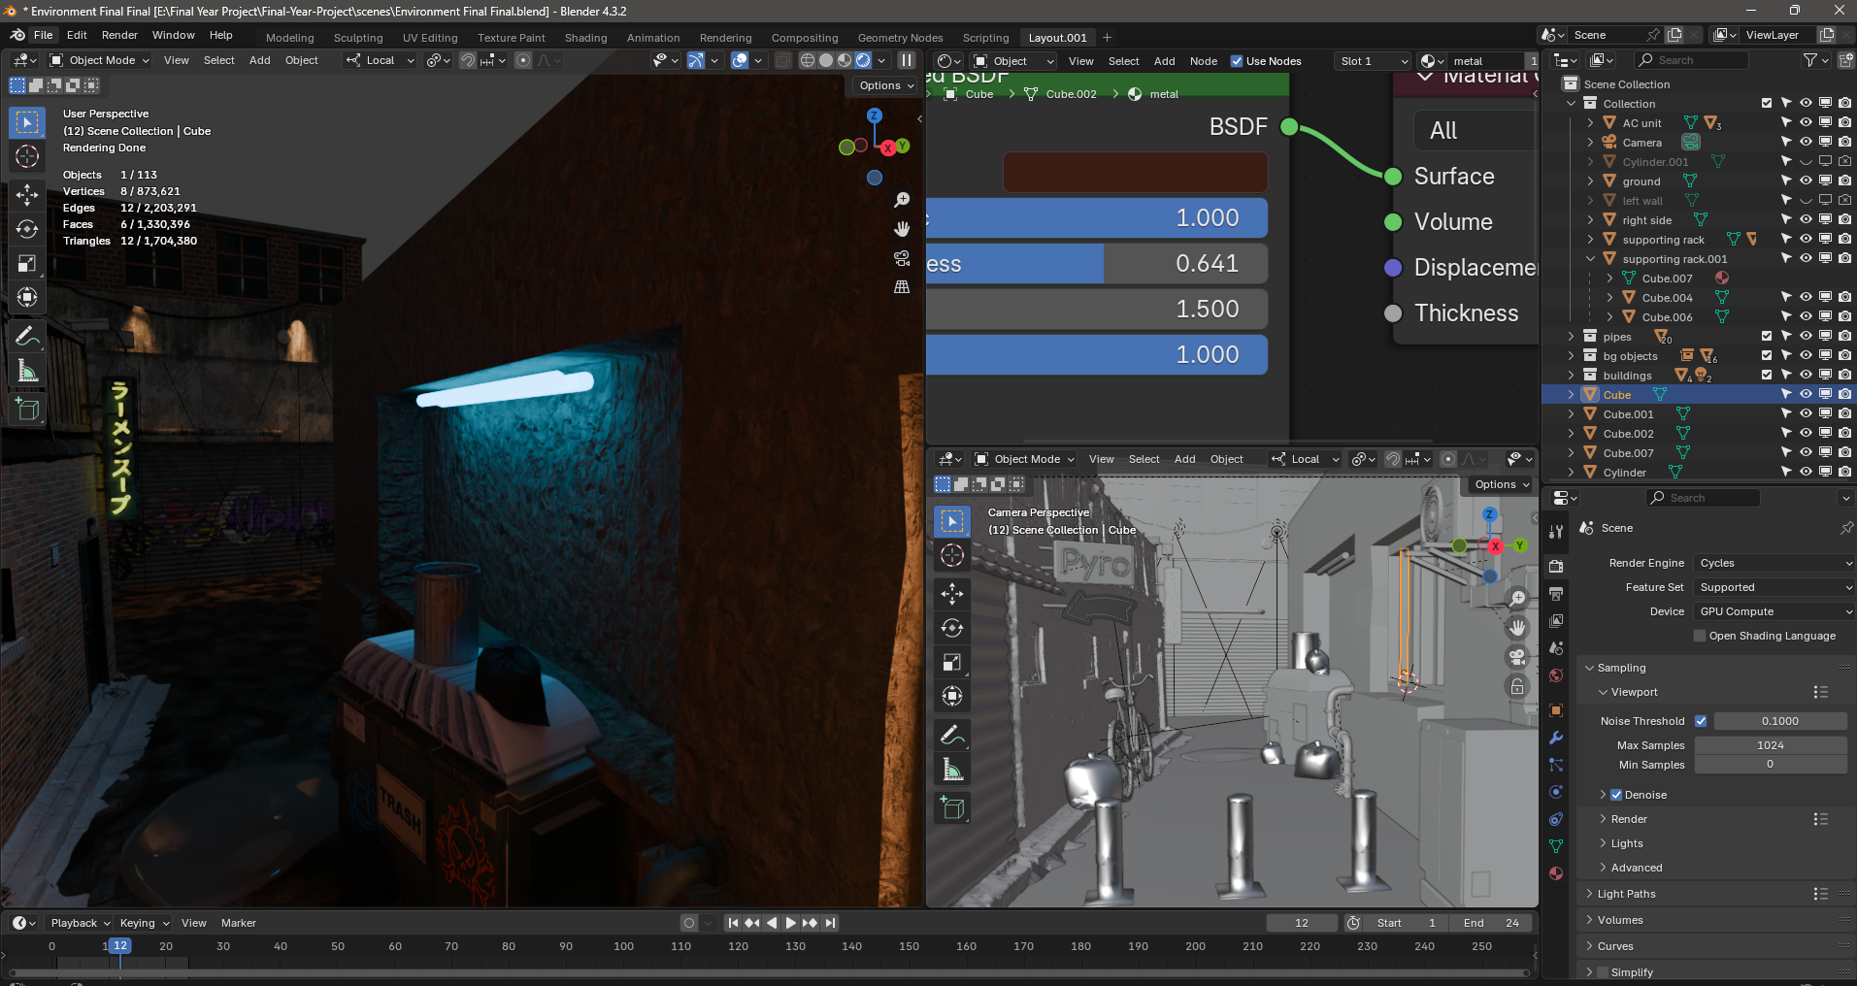

Figure 92 Tube Lights with blue emissive

### Neon Signs

The Neon Signs were created and then given a neon emissive glow.

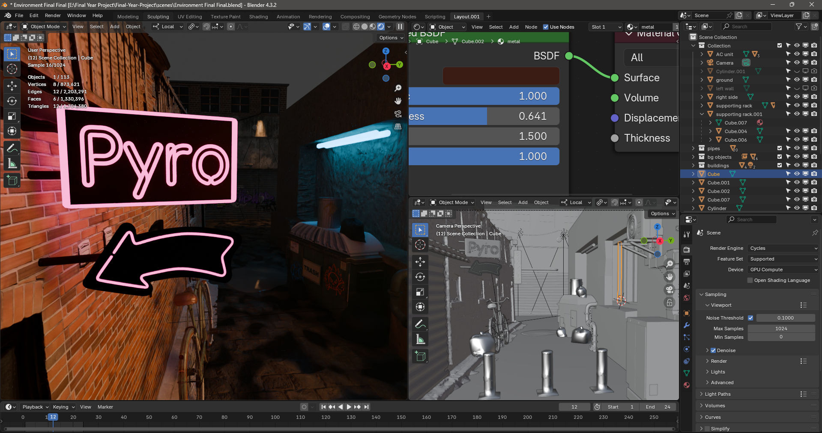

Figure 93 Neon Signs

### Spotlights

Spotlights were added to the houses to give a streetlamp vibe

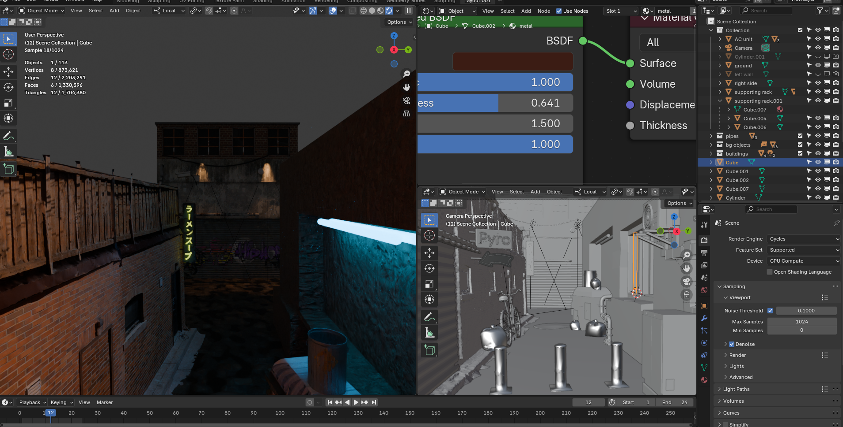

Figure 94 Use of spot lights

### World Lighting

The world lighting was given a grey background texture to simulate nighttime.

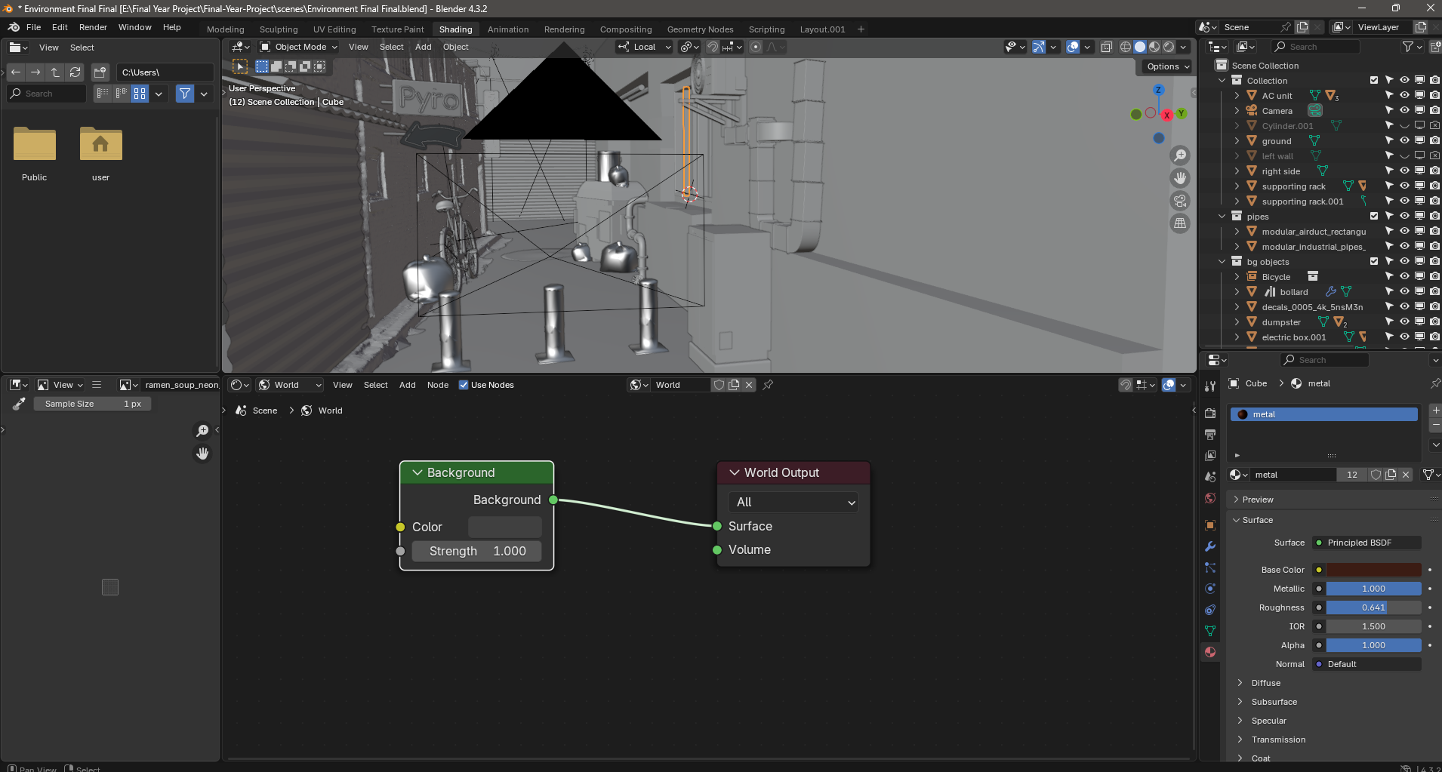

Figure 95 Texturing world lighting

## Render Settings

The scenes were rendered using Arnold renderer. The images were exported in .exr format. GPU rendering was used as it is faster compared to CPU Rendering. A denoiser was also added to remove noise leading to a clean export.

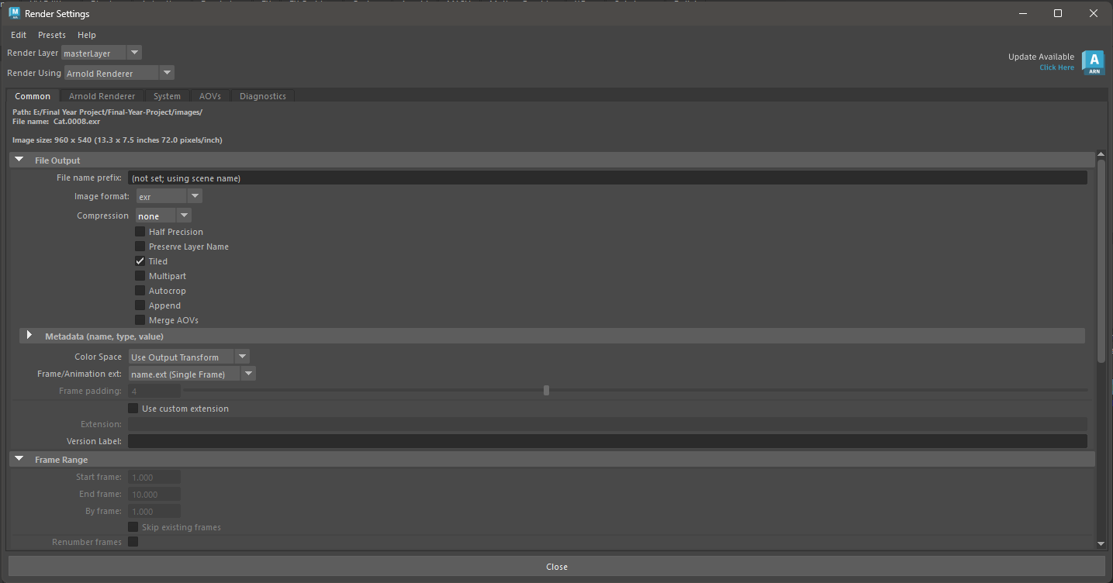

Figure 96 Rendering Settings 1

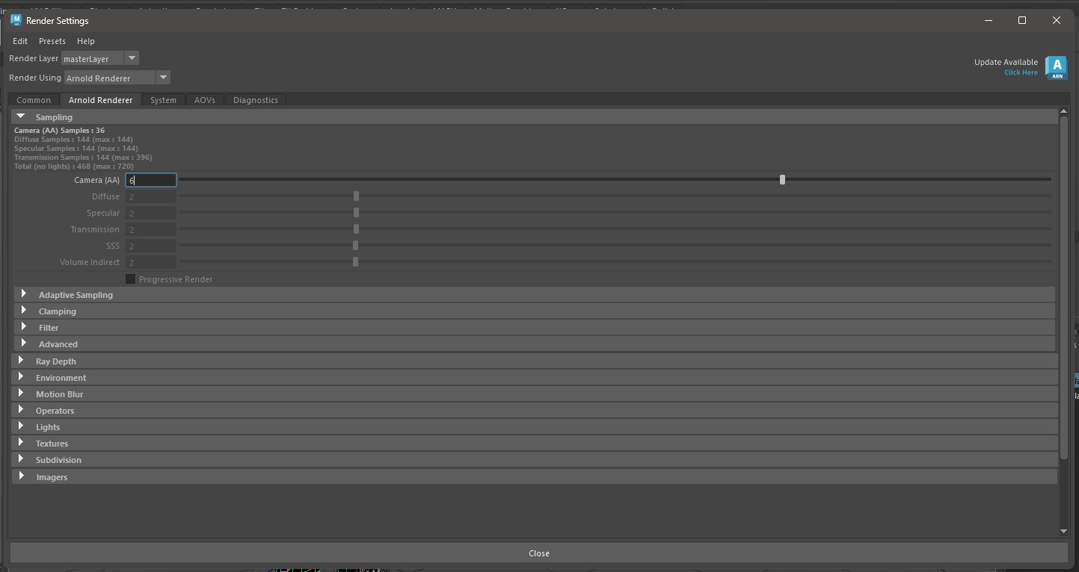

Figure 97 Rendering settings 2

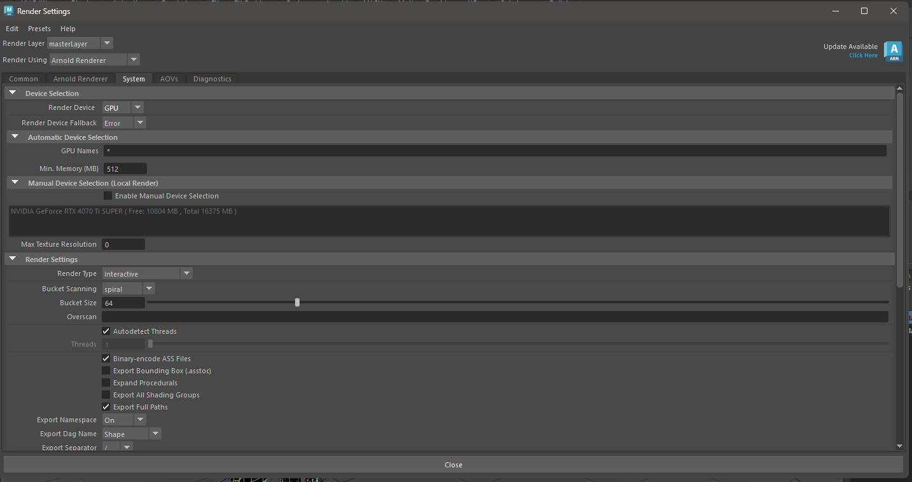

Figure 98 Export Settings 3

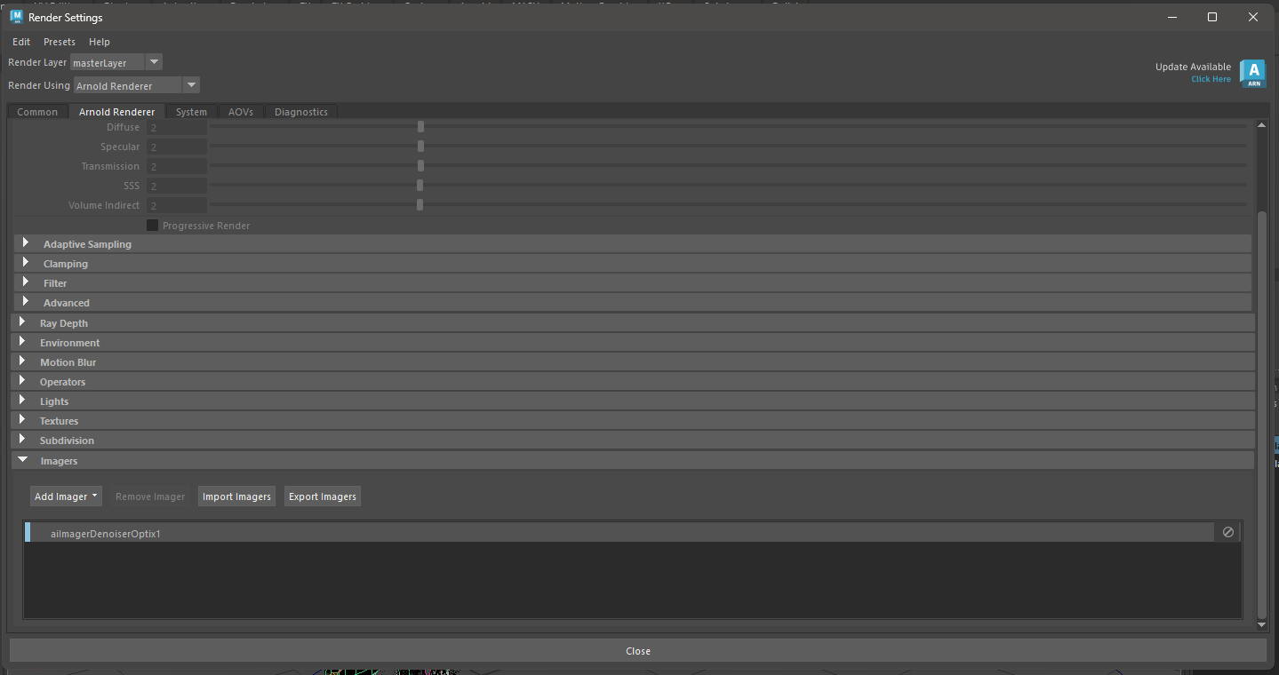

Figure 99 Export Setting 4

# Post-Production

Problems faced and its solutions

## Problem 1 & its solution

During UV unwrapping maya would bug out and some UVs would exist, but their maps would not be shown. This caused problems during the texturing process.

**Solution:** The simple solution was to auto unwrap the missing UVs then re-sewing and cutting edges according to how you want the UV to look

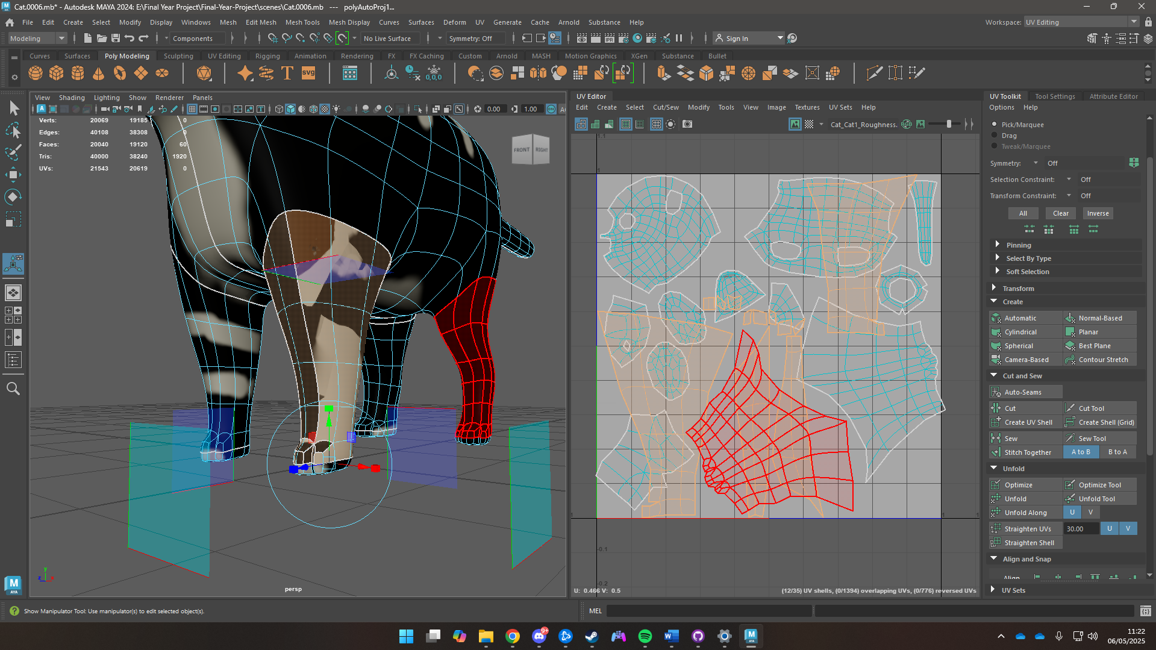

Figure 100 Auto-unwrapping

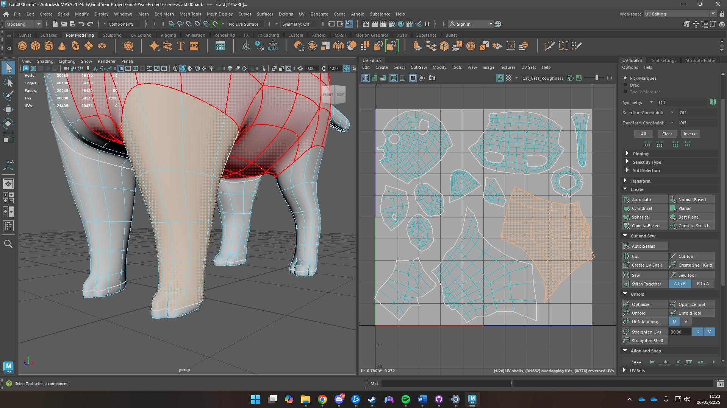

Figure 101 The Solution

## Problem 2 & its solution

Maya kept crashing while creating animations, creating hair using xGen.

Solution: There was really no solution, just reopen Maya and do the same thing all over and hope it doesn’t crash.

## Problem 3 & its solution

Maya didn’t import some textures that were made in blender

Solution: Character animation alembic files were exported to blender and rendered there

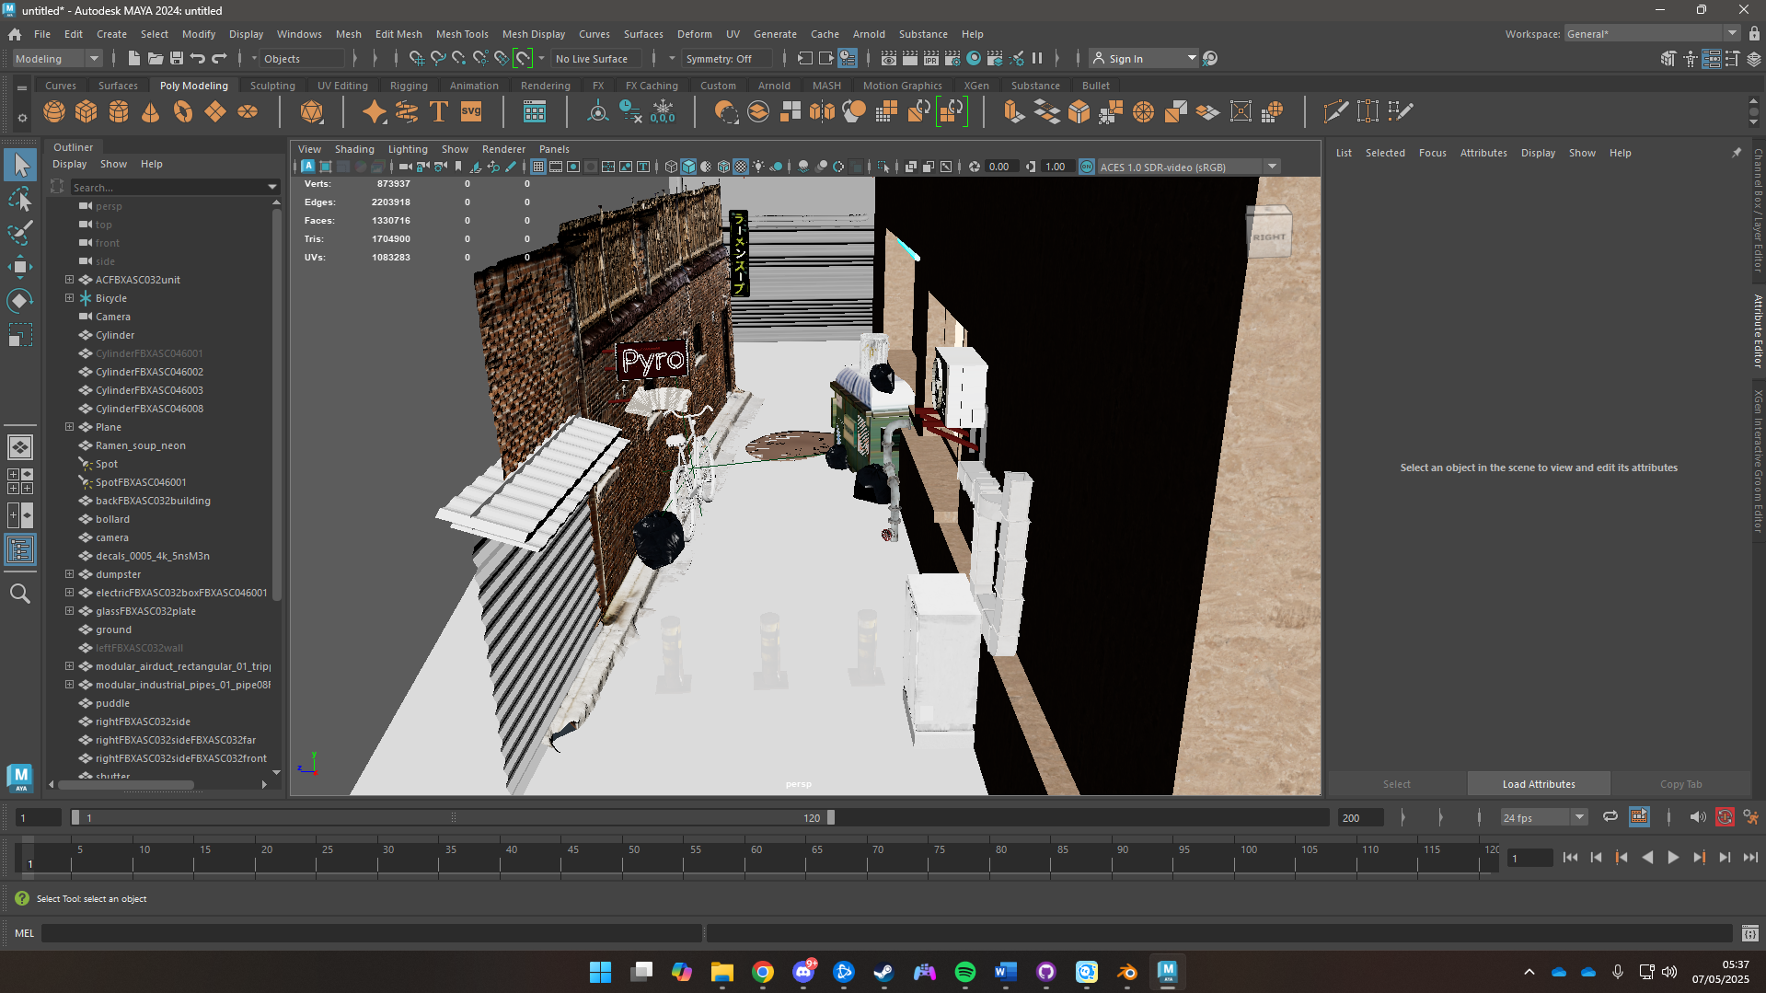

Figure 102 Maya not taking in textures

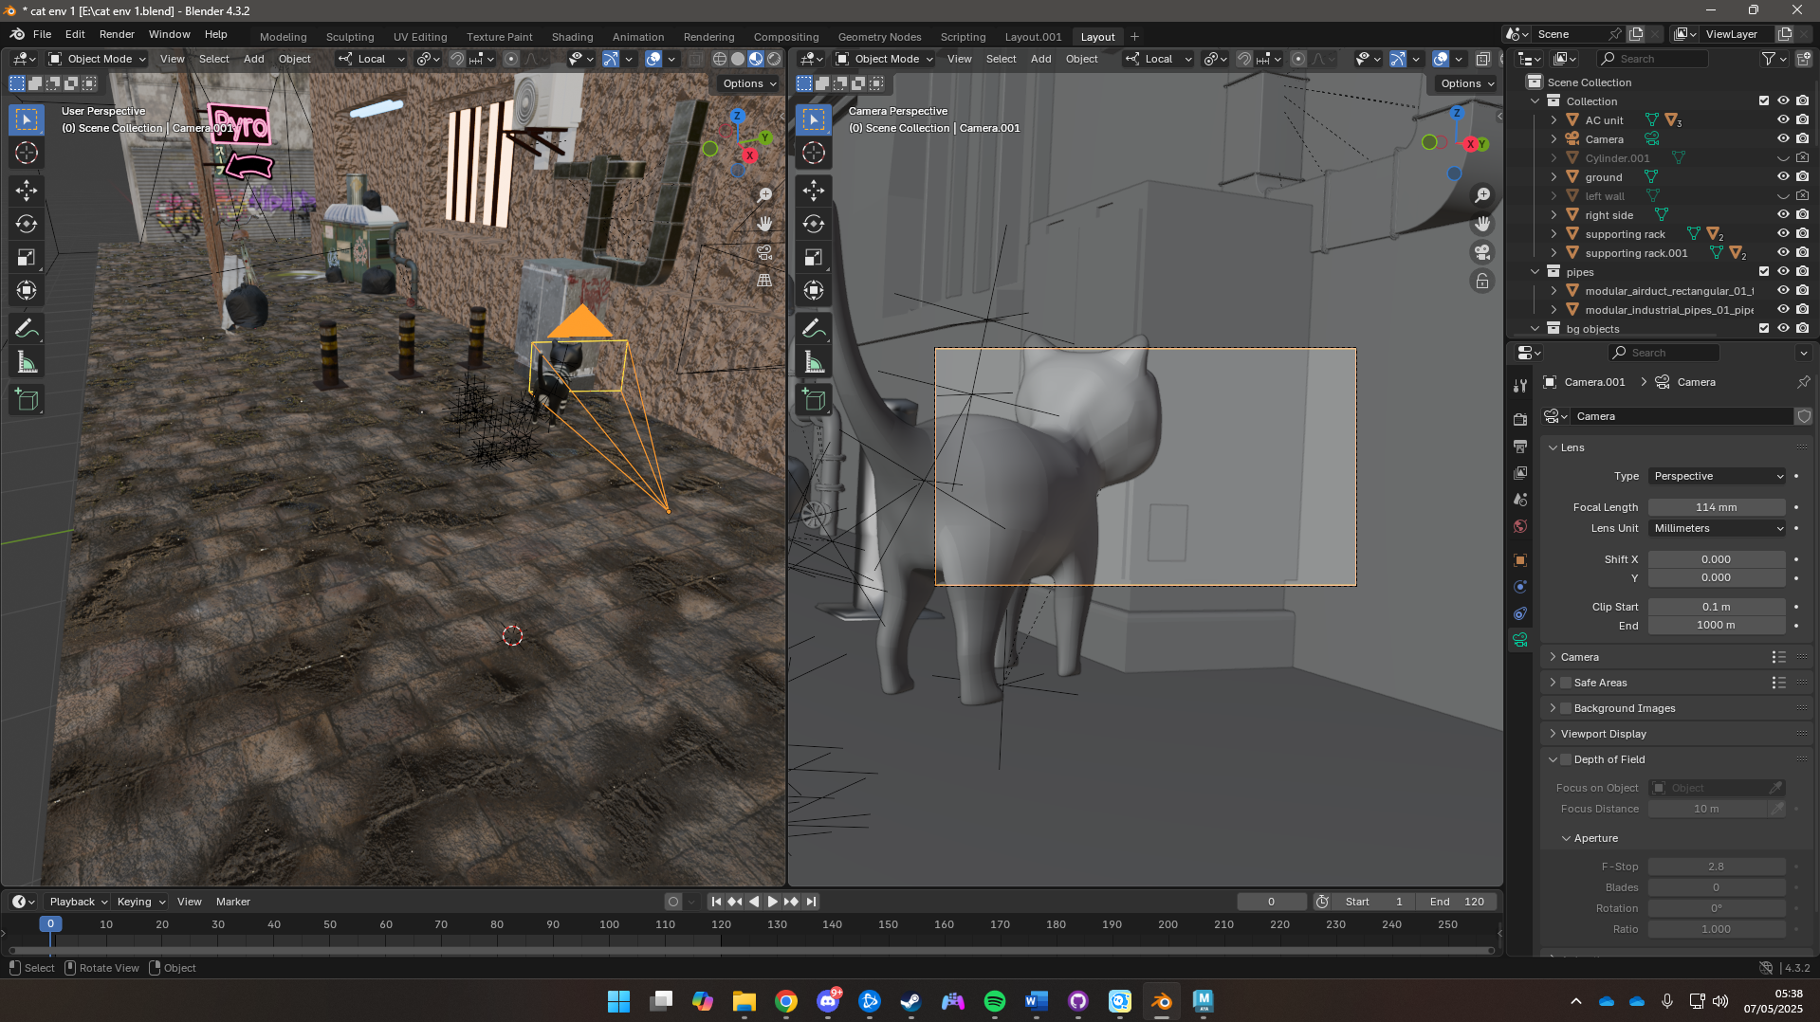

Figure 103 Solution rendering in Blender

# User Testing and Finding

## Survey Form Results

A total of 11 questions were asked, names and emails were not revealed in the documentation, but follow-up questions were asked personally. The survey was provided after the responders watched the video.

Survey Link: <https://forms.gle/tDqngRJbHQZE6XjS6>

The results are as follows

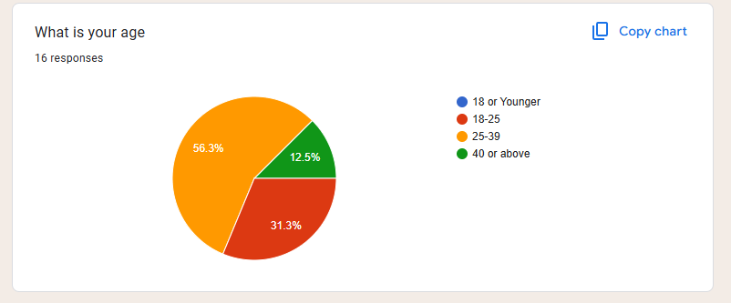

Figure 104 Age Group

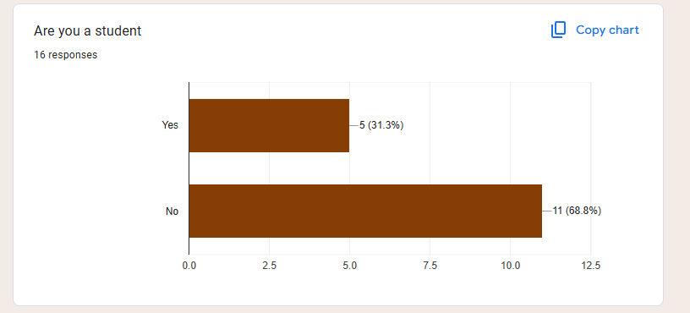

Figure 105 Occupation status

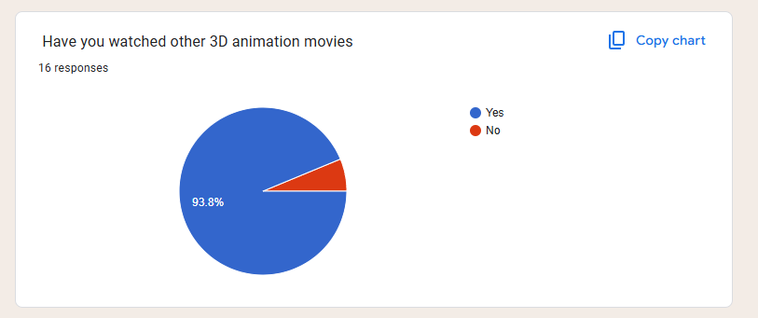

Figure 106 Have they watched other 3D animation movies

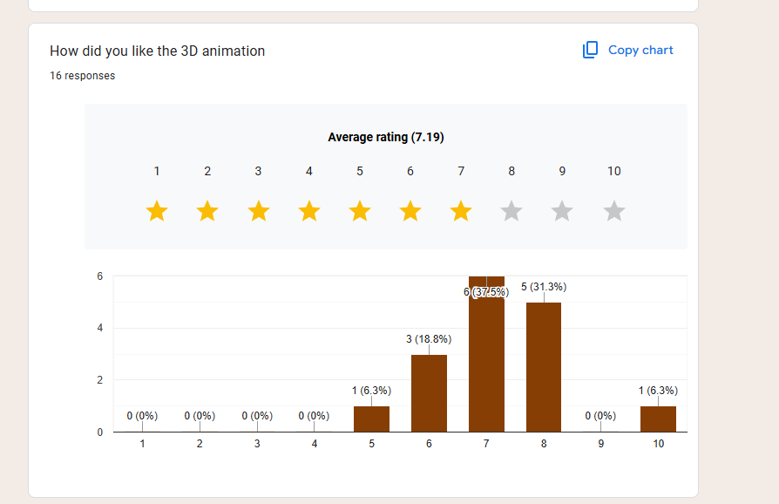

Figure 107 Appreciation of the 3D animation

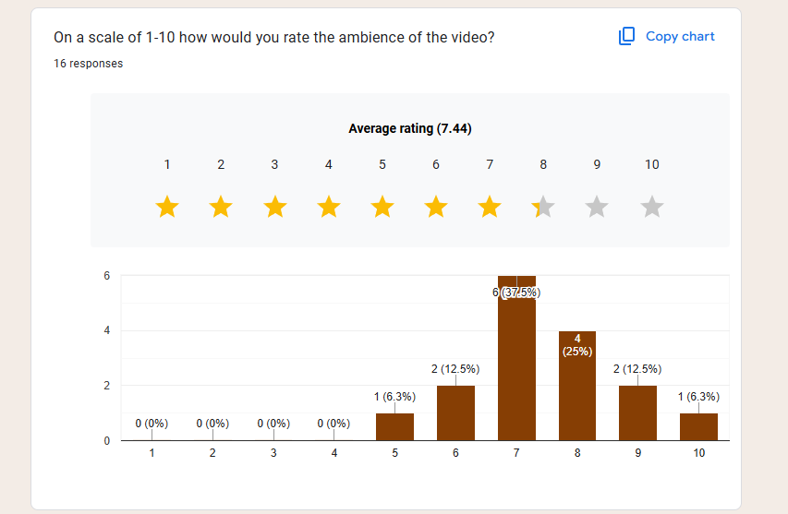

Figure 108 Ambience Rating

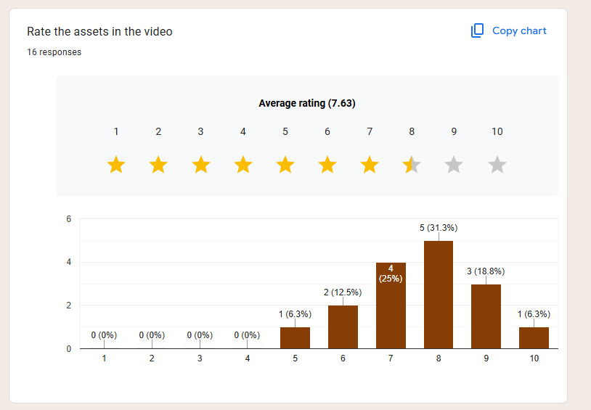

Figure 109 Asset Rating

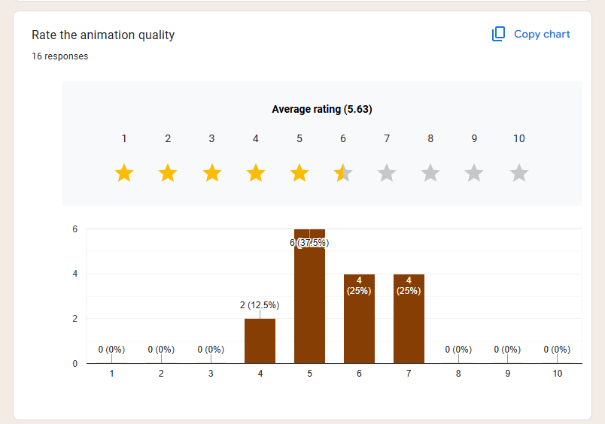

Figure 110 Animation quality rating

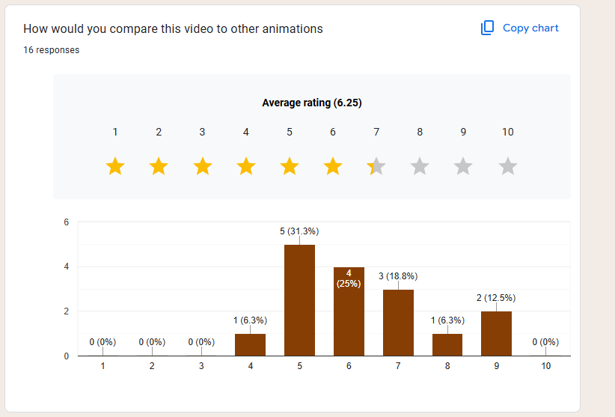

Figure 111 Comparison

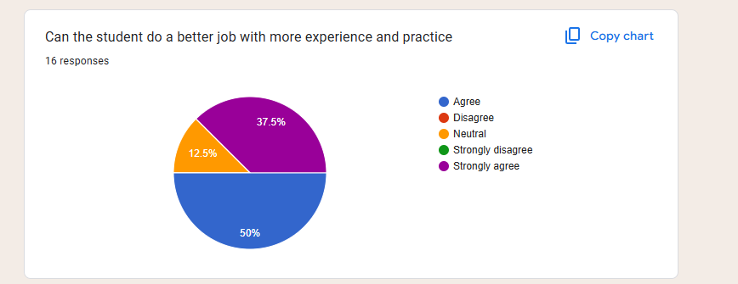

Figure 112 Student skill

## Third Party Testing

**Eva De Roy (Exports officer at Bundesamt für Wirtschaft und Ausfuhrkontrolle)**

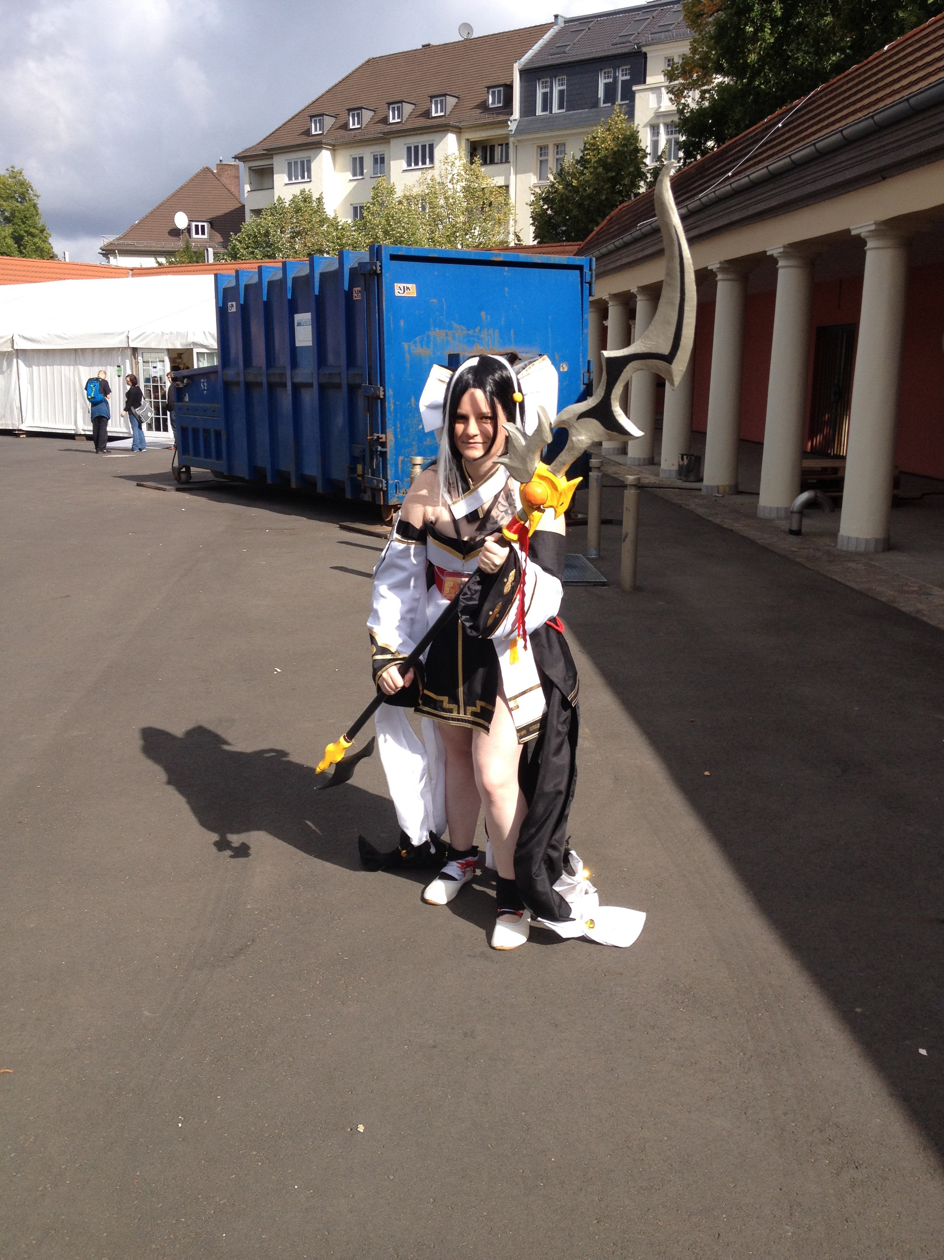

Figure 113 Eva De Roy

The animation looks neat. The aesthetics and mood of the environment look good, and the environment is visually pleasing too. The animation could use some more work as it looks a bit jank. Overall, the effort put in can be seen and it is very commendable. Can’t wait to see what the student will create once he starts working in the industry.

**Prajit Man Shrestha**



Figure 114 Prajit Man Shrestha

The environment and the lighting are mind-blowing. The video in general is properly made. However, the animations were very choppy, and better work could be done on it.

It can be seen that the student has spent a lot of time on making the environment and lighting look good.

**Anna Kasayuke (Project manager)**



Figure 115 Anna Kasayuke

Having known the student for a long time now, it can clearly be seen he has been lazy with some aspects of the 3D animation. The animation could’ve been done much better. However, the environment, lighting, and ambience have hit the spot and look visually stunning.

# Appendix

## Weekly Log

